Gender Pay Gap

2019 - 2020

As a Local Authority we are governed by the Equality Act 2010 (Specific Duties and Public Authorities) Regulations 2017 which came into force on 31 March 2017. These regulations underpin the Public Sector Equality Duty to consider how organisational policies and decision affect people who are protected under the Act. The introduction of this legislation made it statutory for organisations with 250 or more employees to report annually on their gender pay gap.

The gender pay gap is an equality measure that shows the difference in average pay between women and men in the workforce. It provides a framework within which gender pay gaps can be surfaced so that, both inside and outside of the workplace, we can think constructively about why gender pay gaps exist and what to do about them.

Dependent upon the average level of an organisations gender pay gap, this can indicate that
there may be a number of issues to deal with and more detailed analysis may help to identify what those issues are. At Tameside we are committed to monitoring our gender pay gap and ensuring fair pay for all. This first report sets out our starting position, from which we will drive further improvement through analysis, specific interventions and targeted actions.

Tameside is committed to the principles of consistency, fairness and transparency, supporting the fair treatment and reward of all staff irrespective of any differences. We implemented the living wage foundation rate in September 2016, support flexible working practices and promote employee progression through our career development scheme. These initiatives enable people to grow in our organisation whilst balancing family life and other commitments.

Tameside Council is committed to the promotion of equality of opportunity and choice for all employees; making Tameside Council an employer of choice. A diverse and inclusive workforce which develops talent is good for everyone, and reflects the community we work within.

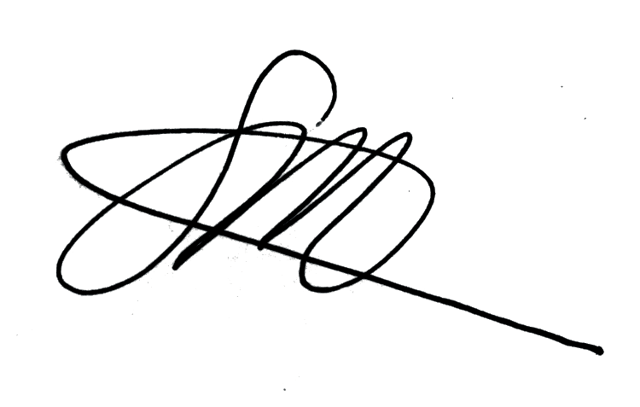
Steven Pleasant MBE
Chief Executive, and Accountable Officer, Tameside & Glossop CCG

All public sector employers are required to publish information about gender pay gaps annually by 31 March each year. This information is based on a snapshot date of pay on 31 March 2019. At this date the Tameside workforce comprised of 63% females and 37% males.

This analysis looks at the gender pay differences within Tameside Council, focusing on the overall pay difference between the male and female workforce. A positive pay gap indicates that men are paid more, whereas a negative pay gap indicates that women are paid more. Where the pay gap exceeds +/-3% it is good practice to analyse the workforce data to understand the reasons for the gender pay difference.

Women paid more Men paid more
Insignificant pay gap

-3% +3%

The gender pay gap is different to equal pay. Equal pay relates to men and women receiving equal pay for equal work, not meeting this requirement has been unlawful for over 40 years. The gender pay gap is a measure of disparity in pay between the average earnings of males and females. This can be measured in various ways.

What do we report on?

Mean gender pay gap | The difference between the mean hourly rate of pay of male full-pay relevant employees and that of female full-pay relevant employees.
Median gender pay gap | The difference between the median hourly rate of pay of male full-pay relevant employees and that of female full-pay relevant employees.
Quartile bands | The proportion of males and females in each quartile band

How the Median is calculated

Women
Pay (within pay grade)
Men
Pay (within pay grade)

Lowest Highest Lowest Highest

Gender pay gap = Median pay men - Median pay women
Median pay men

x 100

How the Mean is calculated

Women
Pay (within pay grade)
Men
Pay (within pay grade)

Lowest Highest Lowest Highest

Gender pay gap = Mean pay men - Mean pay women
Mean pay men

x 100

Interpreting the Mean/Median figures

- A positive percentage figure (which almost all organisations are likely to have) reveals that typically or overall, female employees have lower pay or bonuses than male employees.

- A negative percentage figure (which some organisations may have) reveals that typically or overall, male employees have lower pay or bonuses than female employees.

- A zero percentage figure (which is highly unlikely, but could exist for a median pay gap where a lot of employees are concentrated in the same pay grade) would reveal no gap between the pay or bonuses of typical male and female employees or completely equal pay or bonuses overall.

Using these two different types of average is helpful to give a more balanced overview of an employer’s overall gender pay gap:

- Mean averages are useful because they place the same value on every number they use, giving a good overall indication of the gender pay gap, but very large or small pay rates or bonuses can ‘dominate’ and distort the answer. For example, mean averages can be useful where most employees in an organisation receive a bonus but could be less useful in an organisation where the vast majority of bonus pay is received by a small number of board members.

- Median averages are useful to indicate what the ‘typical’ situation is i.e. in the middle of an organisation and are not distorted by very large or small pay rates or bonuses.
However, this means that not all gender pay gap issues will be picked up. For example, a median average might show a better indication of the ‘middle of the road’ pay gap
in a sports club with a mean average distorted by very highly paid players and board members, but it could also fail to pick up as effectively where the pay gap issues are most pronounced in the lowest paid or highest paid employees.

Like most public sector organisations, Tameside’s workforce has a higher percentage of females; 63% female and 37% males.

Tameside’s workforce undertakes a wide range of jobs including: engineering, health, education, finance, human resources, information technology and communication, social care and professional business support services. This diverse range of jobs provides a number of different career opportunities and pathways for employees to develop.

Diagram 1: Total Workforce Demographic

63%
Workforce total female
1583

Workforce Total
2501

Workforce total male
918

37%

Diagram 2: Total Organisation Demographic

Quartile

Upper

Upper Middle

Lower Middle
Total people in Quartile

625

625

626
% Female % Male

61% 39%

72% 28%

63% 37%

Lower
625

58% 42%

1583 918

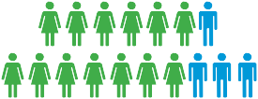
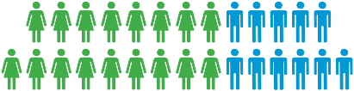
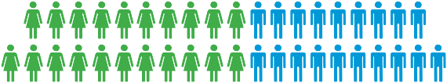
Diagram 3: Quartile Profile

Quartile | Hourly pay up to
Lower | £10.79
Lower Middle | £13.37
Upper Middle | £16.72
Upper | £91.93

Diagram 4: Workforce Distribution by Gender

Quartile |  | Count of female |  | Count of male
Lower |  | 361 (23%) |  | 264 (29%)
Lower Middle |  | 395 (25%) |  | 231 (25%)
Upper Middle |  | 448 (28%) |  | 177 (19%)
Upper |  | 379 (24%) |  | 246 (27%)

Females heavily populate the middle quartiles whereas the distribution of males is more evenly spread with a slightly higher percentage in the upper quartile.

1583 918

2501

Women 63.30% Men 36.70%

Mean - 2019 - 2020
Average hourly rate of pay and the percentage difference between

GAP
£0.36p
+2.37%

£14.82 £15.18

Median - 2019 - 2020
Middle hourly rate of pay and the percentage difference between

GAP
£1.11p
-8.92%

£13.55 £12.44

Tameside’s mean gender pay gap is +2.37% meaning that on average females have lower pay than males. The positive mean percentage reflects that men on average earn more due to there being more men populating the senior jobs within the Local Authority. Whilst this demonstrates there is a gender pay gap of +2.37%, this does compare favourably with the national gender pay gap of +17.3%.

Overall there is a higher percentage of males in the highest paid jobs (27%), compared to 24% of females which results in a positive mean gender pay gap. However the median gender pay gap is -8.92% highlighting that females, on average earn more than males. This higher median percentage reflects that more females populate jobs that are in the middle pay range (pay grades F to H).

Tameside’s low gender pay gap has been achieved through a variety of means, in particularly:

- Promotion of flexible working and family friendly procedures

- Application of a rigorous process for job evaluation and payment principles

We will continue to monitor our workforce, empower talent at all levels and support flexible working approaches to enable people to grow and develop within the organisation.

