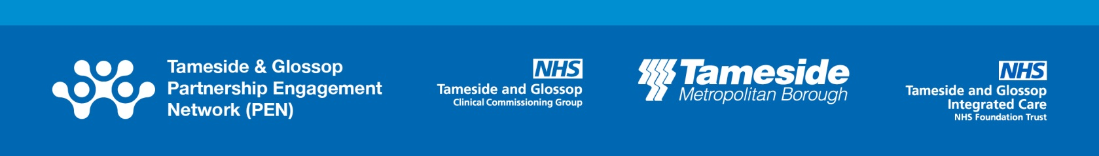
November 2019

Our regular updates enable us to keep you informed of upcoming activity including PEN events and engagement or consultation work across Tameside and Glossop which may be of interest to you.

We want to invite as many people as possible from across Tameside & Glossop to join the PEN family. If you know others who would be interested in hearing about upcoming activity including PEN events and engagement or consultation work across Tameside and Glossop please encourage them to register here.

Things to be aware of this month include:

- October PEN Conference: thank you again to those who attended last month’s PEN Conference where participants came together to discuss how to encourage people to be More People, More Active, More Often; Improving Access to Cycling & Walking – Mayor’s Challenge Fund; Health Inequalities; Patient Experience and Service User Engagement; Volunteer Strategy; Co-operative Councils; SAMMIE Campaign (Fire & Rescue Service) and; Active Parks. A full feedback report for the conference is now available – the report can be found attached to this e mail and is also accessible here.

Local engagement and consultations
There are a number of consultations taking place which you may wish to take part in. For further information and to have your say please follow the relevant links below:

- Health Improvement Stakeholder Engagement – Tameside Council is looking to find out about the support available to improve your health and wellbeing. They want to find out how, when and why you use services and facilities. The closing date for this survey is 24 November 2019.

Regional engagement and consultations

Listed below are consultations taking place at a regional level which you may wish to take part in. For further information and to have your say please follow the relevant links below:

- Greater Manchester Hate Crime Plan – Greater Manchester is a place where everyone should feel safe to be themselves. There is a lot of work taking place to tackle hate crime in each area of Greater Manchester but it is felt that it could be more effective if we work together. So, GMCA are creating the Greater Manchester Hate Crime Plan to help prevent and tackle hate crime. If you’ve been a victim or witness of hate, they also want to hear about your experiences, whether you reported it or not. Sharing your experiences and suggestions will help us to get a better understanding of what is working and what can be improved. The closing date is 20 November 2019.
- Doing Buses Differently – proposed franchising scheme for Greater Manchester – Greater Manchester is consulting on a proposed bus franchising scheme. This would mean bus services would be under Greater Manchester’s control and they would decide which bus services would be provided, like the way buses are run in London and other major cities. GM would set the routes, timetables, tickets and standards, while bus operators would run the services. You can share your views on the proposals by following the link. The deadline is 8 January 2020.
- LGBT Foundation Trans and Non-Binary People Affected by Cancer – LGBT Foundation is currently looking to inform healthcare professionals on how they can best support trans and non-binary people affected by cancer. They want to hear experiences of those who received such care in order to understand where improvements can be made.

National engagement and consultations

There are currently a number of pieces of engagement and /or consultation work being led by Government departments / agencies that you may wish to take part in. For further information and to have your say please follow the relevant links below:

- Sprinklers and other fire safety measures in new high-rise blocks of flats – This consultation outlines the government’s proposal on options to reduce the trigger height for sprinkler provision in new high-rise blocks of flats in England, alongside other fire safety measures – improving wayfinding signage within blocks of flats and installing evacuation alert systems for use by fire and rescue services. The deadline for this is 28 November.
- Statutory guidance review for local youth services: have your say – The review is designed to highlight the positive role Local Authorities should play in the provision of youth services. The government want to have an open conversation about the statutory guidance document, what is working well, and what government can do to strengthen it further. The closing date is 1 December.
- Independent review of Prevent: call for evidence – The review will critically examine and report on the government strategy for supporting people vulnerable to being drawn into terrorism. The consultation closes on 9 December.

