Tameside Outbreak Control Plan – executive summary

Introduction
The Outbreak Control Plan for Tameside provides a high level overview of the governance structures, plans and actions in place to prevent and manage outbreaks of Covid-19 in specific settings and in the wider community. The plan will be continually reviewed and updated to reflect emerging evidence as more becomes known about the virus.
The circle of health protection action illustrates our overarching approach to health protection and outbreaks:
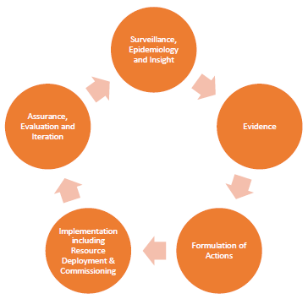

Specifically for Covid-19, seven themes have been identified nationally as key priorities. These consist of a mixture of settings and system enablers:
- Care Homes and schools
- High risk places, locations and communities
- Local testing capacity
- Contact tracing in complex settings
- Data integration
- Vulnerable people
- Local boards.
The Covid-19 Local Outbreak Control plan considers each of these priorities in turn, dividing activities into two main sections: Living with Covid; and Response.

Living with Covid
A preventative approach – ensuring that partners and communities have the tools they need to prevent the spread of Covid-19 – is the best way to reduce transmission and avoid outbreaks. Clear, effective communication; community engagement; test and trace systems; infection control and PPE use; support to individuals and organisations; use of data; and working with high risk settings and groups are all discussed in detail as measures which can help to prevent the transmission of Covid-19.
Detailed descriptions of actions for specific settings in Tameside (in particular for schools and care homes) are contained in Standard Operating Procedures linked to from this report.

Response
Where outbreaks of Covid-19 do occur, the outbreak must be identified and managed via defined command and control structures. The key steps to be undertaken will be led by Tameside Council in conjunction with PHE, and consist of notification; investigation and risk assessment; advice and controls; and continued follow up. If the outbreak is particularly complex an outbreak control meeting may be called, and further investigations (such as mass testing of asymptomatic contacts) may be recommended. The outbreak can be declared over 28 days after the last case of Covid-19 infection.

For further information on this plan, please email the Single Point of Contact (SPOC): covid-19@tameside.gov.uk .

