Please see R4GM’s page for more information: Let's sort it out Tameside | Recycle for Greater Manchester : Recycle for Greater Manchester
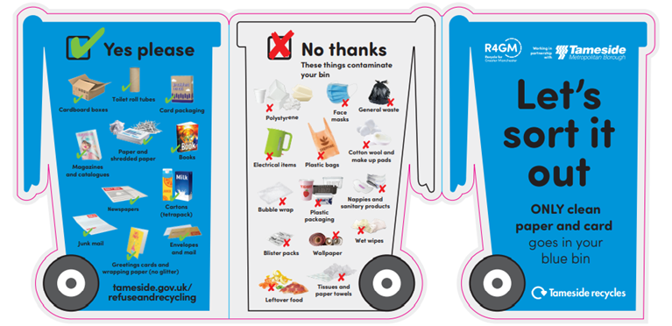

FAQS
What goes in my paper and card bin?
Only cardboard, card packaging, paper and shredded paper, magazines, catalogues, books, envelops, mail, junk mail, greeting cards and wrapping paper (these need to be glitter, plastic and foil free), tetra packs such as food and drinks cartons.
For guidance on what goes into each bin please see: What You Need To Put In Each Bin (tameside.gov.uk).
Do I need to take tops off drinks cartons?
Yes, take lids off and throw it in your green general waste bin.
What do I do if the paper or card has glitter on it?
You can rip off the parts that have glitter and put it in your green general waste bin and recycle the rest of the paper in your blue paper and card bin
Can I recycle paper plates in my blue bin?
Paper plates can be recycled in your paper and card bin at home, even when stained or dirty. Just make sure there is no leftover food on them. However if they are wet, too greasy/ dirty please put it in the general waste bin.
What happens to my paper and card after it is collected?
Your paper and card is taken to a re-processing facility, where only clean paper and card is sorted and graded. It is then bailed and transported to a number of re-processors for recycling back into new products.
Why is it a problem if I put the wrong things, doesn’t it all get sorted once collected?
We receive too much material for it to be sorted and for all the wrong items to be taken out. There are also health and safety implications and restrictions in place to protect staff from removing the wrong items. Wrong things in the recycling bin lowers the quality and the value of the paper and card collected. It can even mean whole lorry loads of recycling to be rejected.
Why did I get a leaflet/ sticker?
Recently we have seen a massive increase in contamination in the paper and card recycling. We are working on a campaign with R4GM to improve recycling in the blue paper and car bin, an information leaflet and sticker has been delivered to all households with a kerbside collection to remind everyone of how to recycle right. Why not keep it as a reminder?
Why did I get a tag on my bin/ when will my bin be collected?
If you got a red tag on your blue bin this means the wrong items have been put in the paper and card bin. Your bin will not be collected until you remove all the wrong things. Please check the tag to see what you need to remove. Your bin will be collected on the next collection date. You can take any excess waste to your nearest recycling centre.
Please remember to follow Covid- 19 restrictions:
- only visit if you really need to do so
- follow social distancing measures when on site
- wear a face covering
- plan your visit, weekdays are less busy
- sort waste and recycling before your visit to minimise time on site
- all recycling containers are open
- wash your hands before and after your visit

