General Register Office
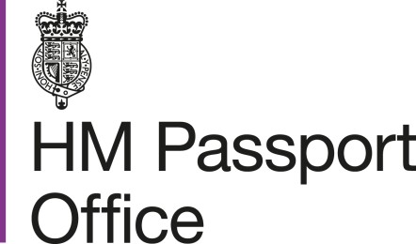

Marriage in the Church of England or Church in Wales
after 3rd May 2021

What will this mean for you?
New marriage legislation means that the way a marriage is registered in England and Wales will change, from 4th May 2021

Each person will still be required to complete legal preliminaries either through the Church via the calling of Banns or by giving notice of marriage at their local register office. The marriage ceremony will remain the same, it is only the manner of marriage registration that is changing.

You will no longer sign a marriage register or be given a Marriage Certificate during the ceremony instead you will sign a Marriage Document. This is a one-page document which contains the details of both people getting married which are needed to register a marriage.

The Marriage Document will be issued by the Minister at the Church where your marriage is taking place and will contain all the details required to complete a marriage registration.

From this date, in addition to father details, other parent details will be able to be recorded ie mother, step-parent.

NB – Should your Church ask that you complete legal marriage preliminaries at your local register office you should refer to the leaflet which relates to marriage at a civil or religious building.

Information included on the Marriage Document
A Marriage document will include the details of each person getting married: name and surname, date of birth, condition, address and occupation.
You can record your mother, father or parents’ details on the Marriage Document and in the marriage registration. There is now provision to include step-parents.
If you didn’t give these details when calling Banns or giving notice at the register office, you can provide the details either prior to or on the day of your marriage

Signing the Marriage Document
The Marriage Document will be signed after your marriage ceremony.
You will be asked to check the details entered on the Marriage Document to confirm they are accurate and spelt correctly. Once checked, you, your witnesses and the officiating minister will each sign the Marriage Document.

Registering the marriage.
The officiating minister will forward the completed, signed Marriage Document to the register office in the area where the church is located. This will be done within 21 days of your ceremony taking place. The details will be entered onto the electronic marriage register within 7 days of the signed Marriage Document being received at the register office; only then will a marriage certificate be available.

Why can’t you sign a marriage register?
From 4th May 2021 paper marriage registers will no longer be used; instead a central electronic registration system will become the legal register. The change in the law means that the details of your marriage will be recorded on a Marriage Document. It is from this document that your marriage registration will be created.

When will you be able to obtain a Marriage Certificate?
Once the details of the signed Marriage Document have been entered onto the electronic marriage register, you will be able to obtain a marriage certificate from the register office or the General Register Office. This means you will not be able to obtain a marriage certificate on the day of your marriage.

How to obtain a marriage certificate.
Marriage certificates will be available from the register office in the area where your marriage took place.

To obtain a marriage certificate please contact

Tameside Register Office
Dukinfield Town Hall
King Street
Dukinfield
SK16 4LA
tameside.registrars@tameside.gov.uk
Please note the fee is £11.00 per certificate payable by card.

Further questions?
If you have any questions that have not been answered in this leaflet, you should check the details on www.gov.uk website
If you cannot find the answer to your question you should contact the minister at the Church where your marriage is taking place or the register office in the area of your marriage or contact the General Register Office on tel: 0300 123 1837 or email: GROcasework@gro.gov.uk

Marriage certificates are also available from the General Register Office at www.gov.uk

https://www.gov.uk/order-copy-birth-death-marriage-certificate

