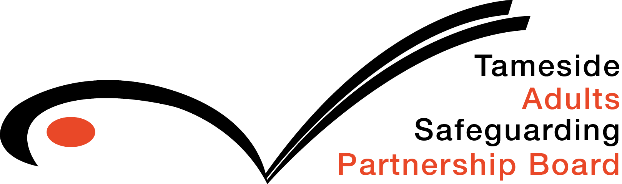

Self - Neglect Guidance

Review – June 2018

**Self-Neglect Guidance**

**The purpose of this guidance**

**This guidance is reference for practitioners responding to situations where self-neglect is evident. It is envisaged that this will provide an understanding of self-neglect in the context of safeguarding adults and aid a proportionate response when supporting the Adult.**

**Definitions**

Self-Neglect

There is no accepted operational definition of self-neglect nationally or internationally due to the dynamic and complexity of self-neglect.

Gibbons et al (2006) defined it as “the inability (intentionally or non-intentionally) to maintain a socially and culturally acceptable standard of self-care with the potential for serious consequences to the health and well-being of those who self-neglect and perhaps too to their community”.

**Indicators associated with self-neglect**

* Living in very unclean, sometimes verminous circumstances, such as living with a toilet completely blocked with faeces
* Neglecting household maintenance, and therefore creating hazards within and surrounding the property
* Portraying eccentric behaviour / lifestyles
* Obsessive hoarding
* Poor diet and nutrition. For example, evidenced by little or no fresh food in the fridge, or what is there, being mouldy
* Declining or refusing prescribed medication and / or other community healthcare support
* Refusing to allow access to health and / or social care staff in relation to personal hygiene and care
* Refusing to allow access to other organisations with an interest in the property, for example, staff working for utility companies (water, gas, electricity)
* Repeated episodes of anti-social behaviour – either as a victim or perpetrator
* Being unwilling to attend external appointments with professional staff whether social care, health or other organisations (such as housing)
* Poor personal hygiene, poor healing / sores, long toe nails;
* Isolation
* Failure to take medication.

This list is not exhaustive.

* The involvement of an Independent advocate or an Independent Mental Capacity Advocate (IMCA) should be considered in appropriate circumstances. Where the individual refuses to participate or engage with agencies or provide access, information obtained from a range of other sources may ‘hold the key’ to achieving access or to determining areas / levels of risk.
* The embedded document will provide additional guidance regarding decision making.



* NB: Careful attention needs to be given to the needs of children in a household where self-neglect has been identified as a concern for the adult. In these circumstances children’s services must be contacted for advice/consultation at the Public Service Hub 342 4101.
* The needs of any animals in the household should also be considered and appropriate agencies contacted.

**The safeguarding duties apply to an adult who:**

* has needs for care and support (whether or not the local authority is meeting any of those needs);
* and is experiencing, or is at risk of, abuse or neglect;
* and as a result of those care and support needs is unable to protect themselves from either the risk of, or the experience of abuse or neglect.

**The aims of adult safeguarding are to**:

* stop abuse or neglect wherever possible
* prevent harm and reduce the risk of abuse or neglect to adults with care and support needs;
* safeguard adults in a way that supports them in making choices and having control about how they want to live;
* promote an approach that concentrates on improving life for the adults concerned;
* raise public awareness so that communities as a whole, alongside professionals, play their part in preventing, identifying and responding to abuse and neglect;
* provide information and support in accessible ways to help people understand the different types of abuse, how to stay safe and what to do to raise a concern about the safety or well-being of an adult; and
* address what has caused the abuse or neglect

**Six key principles underpin all adult safeguarding work**

**Empowerment** – People being supported and encouraged to make their own decisions and informed consent.

*“I am asked what I want as the outcomes from the safeguarding process and these directly inform what happens.”*

**Prevention** – It is better to take action before harm occurs.

*“I receive clear and simple information about what abuse is, how to recognise the signs and what I can do to seek help.”*

**Proportionality** – The least intrusive response appropriate to the risk presented.

*“I am sure that the professionals will work in my interest, as I see them and they will only get involved as much as needed.”*

**Protection** – Support and representation for those in greatest need.

*“I get help and support to report abuse and neglect. I get help so that I am able to take part in the safeguarding process to the extent to which I want.”*

**Partnership** – Local solutions through services working with their communities. Communities have a part to play in preventing, detecting and reporting neglect and abuse.

*“I know that staff treat any personal and sensitive information in confidence, only sharing what is helpful and necessary. I am confident that professionals will work together and with me to get the best result for me.”*

**Accountability** – Accountability and transparency in delivering safeguarding.

*“I understand the role of everyone involved in my life and so do they.”*

**Making Safeguarding Personal**

The wishes of the adult will always be sought in the first instance. The purpose of the initial discussion with the adult is to decide whether any actions need to be taken to help and protect the adult, the approach should be person led and outcome focused. Discussions with the adult should engages them in a conversation about how best to respond to their safeguarding situation in a way that enhances involvement, choice and control as well as improving quality of life, wellbeing and safety.

In the majority of such instances the needs of adults who are at risk of self-neglect will be addressed through multi-disciplinary assessments without the need to initiate the safeguarding adult procedure.

Initially, it will be necessary to determine the mental capacity of the individual to make decisions about serious risks to their health and well-being and whether he/she has any mental health needs. If the individual’s needs can be addressed through implementation of the Mental Health Act or Mental Capacity Act procedures these would be applied.

The Care Act 2014 states:-

*….If the adult has the mental capacity to make informed decisions about their safety and they do not want any action to be taken, this does not preclude the sharing of information with relevant professional colleagues. This is to enable professionals to assess the risk of harm and to be confident that the adult is not being unduly influenced, coerced or intimidated and is aware of all the options. This will also enable professionals to check the safety and validity of decisions made. It is good practice to inform the adult that this action is being taken unless doing so would increase the risk of harm*… (*(Care and Support Statutory guidance October 2014:14.76.)*

… *If the adult has the capacity to make decisions in this area of their life and declines assistance, this can limit the intervention that organisations can make. The focus should therefore be, on harm reduction… (Care and Support Statutory guidance October 2014:14.192.)*

If the adult has the capacity to make decisions in this area of their life and declines assistance, this can limit the intervention that organisations can make. The focus should therefore be, on harm reduction.

If the above actions are relevant a Safeguarding adult concern form should be completed indicating what actions are to be taken. This will be recorded as a concern only.

**When to invoke a Safeguarding Adult Enquiry**

The Care Act refers to:

*The potential for ‘undue influence’ will need to be considered if relevant. If the adult is thought to be refusing intervention on the grounds of duress then action must be taken.*

In cases where the Adult appears to be in a situation of self-neglect due to undue influence then a Safeguarding Adult Enquiry can be lawfully invoked.

Examples of this maybe where:-

*An Adult is not eating to ensure there is no pressure on the Adult to support the extended family financially to provide an adequate diet.*

If the Safeguarding Adult Manager considers this to be a proportionate response to safeguard the Adult, then a concern form will be completed indicating a statutory enquiry has been raised and the safeguarding enquiry form will be submitted when the enquiry is concluded.