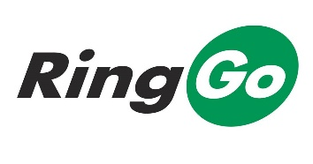
Tameside Cashless Parking – Frequently Asked Questions

RingGo cashless parking comes to Tameside!
Motorists using Council on-street parking bays across Ashton Town Centre will now be able to use the RingGo cashless parking service to book and pay for their parking.
Approximately 150 spaces (which were previously limited waiting parking bays) across 20 locations in the Town Centre have now been converted into cashless parking bays.
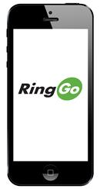
What is Ringo and how does it work?
RingGo is a quick, easy to use mobile phone service, which lets you pay for your parking with a credit or debit card, rather than using cash at a machine.
With RingGo:

- You no longer need to carry change
- You don’t have to visit a parking machine
- You don’t need to walk back with a parking ticket – Civil Enforcement Officers check which vehicles are parked with RingGo via their handheld units
How do I register with RingGo?
To save time you can pre-register with RingGo by:
- Using the RingGo smartphone app (downloadable free of charge either through your handset or from the relevant store);
- Via the internet by visiting the RingGo registration page https://www.myringgo.co.uk/register
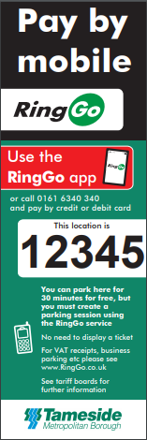
- By ringing 0161 634 0340 (calls charged at the standard rate)
You will be asked to provide:
- The number plate, colour and make of your vehicle
- Your payment card details
Once you have registered, RingGo recognises your mobile phone number and retrieves the information you have given previously.
So, when you pay to park the only information you will need to provide is:
- The location code where you are parked. Each location offering RingGo has its own five digit location code which will be shown on a sign, e.g. 12345
- The length of time you want to park.
- Your payment card’s three digit security code.
If you would like more information about how the service operates you can watch a video at www.myRingGo.co.uk/howitworks
How much does it cost?
The new parking charges operate Monday to Saturday 8am to 6pm.
- Parking up to half an hour is free of charge. If you are parking for 30 minutes or less the session will be free but you must still create a RingGo session unless you are a Blue Badge holder.
- Parking up to one hour (includes the first free half hour) £1.00
- Parking up to the maximum allowed two hours £2.00
RingGo text reminders
Once a session is booked you will automatically receive RingGo text notifications (charged at 15p per message). So if you’re running late or simply want to stay a little longer you can top up your parking without having to return to your vehicle.

Text confirmations/alerts are optional so if you do not want to receive them you can simply turn them off by accessing your RingGo account and switching them off in the Notification settings.

Blue Badge holders
If you are a Blue Badge holder you can park in any on street, cashless parking bay free of charge for an unlimited period, without having to register or create a session with RingGo. However, please ensure that your Blue Badge is displayed correctly.
Text to Park
You can also use the quick and easy RingGo “text to park” option. For details on how to set up the service for your particular location visit https://www.myringgo.co.uk/texttopark
Can I get a VAT receipt
Need a VAT receipt for your RingGo parking session? You can view and print it online by logging into the RingGo website. Alternatively, if you provide us with your email address when setting up your profile you will automatically receive a receipt every time you park.
Locations of parking bays in Ashton Town centre
Location | Zone Code
Alexandra Road | 24600
Booth Street | 24601
Church Street | 24602
Cotton Street East | 24603
Cowhill Lane | 24604
Delamare Street | 24605
Enville Street | 24606
Fleet Street | 24607
Grey Street | 24608
Mill Lane | 24609
Newton Street | 24610
Old Street East End | 24611
Old Street West End | 24612
Penny Meadow | 24613
Parking Bay St Michael's Square | 24614
Stamford Street Central | 24615
Turner Lane | 24616
Warrington Street | 24617
Wellington Street | 24618
Williamson Street | 24619
More information on Ringo
For general information about RingGo please visit their website at https://www.myringgo.co.uk/; or if you have a specific question about how RingGo operates, please visit their help page at https://www.myringgo.co.uk/help which contains a lot of answers to common queries.

