Statement of Reasons

Manchester Road, Mossley is a section of the A635 that runs between Stalybridge and Greenfield. As such it comprises a highly trafficked route through the borough that is residential, commercial and industrial in nature.

In recent years there have been a number of new housing developments in Mossley that require access/egress from Manchester Road. The council has received numerous reports from residents that visibility is being compromised by vehicles parking too close to these junctions, especially when exiting on to Manchester Road.

The proposed waiting restrictions on the south east side of Manchester Road ‘from a point 15 metres south of its junction with the entrance to the Woodend Mill trading estate to a point 155 metres north east of that junction’, are designed to prevent obstructive parking and enhance visibility at the entrance to Woodend Mill and at the various entrances to Woodend Manor (a small housing development comprising of approximately 16 residential properties). The restrictions extend to cover the gated entrance to the driveway of property number 317 Manchester Road and the frontage of this property that projects onto the footway.

The proposed waiting restrictions on the south east side of Manchester Road ‘from its junction with Three Counties Road for a distance of 53 metres in a south westerly direction’, afford junction protection for vehicles turning left onto Manchester Road. The proposals also serve to prevent obstructive parking on the section of carriageway between footways so that pedestrians are not forced to walk into the road here.

Waiting restrictions are also proposed on Manchester Road at its junction with Roughtown Road. Roughtown Road is an historic track road that has recently been made ‘one-way’ in a downhill direction. Owing to the geometry of the junction here and the fact that the volume of traffic exiting onto Manchester Road may increase, waiting restrictions are considered appropriate at this location.

Weir Mill is a converted mill on Manchester Road that houses a number of business premises. It has a car park but vehicles also park along the east side of Manchester Road up to the access road leading to the carpark. Waiting restrictions are proposed at either side of the access road to ensure adequate visibility when exiting onto Manchester Road.

Engineering Services is of the opinion that the implementation of waiting restrictions at the proposed locations will prevent obstructive parking and improve visibility for both pedestrian and vehicular traffic, thereby enhancing road safety along this route.

All existing restrictions are to remain.

TAMESIDE METROPOLITAN BOROUGH (MANCHESTER ROAD AREA, MOSSLEY) (PROHIBITION OF WAITING) ORDER 2023

Tameside Metropolitan Borough Council proposes to make the above Order under the Road Traffic Regulation Act 1984 the effects of which will be to introduce:-

No Waiting at Any Time restrictions on: - (1) Manchester Road (north west side) from a point 15 metres north east of its junction with Hob Mill Rise to a point 15 metres south west of that junction; (2) Manchester Road (north west side) from a point 15 metres north east of its junction with Waters Reach to a point 12 metres south west of that junction; (3) Manchester Road (west side) from a point 15 metres north east of its junction with Roughtown Road to a point 15 metres south west of that junction; (4) Manchester Road (south east side) from a point 15 metres south west of its junction with the entrance to Woodend Mill Trading Estate to a point 155 metres north east of that junction; (5) Manchester Road (south east side) from its junction with Three Counties Road for a distance of 53 metres in a south westerly direction; (6) Manchester Road (east side) from a point 29 metres south of the southerly gable end of Weir Mill for a distance of 29 metres in a southerly direction; (7) Springmill Drive (east side) from its junction with Manchester Road for a distance of 15 metres in a northerly direction; (8) Springmill Drive (west side) from its junction with Manchester Road for a distance of 19 metres in a northerly direction.
A copy of the proposed Order, plan and statement of reasons relating thereto may be inspected online via http://www.tameside.gov.uk/trafficregulationorders or be sent to you at your request by e-mailing trafficoperations@tameside.gov.uk and asking for the Manchester Road Area deposited documents. Objections or comments to the proposals stating the grounds on which they are being made must be submitted in writing to the undersigned or by email to trafficoperations@tameside.gov.uk. The statutory consultation period is 28 days ending on 13 July 2023. If you wish to discuss the proposals please contact Joanne Biddle on 0161 342 2879.

Date: 15 June 2023

E Varnam; Assistant Director of Operations and Neighbourhoods; Tameside One, Market Place, Ashton-under-Lyne, OL6 6BH

Manchester Road/Hob Mill Rise Manchester Road/Roughtown Road
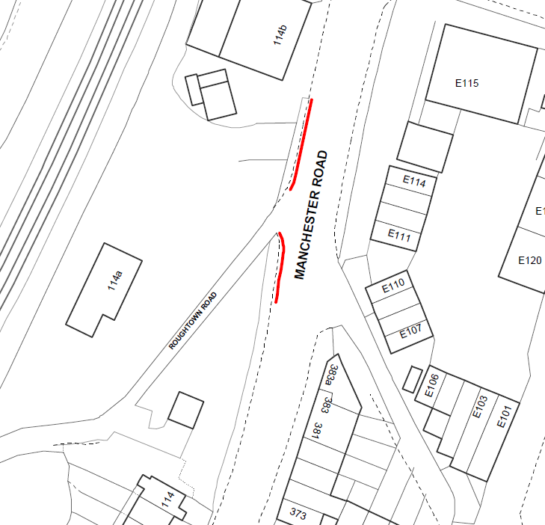
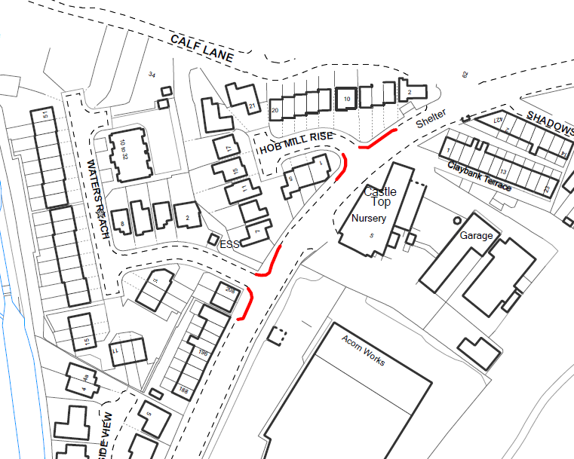
Manchester Road/Waters Reach

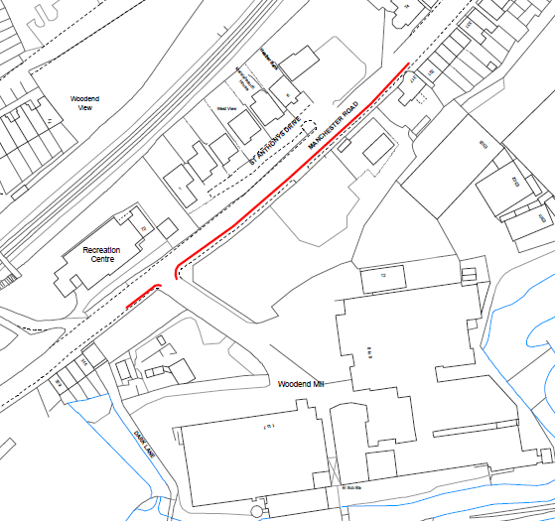
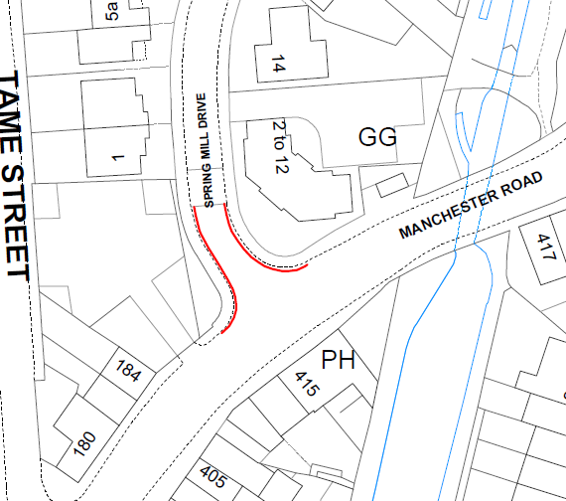
Springmill Drive Manchester Road/Woodend Mill

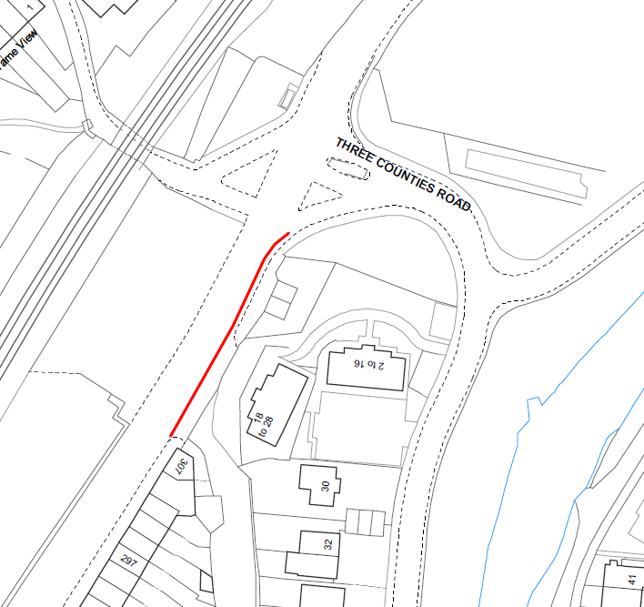
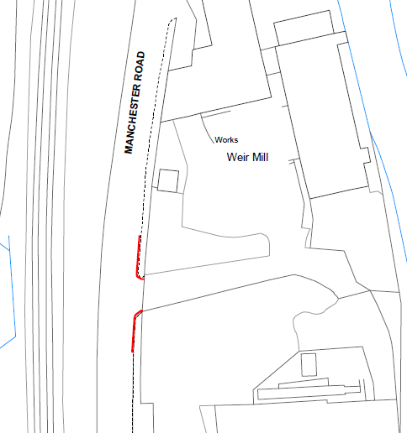
Manchester Road/Three Counties Road Manchester Road/Weir Mill

TAMESIDE METROPOLITAN BOROUGH COUNCIL

TAMESIDE METROPOLITAN BOROUGH
(MANCHESTER ROAD AREA, MOSSLEY)
(PROHIBITION OF WAITING) ORDER 2023

Tameside Metropolitan Borough Council in exercise of its powers under Sections 1(1), 2(1) and 2(2) of the Road Traffic Regulation Act 1984 (“the Act”) and of all other enabling powers and after consultation with the Chief Officer of Police in accordance with Part III of Schedule 9 to the Act hereby makes the following Order:-

1. (1) In this Order:-

“disabled person’s badge” has the same meaning as in the Disabled Persons (Badges For Motor Vehicles)(England) Regulations 2000;
DRAFT

“disabled person’s vehicle” means a vehicle which displays a disabled person’s badge in accordance with the provisions of the Disabled Persons (Badges for Motor Vehicles) (England) Regulations 2000 as amended, or under any succeeding legislation, and shall include a badge issued under regulations having effect in Scotland or Wales under Section 21 of the Chronically Sick and Disabled Person’s Act 1970, and a recognised badge under Section 21A and B of the 1970 Act;

“parking disc” means a disc issued by a local authority, 125 millimetres square, coloured blue and capable of showing the quarter hour period during which a period of waiting begins.

- For the purpose of this Order a vehicle shall be regarded as displaying:-

- a disabled person’s badge in the relevant position, when:-

- the badge is exhibited on the dashboard or facia of the vehicle so that the front of the badge is clearly legible from the outside of the vehicle or;

- where a vehicle is not fitted with a dashboard or facia, the badge is exhibited in a conspicuous position on the vehicle, so that the front of the badge is clearly legible from the outside of the vehicle.

- a parking disc in the relevant position if;

- the disc is exhibited on the dashboard or facia of the vehicle and shows the quarter hour period during which a period of waiting began and that period is clearly legible from the outside of the vehicle or;

- where the vehicle does not have a dashboard or facia, the disc is exhibited in a conspicuous position on the vehicle, so that, when marked to show the quarter hour period during which a period of waiting began and that period is clearly legible from the outside of the vehicle.

- except where otherwise stated, any reference in this Order to a numbered Article or Schedule is a reference to the Article or Schedule bearing that number in this Order.

DRAFT
- Save as provided in Article 3 to this Order no person shall except upon the direction or with the permission of a police constable in uniform or of a civil enforcement officer, cause or permit any vehicle to wait at any time on the sides of lengths of roads specified in the Schedule to this Order.

3. (1) Nothing in Article 2 shall render it unlawful to cause or permit any vehicle to wait on the sides of lengths of roads referred to therein for so long as may be necessary to enable:-

- persons to board or alight from a vehicle;

- the vehicle, if it cannot conveniently be used for such purpose in any other road, to be used in connection with any of the following operations, namely:-

- building, industrial or demolition operations;

- the removal of any obstruction to traffic;

- the maintenance, improvement or reconstruction of the said sides of lengths of roads; or

- the laying, erection, alteration or repair in, or the land adjacent to, the sides of lengths of roads of any sewer or of any main, pipe or apparatus for the supply of gas, water or electricity or any electronic communications network as defined in the Communications Act 2003.

- the vehicle, if it cannot conveniently be used for such purpose in any other road, to be used in the service of a local authority or any other Authority in the pursuance of statutory powers or duties;

- the vehicle, to be used for the purpose of delivering or collecting postal packets as defined in the Postal Services Act 2000;

- the vehicle to wait at or near to any premises situated on or adjacent to the sides of lengths of roads for so long as such waiting is reasonably necessary in connection with any wedding or funeral; or

- the vehicle to be used for Fire Brigade, Ambulance or Police purposes.

- Nothing in Articles 2 to this Order shall render it unlawful to cause or permit any vehicle to wait for so long as may be necessary for the purpose of enabling goods to be loaded onto or unloaded from the vehicle on the sides of lengths of roads specified in the Schedule to this Order, at any time.

- Nothing in Article 2 to this Order shall render it unlawful to cause or permit a disabled person’s vehicle which displays in the relevant position a disabled person’s badge and a parking disc (on which the driver, or person in charge of the vehicle, has marked the time at which the period of waiting began) to wait on any of the sides of lengths of roads referred to in the Schedule to this Order for a period not exceeding three hours (not being a period separated by an interval of less than one hour from a previous period of waiting by the same vehicle on the same side of length of road on the same day)
DRAFT
4. The prohibitions and restrictions imposed by this Order shall be in addition to and not in derogation from any restrictions or requirement imposed by any regulations made or having effect as if made under the said Act of 1984 or by or under any other enactment.

The Order shall come into operation on the <date> day of <month and year> and may be cited as THE TAMESIDE METROPOLITAN BOROUGH (MANCHESTER ROAD AREA, MOSSLEY) (PROHIBITION OF WAITING) ORDER 2023.

THE COMMON SEAL OF TAMESIDE
METROPOLITAN BOROUGH COUNCIL
was hereunto affixed on the <date> day of
<month and year> in the presence of

Authorised Signatory

SCHEDULE

No Waiting at Any Time

Manchester Road  north west side | - | from a point 15 metres north east of its junction with Hob Mill Rise to a point 15 metres south west of that junction.
Manchester Road  north west side | - | from a point 15 metres north east of its junction with Waters Reach to a point 12 metres south west of that junction.
Manchester Road  west side | - | from a point 15 metres north east of its junction with Roughtown Road to a point 15 metres south west of that junction.
Manchester Road  south east side | - | from a point 15 metres south west of its junction with the entrance to Woodend Mill Trading Estate to a point 155 metres north east of that junction.  DRAFT
Manchester Road  south east side | - | from its junction with Three Counties Road for a distance of 53 metres in a south westerly direction.
Manchester Road  east side | - | from a point 29 metres south of the southerly gable end of Weir Mill for a distance of 29 metres in a southerly direction.
Springmill Drive  east side | - | from its junction with Manchester Road for a distance of 15 metres in a northerly direction.
Springmill Drive  west side | - | from its junction with Manchester Road for a distance of 19 metres in a northerly direction.

