TAMESIDE METROPOLITAN BOROUH COUNCIL
(MOSSLEY ROAD, ASHTON UNDER LYNE)
(PROHIBITION OF WAITING) ORDER 2020

TAMESIDE METROPOLITAN BOROUGH COUNCIL
(ROSE HILL ROAD AREA, ASHTON UNDER LYNE)
(20 MILE PER HOUR SPEED LIMIT) ORDER 2020

TAMESIDE METROPOLITAN BOROUGH COUNCIL
(MOSSLEY ROAD, ASHTON UNDER LYNE) (PARALLEL CROSSING) 2020

TAMESIDE METROPOLITAN BOROUGH COUNCIL
(MOSSLEY ROAD, ASHTON UNDER LYNE) (SHARED FOOTWAY/ CYCLEWAY) 2020

TAMESIDE METROPOLITAN BOROUGH COUNCIL
(ROSE HILL ROAD, ASHTON UNDER LYNE) (TRAFFIC CALMING FEATURE) 2020

TAMESIDE METROPOLITAN BOROUGH COUNCIL
(MOSSLEY ROAD, ASHTON UNDER LYNE) (BUS STOP CLEAR WAY, 24 HOUR) 2020

In accordance with the Road Traffic Regulation Act 1984 Tameside Metropolitan Borough Council propose to make the above orders to:

- extend the existing ‘no waiting at any time’ restrictions on:

- Mossley Road, south side, from its junction with Mellor Road for a distance of 66 metres in an easterly direction.
- Mossley Road, north side, from its junction with Rose Hill Road for a distance of 30 metres in an easterly direction.
- Rose Hill Road, east side, from its junction with Mossley Road for a distance of 36 metres in a northerly direction
- Rose Hill Road, west side, from its junction with Mossley Road for a distance of 42 metres in a northerly direction

- introduce ‘no waiting at any time’ restrictions on:

- Mossley Road, south side, from a point 185 metres north east of its junction with Mellor Road for a distance of 70 metres in a north easterly direction
- Mossley Road, north side, from a point 15 metres west of its junction with Old Road to a point 15 metres east of that junction
- Old Road, both sides, from its junction with Mossley Road for a distance of 10 metres in a northerly direction.

- extend the existing 20 mile per hour speed limit on Rose Hill Road, from its junction with the southerly junction with Rose Hill Crescent to its junction with Mossley Road

- introduce a 20 mile per hour speed limit on:

- Palace Road, for its entire length
- Leech Avenue, for its entire length
- Hurst Hall Drive, for its entire length
- Chippendale Place, for its entire length
- Hadfield Crescent, for its entire length
- Townsley Grove, for its entire length

In accordance with the Highways Act 1980 Tameside Metropolitan Borough Council propose to:

- introduce a Parallel Crossing on Mossley Road, centred approximately 8 metres north east of Rose Hill Road, the ‘controlled zone’ will prevent stopping on zig zag markings, both sides of Mossley Road from a point 2 metres south west of its junction with Rose Hill Road for a distance of 42 metres in a north easterly direction.

- introduce a Shared Footway and Cycle facility on:

- Mossley Road, north side, from a point 125 metres south west of its junction with Rose Hill Road to a point 20 metres north east of that junction.
- Mossley road, south side, from its junction with Mellor road for a distance of 35 metres in a north easterly direction.
- Rose Hill Road, east side, from its junction with Mossley Road for a distance of 36 metres in a northerly direction.

- introduce a Flat Top Road Hump on Rose Hill Road, Ashton under Lyne (length of top 3 metres; height 75mm; ramp gradient 1 in 10) centred about a point 4 metres north of its junction with Mossley Road.

In accordance with The Traffic Signs Regulations and General Directions 2002, Schedule 19 Tameside Metropolitan Borough Council propose to:

- introduce 24 hour bus stop clearway on Mossley Road, south side from a point 12 metres north east of its junction with Park Square for a distance of 16 metres in a north easterly direction.

A copy of the plan relating thereto may be viewed online via http://www.tameside.gov.uk/trafficregulationorders. If you wish to discuss the proposals please contact Lauren Redfern on 0161 342 3927. Objections or comments to the proposals stating the grounds on which they are being made must be submitted in writing to the undersigned or by email to trafficoperations@tameside.gov.uk by 21st August 2020.

Date 23rd July 2020
E Varnam; Assistant Director of Operations and Neighbourhoods; Tameside One; Market Place; Ashton under Lyne, OL6 6BH

STATEMENT OF REASONS
TAMESIDE METROPOLITAN BOROUH COUNCIL
(MOSSLEY ROAD, ASHTON UNDER LYNE)
(PROHIBITION OF WAITING) ORDER 2020

TAMESIDE METROPOLITAN BOROUGH COUNCIL
(ROSE HILL ROAD AREA, ASHTON UNDER LYNE)
(20 MILE PER HOUR SPEED LIMIT) ORDER 2020

TAMESIDE METROPOLITAN BOROUGH COUNCIL
(MOSSLEY ROAD, ASHTON UNDER LYNE) (PARALLEL CROSSING) 2020

TAMESIDE METROPOLITAN BOROUGH COUNCIL
(MOSSLEY ROAD, ASHTON UNDER LYNE) (SHARED FOOTWAY/ CYCLEWAY) 2020

TAMESIDE METROPOLITAN BOROUGH COUNCIL
(ROSE HILL ROAD, ASHTON UNDER LYNE) (TRAFFIC CALMING FEATURE) 2020

TAMESIDE METROPOLITAN BOROUGH COUNCIL
(MOSSLEY ROAD, ASHTON UNDER LYNE) (BUS STOP CLEAR WAY, 24 HOUR) 2020

The Mayors Challenge Fund (MCF) aims to kick start the delivery of Chris Boardman’s vision for Greater Manchester to become a city region where walking and cycling are the natural choices for shorter journeys. This supports Greater Manchester's Transport Strategy 2040, the Made to Move report and the Bee Network infrastructure proposal.
The MCF has so far made £160 million available to deliver schemes across Greater Manchester between now and 2022. This has been made possible thanks to national government’s Transforming Cities Fund. This aims to improve productivity and spread prosperity through investment in public and sustainable transport in some of the largest English city regions. This was first announced by the Prime Minister in November 2017.
- Find out more about Made to Move and The Bee Network proposal

What is the Bee Network?
The Bee Network proposal is a vision to make Greater Manchester an easier place for people to get around on foot or by bike.
Our aim is to make the region a nicer place to live, work, get on and grow old and to connect every neighbourhood and community, while helping people to be less dependent on cars.
The proposal is a vision for Greater Manchester to become the very first city-region in the UK to have a fully joined-up cycling and walking network: the most comprehensive in Britain covering over 1,800 miles.
This link provides access to the Bee Network routes being planned across Greater Manchester: https://mappinggm.org.uk/bee-network/

The Bee Network in Tameside
We want to create a genuine culture of walking and cycling in Tameside so that it becomes the natural choice for as many short trips as possible.
In Tameside, it is estimated that we spend £26m per annum in avoidable costs to the health system. This is due to treating people for illnesses that could have been prevented if people were more physically active. When you couple that with the fact that 30% of trips under 1km in Greater Manchester are made by car, the equivalent of 15 minutes walking or 4 minutes cycling, the benefits and need for an improved system becomes instantly clear. Not only is walking and cycling good for our health and will reduce pressures on our services, but it reduces congestion and improves air quality too.
To help make walking and cycling the easier and safer option, we have developed a number of schemes to improve our walking and cycling infrastructure across the borough.
This consultation focuses on the highway located north west of Chadwick Dam and has been designed to support these proposals, as there were also complaints regarding traffic locally, there some additional waiting restrictions included around Old road and the Hearos of Waterloo Public House and the 20 mile per hour zone has been extended along Palace Road, including side streets.

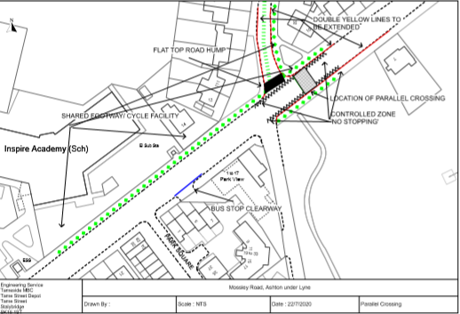

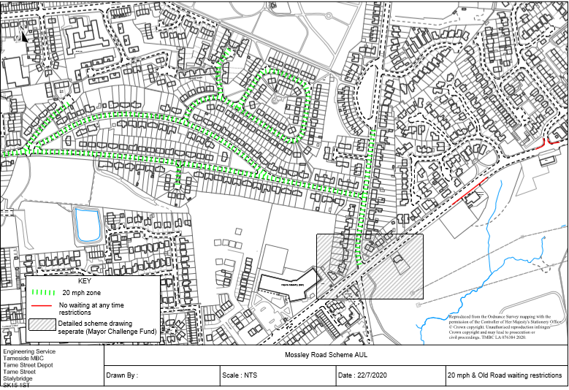

TAMESIDE METROPOLITAN BOROUGH COUNCIL

TAMESIDE METROPOLITAN BOROUGH
(MOSSLEY ROAD, ASHTON UNDER LYNE)
(PROHIBITION OF WAITING) ORDER 2020

THE TAMESIDE METROPOLITAN BOROUGH COUNCIL in exercise of its powers under Sections 1(1), 2(1), 2(2) of the Road Traffic Regulation Act 1984 (“the Act”) and Part IV of Schedule 4 and all other enabling powers and after consultation with the Chief Officer of Police in accordance with Part III of Schedule 9 to the Act hereby makes the following Order:-

1. (1) In this Order:-

“disabled person’s badge” has the same meaning as in the Disabled Persons (Badges For Motor Vehicles)(England) Regulations 2000;

“disabled person’s vehicle” means a vehicle which displays a disabled person’s badge in accordance with the provisions of the Disabled Persons (Badges for Motor Vehicles) (England) Regulations 2000 as amended, or under any succeeding legislation, and shall include a badge issued under regulations having effect in Scotland or Wales under Section 21 of the Chronically Sick and Disabled Person’s Act 1970, and a recognised badge under Section 21A and B of the 1970 Act.

“parking disc” means a disc issued by a local authority, 125 millimetres square, coloured blue and capable of showing the quarter hour period during which a period of waiting begins;

- For the purpose of this Order a vehicle shall be regarded as displaying:-

- a disabled person’s badge in the relevant position, when:-

- the badge is exhibited on the dashboard or facia of the vehicle so that the front of the badge is clearly legible from the outside of the vehicle or;

- where a vehicle is not fitted with a dashboard or facia, the badge is exhibited in a conspicuous position on the vehicle, so that the front of the badge is clearly legible from the outside of the vehicle.

- a parking disc in the relevant position if;

- the disc is exhibited on the dashboard or facia of the vehicle and shows the quarter hour period during which a period of waiting began and that period is clearly legible from the outside of the vehicle or;

- where the vehicle does not have a dashboard or facia, the disc is exhibited in a conspicuous position on the vehicle, so that, when marked to show the quarter hour period during which a period of waiting began and that period is clearly legible from the outside of the vehicle.

- except where otherwise stated, any reference in this Order to a numbered Article or Schedule is a reference to the Article or Schedule bearing that number in this Order.

- Save as provided in Article 3 to this Order no person shall except upon the direction or with the permission of a police constable in uniform or of a civil enforcement officer, cause or permit any vehicle to wait at any time on the sides of lengths of roads specified in the Schedule to this Order.

- (1) Nothing in Articles 2 render it unlawful to cause or permit any vehicle to wait on the sides of lengths of roads referred to therein for so long as may be necessary to enable:-

- persons to board or alight from a vehicle;

- the vehicle, if it cannot conveniently be used for such purpose in any other road, to be used in connection with any of the following operations, namely:-

- building, industrial or demolition operations;

- the removal of any obstruction to traffic;

- the maintenance, improvement or reconstruction of the said sides of lengths of roads; or

- the laying, erection, alteration or repair in, or the land adjacent to, the sides of lengths of roads of any sewer or of any main, pipe or apparatus for the supply of gas, water or electricity or any electronic communications network as defined in the Communications Act 2003.

- the vehicle, if it cannot conveniently be used for such purpose in any other road, to be used in the service of a local authority or any other Authority in the pursuance of statutory powers or duties;

- the vehicle, to be used for the purpose of delivering or collecting postal packets as defined in the Postal Services Act 2000;

- the vehicle to wait at or near to any premises situated on or adjacent to the sides of lengths of roads for so long as such waiting is reasonably necessary in connection with any wedding or funeral; or

- the vehicle to be used for Fire Brigade, Ambulance or Police purposes.

(2) Nothing in Article 2 to this Order shall render it unlawful to cause or permit any vehicle to wait for so long as may be necessary for the purpose of enabling goods to be loaded onto or unloaded from the vehicle on the sides of lengths of roads specified in the Schedule to this Order, at any time.

  - Nothing in Article 2 to this Order shall render it unlawful to cause or permit a disabled person’s vehicle which displays in the relevant position a disabled person’s badge and a parking disc (on which the driver, or person in charge of the vehicle, has marked the time at which the period of waiting began) to wait on any of the sides of lengths of roads referred to in the Schedule to this Order for a period not exceeding three hours (not being a period separated by an interval of less than one hour from a previous period of waiting by the same vehicle on the same side of length of road on the same day).

- THE TAMESIDE METROPOLITAN BOROUGH (MOSSLEY ROAD AREA, ASHTON-UNDER-

- LYNE) (PROHIBITION OF WAITING) (PART 1) ORDER 2012 shall have the effect as though:

‘Mossley Road, south east side from its junction with Park Square for a distance of 115 metres in a north easterly direction’

‘Mossley Road, north west side from a point 50 metres west of its junction with Rose Hill Road to a point 20 metres north east of that junction’ and ‘Rose Hill Road, both sides, from its junction with Mellor Road for a distance of 15 metres in a northerly direction’ are deleted therefrom

The prohibitions and restrictions imposed by this Order shall be in addition to and not in derogation from any restrictions or requirement imposed by any regulations made or having effect as if made under the said Act of 1984 or by or under any other enactment.

The Order shall come into operation on the XX day of XX 2020 and may be cited as “TAMESIDE METROPOLITAN BOROUGH (MOSSLEY ROAD, ASHTON UNDER LYNE) (PROHIBITION OF WAITING) ORDER 2020”.

THE COMMON SEAL OF TAMESIDE
METROPOLITAN BOROUGH COUNCIL
was hereunto affixed on the XX day of
XX 2020 in the presence of

Borough Solicitor

SCHEDULE

No Waiting At Any Time

Mossley Road  south east side | from its junction with Park Square for a distance of 137 metres in a north easterly direction
Mossley Road  north west side | from a point 50 metres south west of its junction with Rose Hill Road to a point xx meters north east of that junction.
Mossley Road,  south side, | from a point 185 metres north east of its junction with Mellor Road for a distance of 70 metres in a north easterly direction
Mossley Road, north side, | from a point 15 metres west of its junction with Old Road to a point 15 metres east of that junction
Old Road,  both sides, | from its junction with Mossley Road for a distance of 10 metres in a northerly direction.
Rose Hill Road  east side | from its junction with Mossley Road for a distance of 36 metres in a northerly direction
Rose Hill Road,  west side | from its junction with Mossley Road for a distance of 42 metres in a northerly direction

ROAD TRAFFIC REGULATION ACT 1984

TAMESIDE METROPOLITAN BOROUGH COUNCIL
(ROSE HILL ROAD AREA, ASHTON UNDER LYNE)
(20 MPH SPEED LIMIT) ORDER 2020

The Tameside Metropolitan Borough Council, in exercise of their powers under section 84(1)(a) and (2) of the Road Traffic Regulation Act 1984, and Part IV of Schedule 9 and all other enabling powers, after consultation with the Chief Officer of Police in accordance with Part III of Schedule 9 to that Act, hereby make the following Order:-

- No person shall drive any motor vehicle at a speed exceeding 20 miles per hour on the lengths of roads specified in the Schedule to this Order.

The TAMESIDE METROPOLITAN BOROUGH COUNCIL (KINGS ROAD AREA, ASHTON-UNDER-LYNE) (20 MPH SPEED LIMIT) ORDER 2006 is hereby revoked in its entirety

The prohibitions and restrictions imposed by this Order shall be in addition to and not in derogation from any restrictions or requirement imposed by any regulations made or having effect as if made under the said Act of 1984 or by or under any other enactment.
This Order will come into operation on <><> day of 2020 and may be cited as “TAMESIDE METROPOLITAN BOROUGH COUNCIL (ROSE HILL ROAD AREA, ASHTON UNDER LYNE) (20 MPH SPEED LIMIT) ORDER 2020”.

THE COMMON SEAL OF TAMESIDE
METROPOLITAN BOROUGH COUNCIL
was hereunto affixed on the <><> day of <><><>
2020 in the presence of

Borough Solicitor

Abbeydale Close | its entire length.
Aldergate Grove | its entire length.
Arden Close | its entire length.
Chippendale Place | Its entire length.
Crossley Crescent | its entire length.
Gorsey Lane | from its junction with Hazelhurst Road in a westerly direction to the junction with Abbeydale Close.
Gorsey Way | its entire length.
Grange Park Avenue | its entire length.
Greenhurst Lane | its entire length.
Hampson Road | its entire length.
Hardy Street | its entire length.
Hazel Avenue | its entire length.
Hurst Hall Drive | Its entire length.
Kenworthy Avenue | its entire length.
Kings Road | from the junction of Gorsey Lane in a south westerly direction to the junction with Hampson Road.
Leech Avenue | Its entire length.
Links Place | its entire length.
Lytham Close | its entire length.
Nook Lane | from its junction with Lees Road in a north westerly direction to its junction with St Christopher’s Road.
Palace Road | Its entire length.
Pennine Grove | its entire length.
Rose Hill Crescent | its entire length.
Rose Hill Road | Its entire length.
Rushmere | its entire length.
Silvermere | its entire length.
Springfield Street | its entire length.
St Christopher’s Avenue | its entire length.
St Christopher’s Road | its entire length.
The Mere | its entire length.
Townsley Grove | Its entire length.
Waddicor Avenue | its entire length.
Wellbank Avenue | its entire length.
Weymouth Road | its entire length.

