TAMESIDE METROPOLITAN BOROUGH
(MARKET STREET, STALYBRIDGE)
(PROHIBITION AND RESTRICTION OF WAITING) ORDER 2022

NOTICE is hereby given that the Tameside Metropolitan Borough Council propose to make the above Order under the Road Traffic Regulation Act 1984, and all other enabling powers the effects of which will be to introduce:-
No Waiting at Any Time restrictions on:
Market Street  north side | - | from its junction with Waterloo Road to its junction with Water Street
Market Street  south side | - | from its junction with Waterloo Road for a distance of 10 metres in a westerly direction
Market Street  south side | - | from a point 25 metres west of its junction with Waterloo Road to a point 70 metres east of Water Street
Market Street  south side | - | from its junction with Water Street for a distance of 15 metres in an easterly direction

Limited Waiting, Monday – Saturday, 8-6, 1 hour, no return within 2 hours
Market Street  south side | - | from a point 10 metres west of its junction with Waterloo Road for a distance of 15 metres in a westerly direction
Market Street  south side | - | From a point 70 metres east of its junction with Water Street for a distance of 55 metres in an easterly direction

Existing orders will be revoked or amended as necessary.
A copy of the plan relating thereto may be viewed online via http://www.tameside.gov.uk/trafficregulationorders. If you wish to discuss the proposals please contact Lauren Redfern on 0161 342 3927. Objections or comments to the proposals stating the grounds on which they are being made must be submitted in writing to the undersigned or by email to trafficoperations@tameside.gov.uk by 2 September 2022.
Date 4 August 2022

E Varnam; Assistant Director — Operations and Neighbourhoods; Tameside One, Ashton-u-Lyne OL6 6BH

STATEMENT OF REASONS
TAMESIDE METROPOLITAN BOROUGH
(MARKET STREET, STALYBRIDGE)
(PROHIBITION AND RESTRICTION OF WAITING) ORDER 2022

Tameside MBC has secured funding via the Heritage England Fund to enhance the experience of walking through Stalybridge Town Centre from the Train Station to the Civic Hall. Market Street, Stalybridge has been redesigned to support this desire. The footways are being made wider to encourage pedestrians and the parking is being relocated to either end of Market Street to promote a relaxed feel around the cafes and restaurants encouraging outdoor dining and socialising.

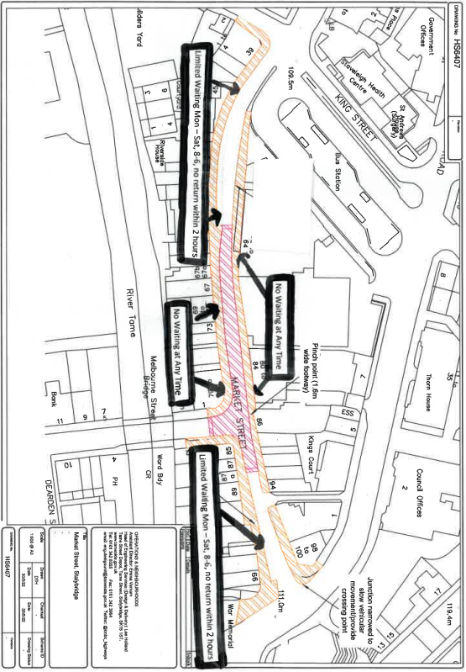

TAMESIDE METROPOLITAN BOROUGH COUNCIL

TAMESIDE METROPOLITAN BOROUGH
(MARKET STREET, STALYBRIDGE)
(PROHIBITION AND RESTRICTION OF WAITING) ORDER 2022

THE TAMESIDE METROPOLITAN BOROUGH COUNCIL in exercise of its powers under Sections 1(1), 2(1), 2(2) and 4(2) of the Road Traffic Regulation Act 1984 (“the Act”) and of Part IV of Schedule 9 to the said Act of 1984 and of all other enabling powers and after consultation with the Chief Officer of Police in accordance with Part III of Schedule 9 to the Act hereby makes the following Order:-

1. (1) In this Order:-

“authorised parking place” means any parking place on a road authorised or designated by an Order made or having effect as if made under the Act of 1984;

“disabled person’s badge” has the same meaning as in the Disabled Persons (Badges For Motor Vehicles)(England) Regulations 2000;

“disabled person’s vehicle” means a vehicle which displays a disabled person’s badge in accordance with the provisions of the Disabled Persons (Badges for Motor Vehicles) (England) Regulations 2000 as amended, or under any succeeding legislation, and shall include a badge issued under regulations having effect in Scotland or Wales under Section 21 of the Chronically Sick and Disabled Person’s Act 1970, and a recognised badge under Section 21A and B of the 1970 Act;

- For the purpose of this Order a vehicle shall be regarded as displaying:-

- a disabled person’s badge in the relevant position, when:-

- the badge is exhibited on the dashboard or facia of the vehicle so that the front of the badge is clearly legible from the outside of the vehicle or;

- where a vehicle is not fitted with a dashboard or facia, the badge is exhibited in a conspicuous position on the vehicle, so that the front of the badge is clearly legible from the outside of the vehicle.

- except where otherwise stated, any reference in this Order to a numbered Article or Schedule is a reference to the Article or Schedule bearing that number in this Order.

- Save as provided in Article 4 to this Order no person shall except upon the direction or with the permission of a police constable in uniform or of a civil enforcement officer, cause or permit any vehicle to wait at any time on the sides of lengths of roads specified in Schedule 1 to this Order.

- Save as provided in Article 4 to this Order no person shall except upon the direction or with the permission of a police constable in uniform or of a civil enforcement officer, cause or permit any vehicle to wait between the hours of 8:00am and 6.00pm on Monday to Saturday inclusive in Schedule 2 to this Order:-

- for a longer period than 1 hour; or

- if a period of less than 2 hours has elapsed since the termination of the last period of waiting, if any, by that vehicle on the same side of length of road.

4. (1) Nothing in Article 2 and 3 shall render it unlawful to cause or permit any vehicle to wait on the sides of lengths of roads referred to therein for so long as may be necessary to enable:-

- persons to board or alight from a vehicle;

- the vehicle, if it cannot conveniently be used for such purpose in any other road, to be used in connection with any of the following operations, namely:-

- building, industrial or demolition operations;

- the removal of any obstruction to traffic;

- the maintenance, improvement or reconstruction of the said sides of lengths of roads; or

- the laying, erection, alteration or repair in, or the land adjacent to, the sides of lengths of roads of any sewer or of any main, pipe or apparatus for the supply of gas, water or electricity or any electronic communications network as defined in the Communications Act 2003.

- the vehicle, if it cannot conveniently be used for such purpose in any other road, to be used in the service of a local authority or any other Authority in the pursuance of statutory powers or duties;

- the vehicle, to be used for the purpose of delivering or collecting postal packets as defined in the Postal Services Act 2000;

- the vehicle to wait at or near to any premises situated on or adjacent to the sides of lengths of roads for so long as such waiting is reasonably necessary in connection with any wedding or funeral; or

- the vehicle to be used for Fire Brigade, Ambulance or Police purposes.

- Nothing in Article 2 and 3 to this Order shall render it unlawful to cause or permit any vehicle to wait for so long as may be necessary for the purpose of enabling goods to be loaded onto or unloaded from the vehicle on the sides of lengths of roads specified in the Schedule to this Order, at any time.

- Nothing in Article 2 and 3 to this Order shall render it unlawful to cause or permit a disabled person’s vehicle which displays in the relevant position a disabled person’s badge, to wait on any of the sides of lengths of roads referred to in those Articles

- THE TAMESIDE METROPOLITAN BOROUGH (STALYBRIDGE TOWN CENTRE) (PROHIBITION AND RESTRICTION OF WAITING AND LOADING) ORDER 2007 shall have the effect as though:-

‘Market Street, south side, from a point 20 metres west of its junction with Trinity Street to a point 20 metres east of its junction with Melbourne Street shall be deleted therefrom.

- THE TAMESIDE METROPOLITAN BOROUGH (MARKET STREET AND WATERLOO ROAD STALYBRIDGE) (PROHIBITION AND RESTRICTION OF WAITING) ORDER 2009 is hereby revoked.

7. THE TAMESIDE METROPLITAN BOROUGH (MARKET STREET, STALYBRIDGE) (PROHIBITION OF WAITING & LOADING) ORDER 2011 is hereby revoked.

The prohibitions and restrictions imposed by this Order shall be in addition to and not in derogation from any restrictions or requirement imposed by any regulations made or having effect as if made under the said Act of 1984 or by or under any other enactment.

The Order shall come into operation on the <> day of <> and may be cited as “TAMESIDE METROPOLITAN BOROUGH COUNCIL (MARKET STREET, STALYBRIDGE) (PROHIBITION AND RESTRICTION OF WAITING) ORDER 2022”

THE COMMON SEAL OF TAMESIDE
METROPOLITAN BOROUGH COUNCIL
was hereunto affixed on the <> day of
<> in the presence of:-

Borough Solicitor.

SCHEDULE 1

No Waiting at Any Time

Market Street  north side | - | from its junction with Stamford Street to its junction with Water Street.
Market Street  south side | - | from its junction with Stamford Street to a point 10 metres west of its easterly junction with Waterloo Road.
Market Street  south side | - | from a point 25 metres west of its easterly junction with Waterloo Road to a point 70 metres east of Water Street.
Market Street  south side | - | from its junction with Water Street for a distance of 15 metres in an easterly direction.
Market Street  south side | - | from its junction with Chapel Street for a distance of 4 metres in a westerly direction.

SCHEDULE 2

Limited Waiting, Monday – Saturday, 8:00am – 6:00pm, 1 hour, no return within 2 hours

Market Street  south side | - | from a point 10 metres west of its easterly junction with Waterloo Road for a distance of 15 metres in a westerly direction.
Market Street  south side | - | from a point 70 metres east of its junction with Water Street for a distance of 55 metres in an easterly direction.
Market Street  south side | - | from a point 4 metres north west of its junction with Chapel Street for a distance of 35 metres in a westerly direction.
Waterloo Road  north side | - | from a point 10 metres east of its junction with Queen Street to a point 30 metres west of its junction with King Street.

