
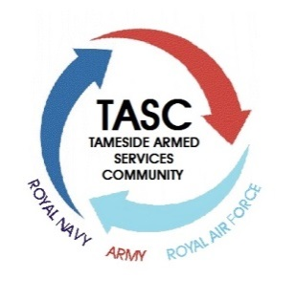
Tameside Armed Services Community
Armed Forces Covenant Updates
As part of the Armed Forces Community Covenant, Tameside Armed Services Community in partnership with Tameside Metropolitan Borough Council is looking to identify individuals and organisations that are keen to support the Armed Forces Covenant in Tameside.
We are asking people to register their name and address with Tameside Armed Services Community. This will enable us and Tameside Metropolitan Borough Council to keep you informed about events; any updates regarding the Armed Forces Covenant, what help is available to you from the Council and anything else we think you may be interested in.
We are also interested in knowing your interest in the Armed Forces Covenant so that we can ensure you are kept as informed as possible.
If you would like to register please complete the slip below and return this to us. If you need more information please do ring David Brown on 0161 342 4080 or Vanessa Rothwell on 0161 342 3392.

Full name: ________________________________________________________________________
Address & Postcode: _________________________________________________________________
_________________________________________________________________
Email: ______________________________________________________________________________
Telephone: __________________________________ Mobile: __________________________
Interest in Covenant: _________________________________________________________________
Are you Ex-service personnel or currently serving? Yes /No
If yes, which branch of service? ___________________________________________________
If yes, what was/is your period of service? Year-year ______________________________________
Service Number: ____________________________________
Do you have membership of any service organisation (RBL etc.) Yes/No
If yes which organisations? __________________________________________________________
TASC in partnership with the Council and its partner bodies are committed to the protection of your personal data and it is confirmed that your name address and contact details given above will be kept safe and that your name and address will only be used to keep you informed of events and to enable you to get the most out of the Armed Forces Covenant.
Please tick if you agree to Tameside Armed Services Community sharing the name, address and contact details you have given on this form, with other Council departments or partnership agencies that could assist you.


Please return completed form to: Tameside Armed Services Community, Denton Town Hall, Market Street, Denton, M34 2AP




Tameside Ex-Forces Employment and Skills Details

What is your current employment status: (please circle)
Employed
Self-employed
Unemployed – looking for work
Unemployed – not looking for work
Other – please specify
If you are unemployed – looking for work, please tell us what type of work areas/ job roles you are seeking (this may help us to understand employment demand in certain roles when engaging with the local business community for employment support within the armed forces community.

Would you like support with CV writing? Yes/No

Would you like support with job searching and/or interview skills? Yes/No

Would you like support with career advice or guidance? Yes/No

Are you interested in developing your skills/ education? If so please tell us what?

Useful websites for ex-service personnel:
Tameside Live Work Invest & Idox: http://www.liveworkinvest.com/

The Forces Employment Charity: http://www.rfea.org.uk/
Civvy Street: http://civvystreetmagazine.co.uk/?job_listing_type=recruitment
Talent Commandos: http://www.talentcommandos.co.uk/
Civilian Transition Partnership: https://www.ctp.org.uk/
Any Other Services required:

