
EasyReader is a reading app produced by Dolphin. It runs on both Apple and Android devices. It provides a simple and accessible way to search for, download and play modified books from RNIB Bookshare on a smartphone, tablet or iPad.
Dolphin EasyReader is available to download for free from both the Apple app store and the Google Play Store.
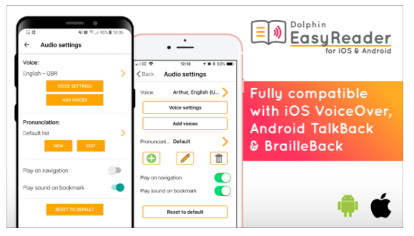
This is a simple guide for pupils, parents and staff to follow to link up the Dolphin EasyReader App to the RNIB Bookshare account.

Your Dolphin EasyReader account is used to synchronise books across devices so you can seamlessly move from reading on your tablet to reading on your smartphone without losing your place.

Installing and setting up Dolphin EasyReader
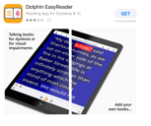
- Find the EasyReader App in the Apple store or Play store and download.

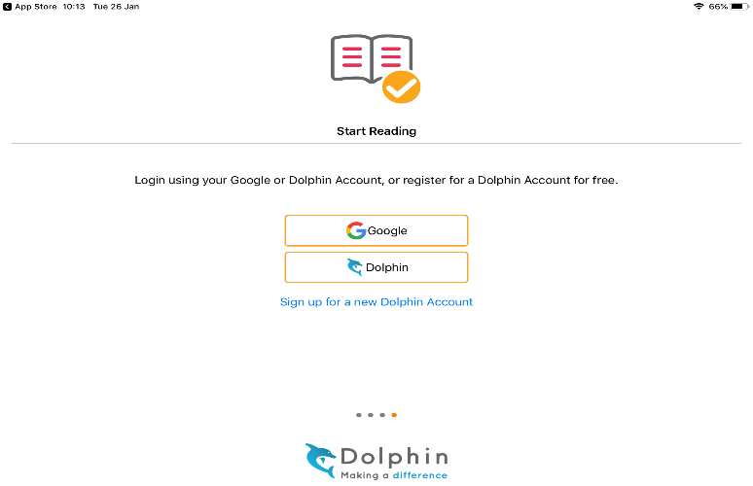
- To use EasyReader App you need to create a free account with Dolphin from within the app. You can do this with an email address and password or sign in with an existing Google account.

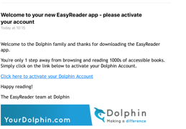
- You will need to validate your EasyReader app in an email which will be sent to the address that you registered with.
- Choose ‘manage libraries’ to select RNIB Reading Services from the list of libraries.
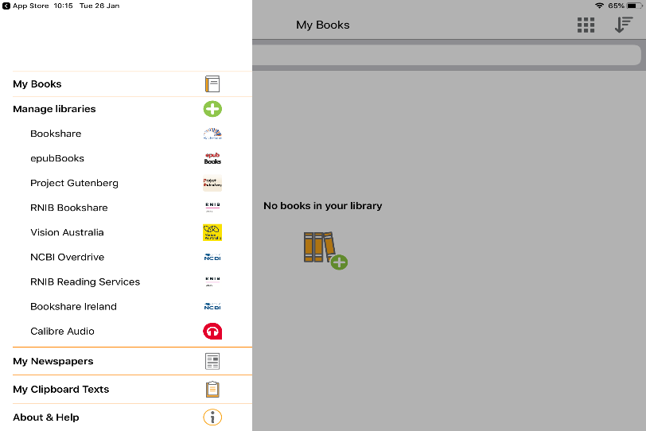

- As you have already signed up for an RNIB Bookshare, you can log in with your bookshare username and password (you only need to do this once!)
Searching for and downloading books
When logged into RNIB Bookshare you have a choice of a log out button, search box, my reading lists, latest and categories.
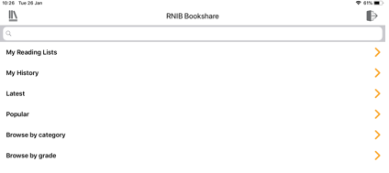
- To find a book follow the RNIB Bookshare guide either search by author, title, key word etc. or choose from latest or categories.

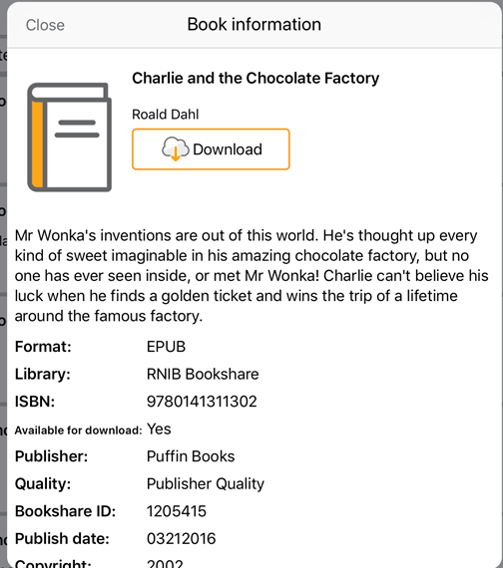
- Each book has a title and a book information button. Selecting either of these will take you to more information where there is a download button. After selecting the book you want, press the download button, the title should begin to download within a few minutes. Preparing is shown then the download progress updates as a percentage.

- Once the book has downloaded, an open button appears. EasyReader will bookmark the reading position of each book you have downloaded.

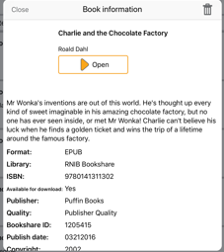
Playing a downloaded book
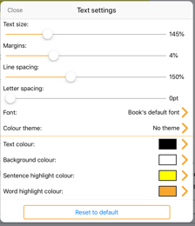
Once the book is open, you can play and navigate through the book by headings, time jump etc. You can change the text size, margins, line spacing, font, text colour and background colour too.
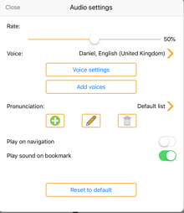
The playback screen contains a number of controls for changing audio speed, default time jump, book information, sleep timer etc. You can change the voice and make it talk faster or slower.

When you start to play the book with a voice over, you can chose if you want the text highlighted.
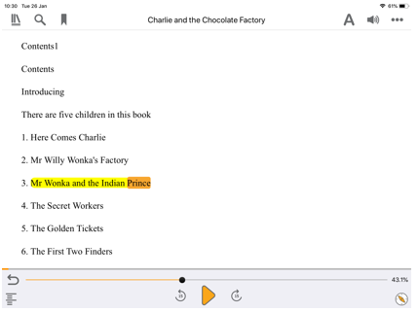

I hope these instructions help you to use the EasyReader App along with your RNIB bookshare account.

Enjoy using your EasyReader App!! Happy reading


