Statement of Reasons
Holden Street, Ashton-under-Lyne runs west to east between Union Road and Whiteacre Road. The road is severed so does not provide a through route for vehicular traffic.

In recent years it has been brought to the council’s attention by residents and ward members that obstructive parking is occurring in the cul-de-sac end of Holden Street, adjacent to Botany Lane, and on the bend at the junction of Holden Street and Botany Lane. Given the proximity to Our Lady of Mount Carmel RC Primary School this is predominantly a problem at school pick up and drop off times but parking in a turning head or too close to a junction on a blind bend is to be discouraged at all times.

There is a private parking area to the rear of properties 45-53 Holden Street (access via Botany Lane). Residents report that they often have difficulty exiting onto Botany Lane when vehicles are parked too close to the junction of this unnamed access road.

On the west side of Botany Lane is a large private carpark with two gated entrances, which ideally should be left clear of parked vehicles.

Concerns have also been raised that visibility at the junction of Botany Lane and Ripon Street is being compromised by parked vehicles.

A resident of Hillgate Street, Ashton-under-Lyne has approached the council to request waiting restrictions on the east side of their street. Given the proximity to Ashton Central Mosque vehicles often double park, which is restricting access and obstructing the pavement.

Engineering Services is of the opinion that the implementation of waiting restrictions at the proposed locations would address the issues raised by preventing obstructive parking at these junctions and lengths of road, thereby enhancing visibility, accessibility and facilitating the free flow of traffic.

THE TAMESIDE METROPOLITAN BOROUGH (HILLGATE STREET AND BOTANY LANE AREA, ASHTON-UNDER-LYNE) (PROHIBITION OF WAITING) ORDER 2024
Please notice that all representations sent in response to this Notice are public documents and may be viewed by anyone. Tameside Metropolitan Borough Council proposes to make the above Order under the Road Traffic Regulation Act 1984 the effects of which will be to introduce No Waiting at Any Time restrictions on: -

(1) Botany Lane (east side) from its junction with Holden Street for a distance of 10 metres in a southerly direction; (2) Botany Lane (east side) from a point 16 metres south of its junction with Holden Street to a point 10 metres south of its junction with Hague Street; (3) Botany Lane (east side) from a point 10 metres north of its junction with Ripon Street to a point 10 metres south of that junction; (4) Botany Lane (east side) from a point 10 metres north of its junction with Ripon Street to a point 10 metres south of that junction; (5) Botany Lane (west side) from its junction with Holden Street for a distance of 41 metres in a southerly direction; (6) Botany Lane (west side) from a point 10 metres north of its junction with Ripon Street to a point 10 metres south of that junction; (7) Hillgate Street (east side) from a point 15 metres south-west of its junction with Holden Street a distance of 62 metres in a south-westerly direction; (8) Holden Street (north side) from a point 54 metres east of its junction with Cottingham Drive up to and including its cul-de-sac end; (9) Holden Street (south side) from a point 12 metres west of its junction with Botany Lane to a point 5 metres east of that junction; (10) Holden Street (south side) from a point 27 metres east of its junction with Botany Lane up to and including its cul-de-sac end; (11) Ripon Street (north side) from a point 10 metres west of its junction with Botany Lane to a point 10 metres east of that junction; (12) Ripon Street (south side) from a point 10 metres west of its junction with Botany Lane to a point 10 metres east of that junction.

A copy of the proposed Order, plan and statement of reasons relating thereto may be inspected online via http://www.tameside.gov.uk/trafficregulationorders or be sent to you at your request by e-mailing trafficoperations@tameside.gov.uk and asking for the Botany Lane, Hillgate Street, Holden Street and Ripon Street Area deposited documents. Objections or comments to the proposals stating the grounds on which they are being made must be submitted in writing to the undersigned or by email to trafficoperations@tameside.gov.uk. The statutory consultation period is 28 days ending on the 19 September 2024. If you wish to discuss the proposals please contact Joanne Biddle on 0161 342 2879.

Date: 22 August 2024

E Varnam; Assistant Director of Operations and Neighbourhoods; PO Box 317, Market Place, Ashton-under-Lyne, OL6 6BH

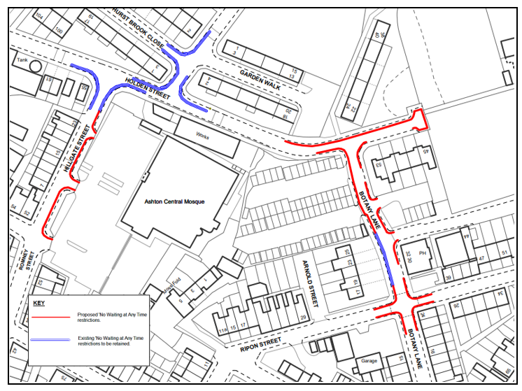
THE TAMESIDE METROPOLITAN BOROUGH

THE TAMESIDE METROPOLITAN BOROUGH
(HILLGATE STREET, HOLDEN STREET, BOTANY LANE & RIPON STREET AREA, ASHTON-UNDER-LYNE)
(PROHIBITION OF WAITING) ORDER 2024
DRAFT

The Tameside Metropolitan Borough Council in exercise of its powers under Sections 1(1), 2(1) and 2(2) of the Road Traffic Regulation Act 1984 (“the Act”) and Part IV of Schedule 9 and all other enabling powers and after consultation with the Chief Officer of Police in accordance with Part III of Schedule 9 to the Act hereby makes the following Order:-

1. (1) In this Order:-

“disabled person’s badge” has the same meaning as in the Disabled Persons (Badges For Motor Vehicles)(England) Regulations 2000;

“disabled person’s vehicle” means a vehicle which displays a disabled person’s badge in accordance with the provisions of the Disabled Persons (Badges for Motor Vehicles) (England) Regulations 2000 as amended, or under any succeeding legislation, and shall include a badge issued under regulations having effect in Scotland or Wales under Section 21 of the Chronically Sick and Disabled Person’s Act 1970, and a recognised badge under Section 21A and B of the 1970 Act;

“parking disc” means a disc issued by a local authority, 125 millimetres square, coloured blue and capable of showing the quarter hour period during which a period of waiting begins.

- For the purpose of this Order a vehicle shall be regarded as displaying:-

- a disabled person’s badge in the relevant position, when:-

- the badge is exhibited on the dashboard or facia of the vehicle so that the front of the badge is clearly legible from the outside of the vehicle or;

- where a vehicle is not fitted with a dashboard or facia, the badge is exhibited in a conspicuous position on the vehicle, so that the front of the badge is clearly legible from the outside of the vehicle.

- a parking disc in the relevant position if;

- the disc is exhibited on the dashboard or facia of the vehicle and shows the quarter hour period during which a period of waiting began and that period is clearly legible from the outside of the vehicle or;

- where the vehicle does not have a dashboard or facia, the disc is exhibited in a conspicuous position on the vehicle, so that, when marked to show the quarter hour period during which a period of waiting began and that period is clearly legible from the outside of the vehicle.

- except where otherwise stated, any reference in this Order to a numbered Article or Schedule is a reference to the Article or Schedule bearing that number in this Order.

- Save as provided in Article 3 to this Order no person shall except upon the direction or with the permission of a police constable in uniform or of a civil enforcement officer, cause or permit any vehicle to wait at any time on the sides of lengths of roads specified in the Schedule to this Order.
DRAFT

3. (1) Nothing in Article 2 shall render it unlawful to cause or permit any vehicle to wait on the sides of lengths of roads referred to therein for so long as may be necessary to enable:-

- persons to board or alight from a vehicle;

- the vehicle, if it cannot conveniently be used for such purpose in any other road, to be used in connection with any of the following operations, namely:-

- building, industrial or demolition operations;

- the removal of any obstruction to traffic;

- the maintenance, improvement or reconstruction of the said sides of lengths of roads; or

- the laying, erection, alteration or repair in, or the land adjacent to, the sides of lengths of roads of any sewer or of any main, pipe or apparatus for the supply of gas, water or electricity or any electronic communications network as defined in the Communications Act 2003.

- the vehicle, if it cannot conveniently be used for such purpose in any other road, to be used in the service of a local authority or any other Authority in the pursuance of statutory powers or duties;

- the vehicle, to be used for the purpose of delivering or collecting postal packets as defined in the Postal Services Act 2000;

- the vehicle to wait at or near to any premises situated on or adjacent to the sides of lengths of roads for so long as such waiting is reasonably necessary in connection with any wedding or funeral; or

- the vehicle to be used for Fire Brigade, Ambulance or Police purposes.

- Nothing in Articles 2 to this Order shall render it unlawful to cause or permit any vehicle to wait for so long as may be necessary for the purpose of enabling goods to be loaded onto or unloaded from the vehicle on the sides of lengths of roads specified in the Schedule to this Order, at any time.

- Nothing in Article 2 to this Order shall render it unlawful to cause or permit a disabled person’s vehicle which displays in the relevant position a disabled person’s badge and a parking disc (on which the driver, or person in charge of the vehicle, has marked the time at which the period of waiting began) to wait on any of the sides of lengths of roads referred to in the Schedule to this Order for a period not exceeding three hours (not being a period separated by an interval of less than one hour from a previous period of waiting by the same vehicle on the same side of length of road on the same day)
DRAFT

- THE TAMESIDE METROPOLITAN BOROUGH (MOSSLEY ROAD AREA, ASHTON-UNDER-LYNE) (PROHIBITION OF WAITING) (PART 1) ORDER 2012 shall have the effect as though in the Schedule to that Order the following sides and lengths of roads were deleted therefrom: -

BOTANY LANE (west side) from a point 7 metres north of its junction with Ripon Street for a distance of 25 metres,

HILLGATE STREET (both sides) from its junction with Holden Street for a distance of 15 metres in a south westerly direction.

- The prohibitions and restrictions imposed by this Order shall be in addition to and not in derogation from any restrictions or requirement imposed by any regulations made or having effect as if made under the said Act of 1984 or by or under any other enactment.

The Order shall come into operation on the <date> day of <month and year> and may be cited as “THE TAMESIDE METROPOLITAN BOROUGH (HILLGATE STREET, HOLDEN STREET, BOTANY LANE & RIPON STREET AREA, ASHTON-UNDER-LYNE) (PROHIBITION OF WAITING) ORDER 2024”

THE COMMON SEAL OF TAMESIDE
METROPOLITAN BOROUGH COUNCIL
was hereunto affixed on the <date> day of
<month and year> in the presence of

Authorised Signatory

SCHEDULE

No Waiting at Any Time

Botany Lane  (east side ) | - | from its junction with Holden Street for a distance of 10 metres in a southerly direction.  DRAFT
Botany Lane  (east side ) | - | from a point 16 metres south of its junction with Holden Street to a point 10 metres south of its junction with Hague Street.
Botany Lane  (east side ) | - | from a point 10 metres north of its junction with Ripon Street to a point 10 metres south of that junction.
Botany Lane  (east side ) | - | from a point 10 metres north of its junction with Ripon Street to a point 10 metres south of that junction.
Botany Lane  (west side) | - | from its junction with Holden Street to a point 10 metres south of its junction with Ripon Street.
Hillgate Street  (west side) | - | from its junction with Holden Street for a distance of 15 metres in a south-westerly direction.
Hillgate Street  (east side) | - | from its junction with Holden Street for a distance of 78 metres in a south-westerly direction.
Holden Street  (north side) | - | from a point 54 metres east of its junction with Cottingham Drive up to and including its cul-de-sac end.
Holden Street  (south side) | - | from a point 12 metres west of its junction with Botany Lane to a point 5 metres east of that junction.
Holden Street  (south side) | - | from a point 27 metres east of its junction with Botany Lane up to and including its cul-de-sac end.
Ripon Street  (north side) | - | from a point 10 metres west of its junction with Botany Lane to a point 10 metres east of that junction.
Ripon Street  (south side) | - | from a point 10 metres west of its junction with Botany Lane to a point 10 metres east of that junction.

