

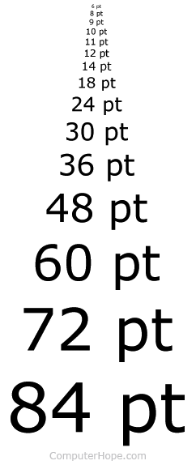
RNIB Bookshare
Instructions for Parents and Schools


A member of the VI Team will have created an account for your child. Your child will have a unique ‘Username’ and a ‘Password’ to use on RNIB Bookshare.

Once you have your child’s account details you will need to follow these steps to download books and adapt them to your child’s preference.
- Go on the internet and write in https://www.rnibbookshare.org/cms/

- Click ‘Login’ at the top of the page.
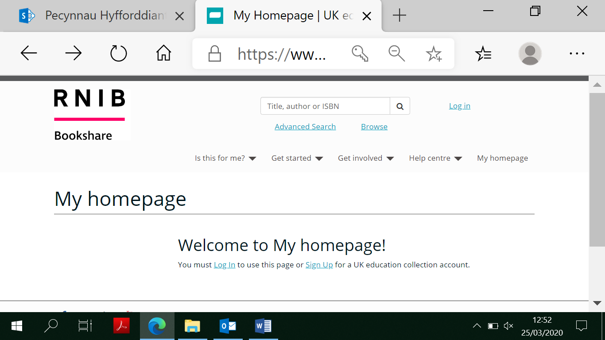

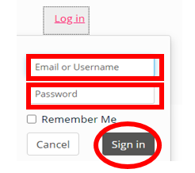
- Write in your child’s ‘Username’ and ‘Password’ and click ‘Sign In’.

- At the top of the page, you will see a box that says ‘Title, author or ISBN’. Click on it to look for a book or an author e.g. Harry Potter or David Walliams. Press the magnifying glass/ search
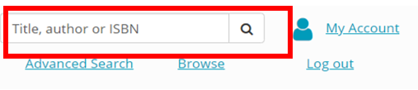
- One you have clicked on the magnifier you will have a selection of books to choose from. Select which book your child wants.

- In the action column there will be different options for you to choose from. Options such as ‘Read Now’ or a dropdown list which might include Word/PDF.

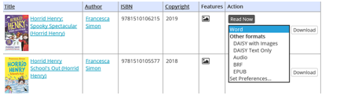

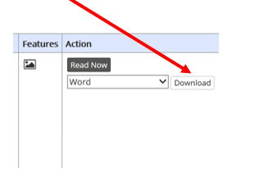
- Choose which format you want the book. If you have chosen Word/PDF then the book will be downloaded for you. Click on download and another webpage will open.

- After a short time the status will change to available. Click on the available option and you will then be able to choose to either open the book or to save it.
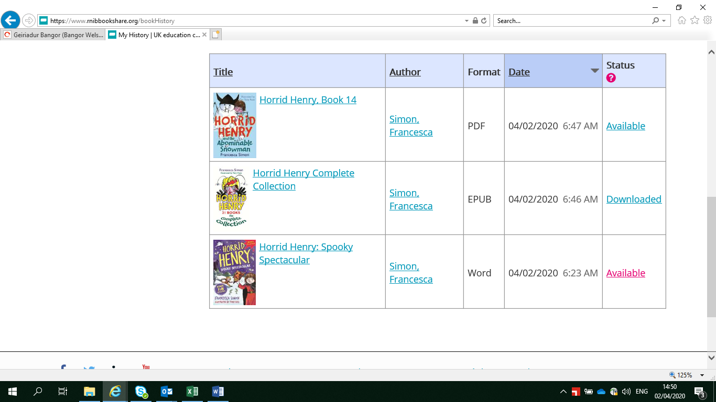

- If you have chosen the option Read Now Click the button.
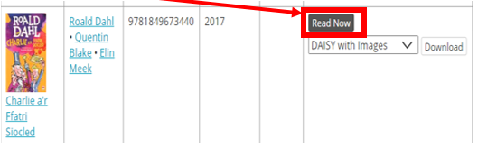

- To change the book to how your child likes it, you need to click on the ‘Settings’ button.
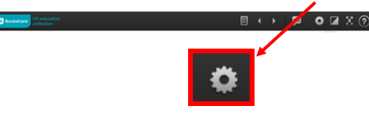

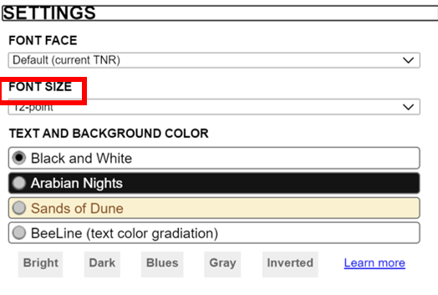
11. Here you are able to change the font size and the colour etc.
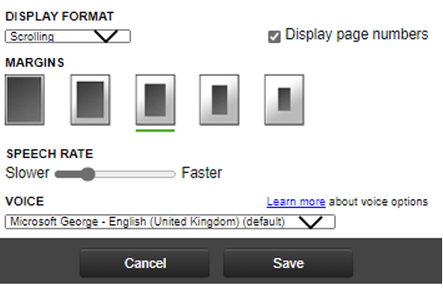

- When you have changed the font size or colour to your child’s preference, the book will be ready to read!

13. Use the arrows and scroll to read.
