
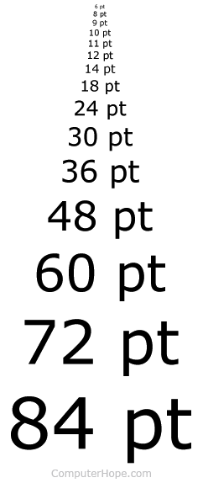

RNIB Bookshare
Instructions for pupils


You will receive a ‘Username’ and a ‘Password’ for you to use on RNIB Bookshare from the VI Team.

After you have them, you will need to follow these steps to download books to adapt them to the way you like
- Go on the internet and write in https://www.rnibbookshare.org/cms/

- Click ‘Login’ at the top of the page.
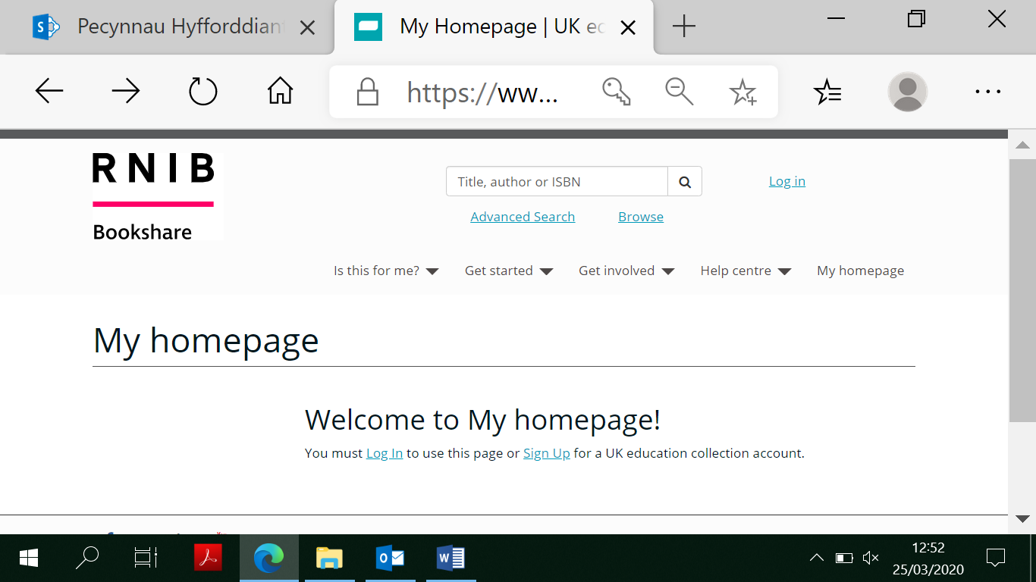

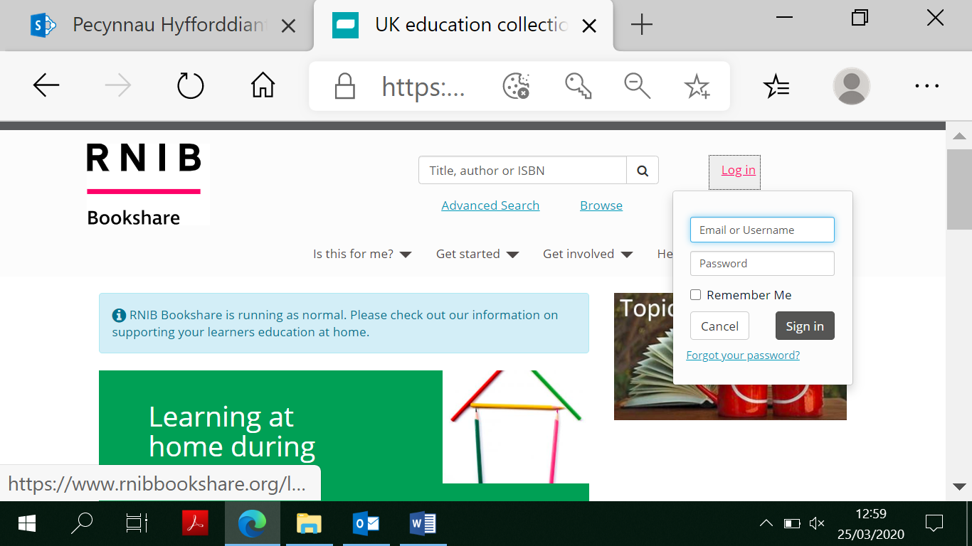
- Write in your ‘Username’ and ‘Password’ and click ‘Sign In’.

- At the top of the page, you will see a box that says ‘Title, author or ISBN’. Click on it to look for a book or an author e.g. Harry Potter or David Walliams.
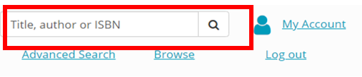
- Scroll through the options and click on a title or front cover that you would like.

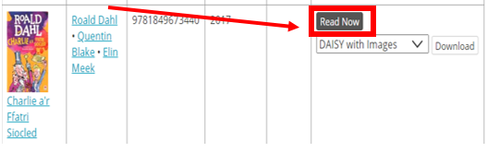
- Click the button on that says ‘Read Now’.

- To change the book to how you like it, you need to click on the ‘Settings’ button.
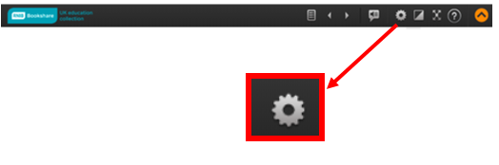
- Here, you are able to change font size and the colour etc. (You should only need to do this once).
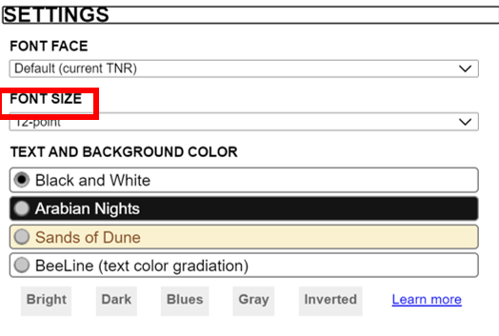
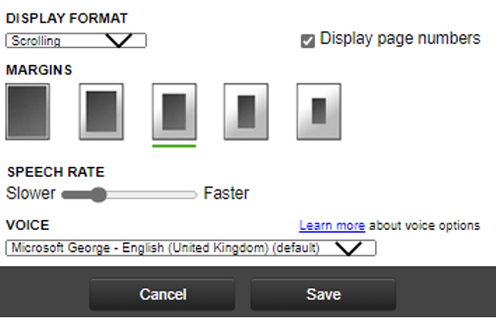
- When you have changed it to the font size or colour you like, you will need to choose whether you want a pdf or a word copy. When you have chosen which one you prefer (or the one they have available) you’ll be ready to read!

10. Use the arrows and scroll to read.
