Tameside MBC
Flood & Water Management Act 2010
Section 19 Investigation Report
King Edwards Court, Hyde
Flood Event - 8 / 9 February 2020

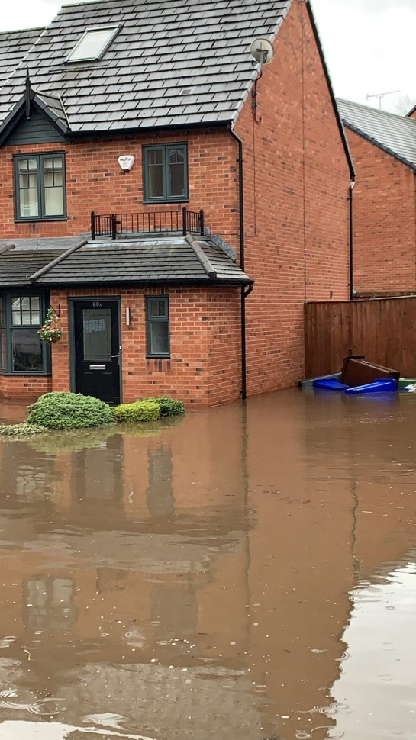

Document History and Status
Revision | Date | Description | By | Review | Approved
A | 05/05/20 | Initial Draft | DH
B | 15/06/20 | Review | JOL
C | 22/07/20 | Updated Draft | DH | JOL
D | 06/08/20 | Final Draft | DH | JOL | JOL
Contents
 | Glossary | 1
1. | Introduction | 4
1.1. | Summary of Events | 4
1.2. | Purpose and Scope of this Report | 4
1.3. | Legislative Background | 4
1.4. | Risk Management Authorities (RMAs) | 5
2. | Overview of Flooding Events | 7
2.1 | Property Impacts | 7
2.2  2.3 | Conditions on 8 and 9 February 2020  Flood Guidance Statement | 7  8
2.4 | EA Flood Alerts | 9
3 | Detailed Location | 10
3.1 | King Edwards Court, Hyde | 11
3.1.1  3.1.2 | Site Overview and Flooding Impacts  Flood Event and Investigation | 11  11
3.1.3 | Risk Management Authorities Responses | 12
3.1.4 | Recommended Actions | 13
4. | Storm Ciara - Infrastructure Impacts | 14
4.1 | Mottram Old Road, Stalybridge | 14
5. | Conclusion | 15
6. | Commitment | 15

Glossary – 1 Acronyms / Initials
AGMA | Association of Greater Manchester Authorities
EA | Environment Agency
GiA | Flood Defence Grant in Aid
GIS | Geographic Information System
HE | Highways England
LLFA | Lead Local Flood Authority
RMA | Risk Management Authority
TMBC | Tameside Metropolitan Council
UU | United Utilities (local sewerage undertaker)

Glossary – 2 General

Assets | Structures, or a system of structures used to provide drainage infrastructure and / or manage flood risk
Catchment | An area that supplies a river system with water (rainwater, snow, etc.) – the area of land where the rainfall drains to a single watercourse
Culvert | A covered channel or pipe to direct the flow of water underground
Flood | The temporary covering by water of land not normally covered with water
Flood Defence Grant  in Aid | Funding made available (subject to approved) by the Environment Agency for reducing flood risk
Groundwater | Water that is in the ground, this is usually referring to water in the saturated zone below the water table
Groundwater  Flooding | Flooding which occurs as a result of groundwater rising above the surface.
Hyrad | HYdrological RADar - An advanced weather radar display system, providing real-time receipt of radar and other hydro-meteorological images
Inlet Structure | Purpose built structures to allow the flow of a watercourse to enter a piped system. Examples below:  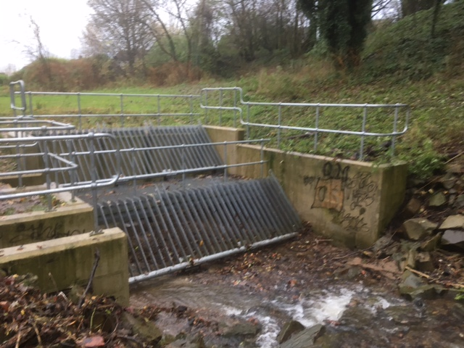  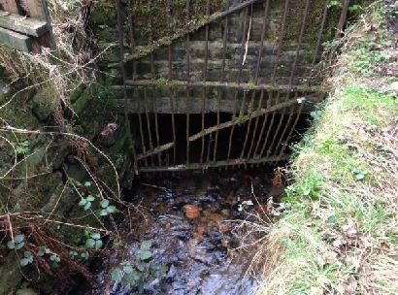  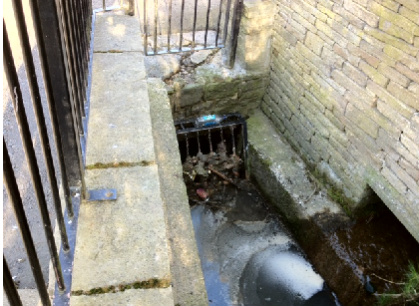
Lead Local  Flood  Authority | An upper tier local authority with particular responsibilities under the Flood and Water Management Act 2010
Main River | A watercourse shown as such on the ‘Main River’ Map, and for which the Environment Agency has certain responsibilities and powers
Ordinary Watercourse | A watercourse that does not form part of a main river
Public Sewer | A sewer which is the responsibility of a sewerage undertaker. Within the Tameside area, this is United Utilities
Recovery | The process of rebuilding, restoring and rehabilitating the community after an incident such as a flood
Reservoir | A natural or artificial lake where water is collected and stored until needed. Some reservoirs in areas such as Tameside were initially built for industry and are no longer serving their original purpose but may have other benefits such as amenity or nature conservation
Return Period | An estimate of the average interval of time between a rainfall event of a certain intensity or size.
Risk | The significance of a potential event in terms of likelihood and consequences
Risk Management  Authorities | Organisations which have a key role in flood and coastal erosion risk management as defined by the Flood and Water Management Act 2010. These include the Environment Agency, the Lead Local Flood Authority, district councils where there is no unitary authority, internal drainage boards, water companies, highways authorities etc.
River ( Fluvial) Flooding | Occurs when the water level in a channel overwhelm the capacity of the channel
Sewer Flooding | Flooding caused by wastewater discharge from sewers
Surface Water (Pluvial)  Flooding | Flooding from rainwater (including snow and other precipitation) which has not entered a watercourse, drainage system or public sewer
Watercourse | Rivers, streams, ditches, drains, cuts, culverts, dikes, sluices, sewers (other than public sewers within the meaning of the Water Industry Act 1991) and passages, through which water flows

- Introduction
1.1 Summary of Events
Localised flooding occurred following intense rainfall on 8 and 9 February 2020. Six properties on King Edwards Court, Hyde were flooded internally and there was extensive external flooding.
A culvert in this location partially blocked leading to a reduction in the amount of water able to pass through the underground system.
1.2 Purpose and Scope of this Report
The flooding event of 8 and 9 February 2020 affected a number of properties; it is classed as a ‘significant’ event under Tameside Metropolitan Borough Council (TMBC) Local Flood Risk Management Strategy and therefore an investigation has been carried out.
The aim of this report is to identify properties affected by this event and investigate the source / cause and recommend any further actions that may be necessary.
1.3 Legislative Background
Section 19 Investigations – Flood and Water Management Act 2010
The Act places a number of duties on Lead Local Flood Authorities (LLFAs) in relation to local flood risk management, one of which is to record and investigate flooding incidents within their area.
Section 19 states –
- On becoming aware of a flood in its area, a lead local flood authority must, to the extent that it considers necessary or appropriate, investigate –
- Which risk management authorities have relevant flood risk management functions, and
- Whether each of those risk management authorities has exercised, or is proposing to exercise, those functions in response to the flood.

- Where an authority carries out an investigation under subsection (1) it must –
- Publish the results of its investigations, and
- Notify any relevant risk management authorities
1.4 Risk Management Authorities (RMAs)
The following organisations are defined as Risk Management Authorities (RMAs) under the Act and have the following flood risk management functions:

Flood Source | Environment Agency | Lead Local Flood Authority (Tameside MBC) | Water Company  (United Utilities) | Highway Authority (Highways England – Motorways & Trunk Roads)
Main River* | Y
Ordinary Watercourse* |  | Y
Highway Surface Water |  | Y |  | Y
Surface Water from other sources |  | Y |  | Y
Groundwater Flooding |  | Y
Water Supply Infrastructure |  |  | Y
* Main rivers have been designated as such by the Environment Agency and tend to be major rivers or rivers with a high flood risk. Ordinary watercourses; other streams etc. not generally classed as Main River.
Partnership meetings are arranged and attended by AGMA, EA, UU and TMBC on a regular basis to discuss specific issues and ongoing matters relating to flood risk across the borough.

    - Environment Agency (EA)
The Environment Agency has a strategic overview of all sources of flooding and coastal erosion (as defined in the Act). It is also responsible for flood and coastal erosion risk management on main rivers and the coast, regulating reservoir safety and working in partnership with the Meteorological (Met) Office to provide flood forecasts and warnings.
For details and guidance on what to do before during and after the floods see –
https://www.gov.uk/government/publications/flooding-what-to-do-before-during-and-after-a-flood
1.4.2 Tameside Metropolitan Borough Council (TMBC)
TMBC has a joint risk management role both in the capacity of highways authority and as Lead Local Flood Authority (LLFA). As a highway authority, TMBC has a duty under the Highways Act 1980 to manage highways that are maintainable at public expense, including highway drainage. As LLFA, TMBC has a number of duties and powers as laid out in the Act including the duty to investigate flooding.
TMBC also take an overseeing role to ensure that RMAs and landowners are fulfilling their responsibilities.
1.4.3 Water Companies
Water companies are responsible for public sewers as defined under The Water Industry Act 1991 and Private Sewers Legislation 2011. They are also responsible for the storage and supply of fresh water to residents and businesses.
1.4.4 Highways England
Highways England has responsibility as highways authority for motorways and trunk roads throughout Tameside.
1.4.5 Riparian Landlords and Residents
Riparian landowners are owners of land adjoining or containing a watercourse. They have certain rights/responsibilities, including the maintenance of watercourses and assets within their ownership to ensure flood risks are not increased upstream, through or downstream of their land.
A free detailed guide can be accessed from:
https://www.gov.uk/government/publications/riverside-ownership-rights-and-responsibilities
Residents who are concerned they may be at risk of flooding should take appropriate action to protect themselves and their property. These actions include registering to receive flood warnings, obtaining a personal supply of sandbags and moving valuable items to higher ground. They also include more resilient and permanent measures such as water resistant doors, air brick covers, floodgates and raised electrical sockets and the fitting of non-return valves on pipes.
However, this location is some distance for the River Tame and this flooding was not as a result of high river levels therefore this area would not be subject to a flood alert.

Further information can be found at –
https://www.gov.uk/government/organisations/environment-agency

2. Overview of Flooding Events
2.1 Property Impacts
Storm Ciara swept across the whole of the UK on Sunday 9 February 2020 bringing heavy rain and very strong winds. The strongest gust recorded was 97 mph at the Needles, Isle of Wight. However, there were widespread gusts of 70 - 80 mph even in less exposed, inland sites, with a squall band of rain bringing some intense thundery downpours, and strong, squally winds.
The highest rain totals were in parts of northwest England and North Wales. Honister Pass, Cumbria (an Environment Agency site) recorded 179.8 mm of rain over the weekend, with 177.0 mm of this coming in the 24 hours up to 16:00 on Sunday 9 February 2020. There was widespread travel disruption as well as some localised flooding and trees being blown down.
Storm Ciara, occurred during the evening of 8 February and morning of 9 February 2020, causing minor, localised flooding in various areas across Tameside.
This report focuses on King Edwards Court, Hyde, where six properties were flooded internally.
2.2 Conditions on 8 and 9 February 2020
Overview
The following information has been used to help provide an overview of conditions that led to flooding.
- Flood Guidance Statement issued by Met Office/Environment Agency (EA)
- Met Office Impact Report

Flood Guidance Statement
These reports, issued by the Flood Forecasting Centre, a partnership between the EA and Met Office, are received regularly by TMBC when there is potential for flooding. This allows TMBC to effectively prepare for weather events in advance.
The report from the 7 February 2020, covering the weekend of 8 and 9 February 2020 stated –
Within Area B (covering the Hyde area of Tameside) on the map below, there was a LOW risk of MINOR surface water flooding.
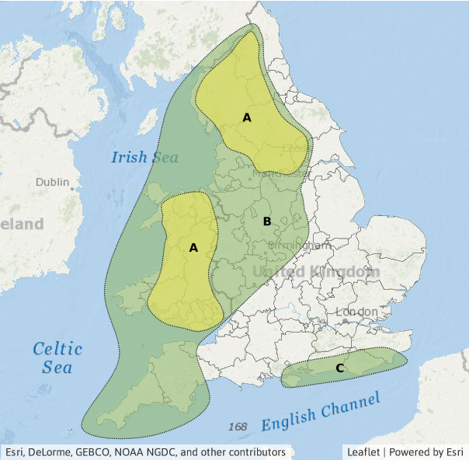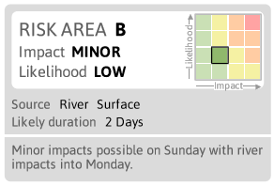
Met Office Impact Report
On Monday 10th a Flood Impact Report was issued by the Met Office, available at –
https://www.metoffice.gov.uk/binaries/content/assets/metofficegovuk/pdf/weather/learn-about/uk-past-events/interesting/2020/2020_02_storm_ciara.pdf
This shows the amount of rainfall that fell during Storm Ciara across the country. Focusing on the area around Hyde, it shows that at the nearest location recording rainfall, 35mm of rain fell from 0900 8 February to 0900 10 February 2020. To put this in context, this is 59% of the average monthly rainfall for February (taking into account data from 1981-2020), falling within a two day period.

2.3 Environment Agency Flood Alerts
Flood alerts and warnings from the EA are based on the severity of flooding expected with regards to rivers and coasts (see table below).
Flood Alert areas generally cover large areas (river catchments). Flood Warning areas are usually more detailed and broken down into specific locations.
Flood Warning Code | What It Means | When It’s Used
Flood Alert | Flooding is possible.  Be prepared. | Two hours to two days in advance of flooding.
Flood Warning | Flooding is expected. Immediate action required. | Half an hour to one day in advance of flooding.
Severe Flood Warning | Severe flooding. Danger to life. | When flooding poses a significant threat to life.

The EA will be targeting residents and businesses in flood affected areas to raise awareness of the flood alert system, with a view to increase the uptake of local residents signed up to receive warnings.
Further information can be found at:
https://www.gov.uk/government/publications/flood-warnings-what-they-are-and-what-to-do
On the 8 and 9 February 2020, no flood warnings were issued for the Tameside area.

The chart below shows the rainfall data, split into 15 minute intervals, from 00:00 8 February to 23:45 10 February 2020, taken from the nearest station in Denton (approximately three miles west of King Edwards Court). It shows that between 11:00am and 12:00pm on 9 February 2020, 15.2mm of rain fell, equivalent to 9% of the average monthly rain falling within one hour.

3 Location Details
3.1 King Edwards Court, Hyde
3.1.1 Site Overview, Flooding Impact
King Edwards Court is located in Hyde, south-east Tameside. There is an unnamed culverted watercourse (shown blue on the plan below) that runs north through the area carrying water from Werneth Low. There is an inlet structure in the vicinity of 41 King Edwards Court, near to an apartment block car park. After which the flow is culverted through various gardens along the estate until it meets another culvert, at the north of the site in a grassed area near another apartment block car park towards King Edward Road. We believe that the watercourse was culverted when the houses to the west of King Edwards Court were built c2008.

A total of six properties were flooded internally, with two sets of residents displaced.
King Edwards Court, Hyde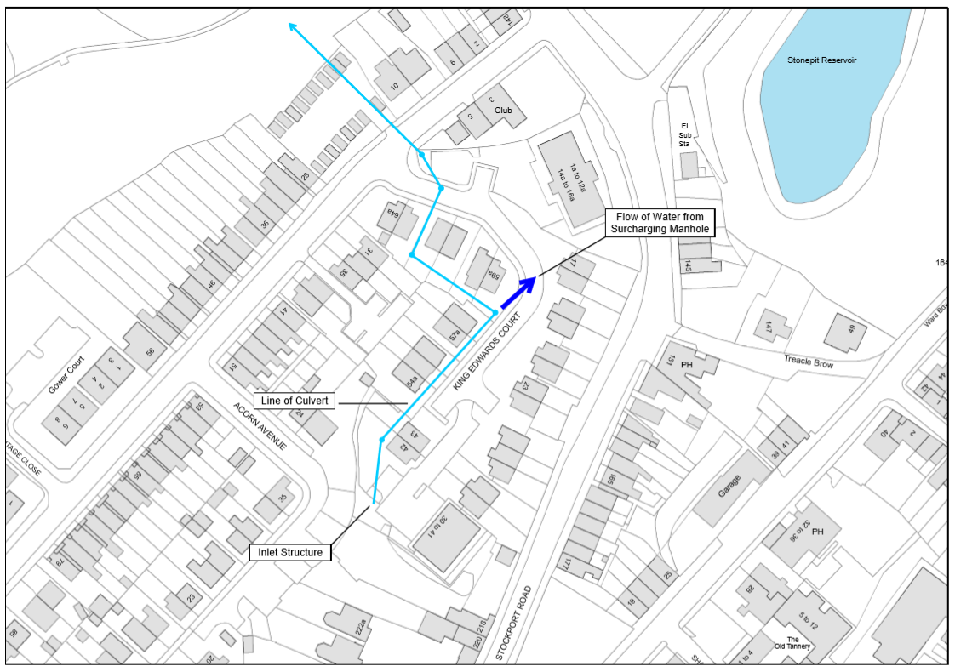
3.1.2 Flood Event and Investigation
Intense rainfall fell on Werneth Low over a period during the evening of the 8 February until the morning of 9 February 2020. This rainfall flowed off Werneth Low via a number of watercources, including the one that runs under King Edwards Court. TMBC was altered to the flood event on 10 February 2020. Flood water had receded but operatives undertook a clear-up operation to remove debris from the roadway.
Tameside MBC drainage engineers and crews together with a Closed Circuit Television (CCTV) contractor commissioned by Tameside MBC surveyed the location following the flooding. The underground pipework and inspection chambers were assessed between the inlet structure near to 41 King Edwards Court and the outfall at King Edward Road. The underground pipes and the inspection chambers were found to be clear and in good order.
However a piece of flagstone was found in the manhole near to King Edward Road.
This piece of flagstone measured c350mmx425mm – below;
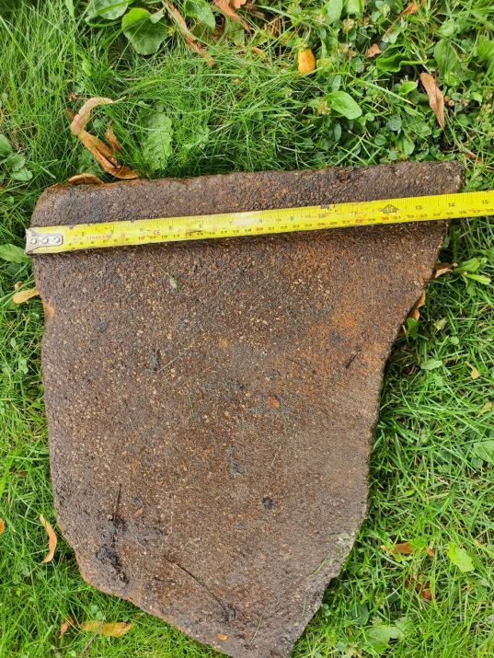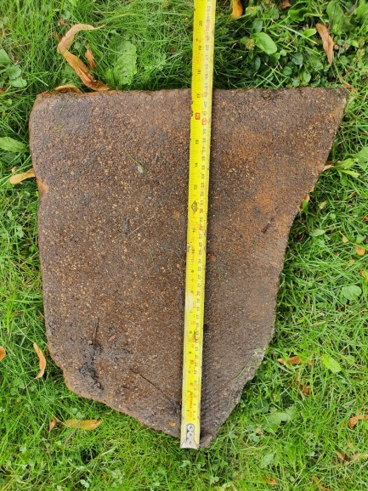
The flagstone significantly reduced the flow through the system. This reduction in capacity caused hydraulic restrictions with the result that the system surcharged at the manhole at the side of 59a King Edwards Court causing localised flooding including internal flooding to six properties.
We have been unable to establish how this flagstone entered the underground system or when. Since the flagstone was removed, there have been a number of occasions of heavy rainfall, during these occurrences, the system at King Edwards Court has functioned correctly and no further issues have been observed.
3.1.3 RMA Responses
The following information has been collected regarding the RMA responses both during and following the February 2020 flooding event in the King Edwards Court area. However, the list is not necessarily comprehensive and may not cover all actions taken by the RMAs.
Prior to the flood event
TMBC –
All listed critical inlet structures were cleaned and cleared of debris on the 6 February 2020. This inlet structure is not part of TMBCs drainage assets and was not attended. However, had it been attended the restriction would not have been visible as it was in the system downstream of the inlet structure.

During the flood event
TMBC –
No action was taken as TMBC were not informed of the issue until 10 February 2020
Following the flood event
TMBC –
Clean up (including cleaning highway drainage system and road sweeping), and inspected the inlet structure on 11, 12 and 13 February 2020

TMBC -
Spoke to residents to understand how many properties were affected and to what extent, initial investigations undertaken.

TMBC -
Commissioned the S19 report

TMBC -
Arranged CCTV investigation to determine cause of flood

EA/TMBC/UU
Continue to liaise regarding this and other sites.

3.1.4 Recommended Actions
Based on the analysis of the February 2020 flooding event, the following actions are recommended to the RMAs.
RMA | Recommended Action
TMBC (Highways Department) | Continue to maintain efficient operation of highway drains
TMBC (LLFA) | Determine if ‘Designation’ of existing inlet structure is appropriate.
United Utilities | Continue to maintain efficient operation of surface water and combined sewers as necessary
Environment Agency | Continue to ensure that ‘main river’ watercourses are suitably maintained
Environment Agency | Review trigger levels for Flood Alerts in this area
Property Owners | Register for flood alerts
Property Owners | Consider Property Level Protection

4. Storm Ciaira - Infrastructure Impacts
Additionally, the following location was also impacted on the weekend of 8 / 9 February 2020;
4.1 Mottram Old Road, Stalybridge
One property on Mottram Old Road reported external flooding following Storm Ciara. A blockage was found within the culvert on an unnamed watercourse under Mottram Old Road which caused the watercourse to surcharge.

5. Conclusion
This report has been produced to document the findings of the Section 19 investigation into the 8 and 9 February 2020 flood in King Edwards Court, Hyde. Its main aim is to identify affected communities, determine why they were affected and to recommend actions to each RMA.
Since the event, there have been a number of meetings between technical officers from TMBC to ascertain an understanding of the weather event and its consequences;
Intense rainfall fell on Werneth Low over a period during the evening of the 8 February until the morning of 9 February 2020. This rainfall flowed off Werneth Low via a number of existing culverts. On this occasion, it appears that debris was washed into the culvert running through King Edwards Court. In particular, part of a flagstone was recovered from a manhole when the system was inspected. The flagstone significantly reduced the amount of water that could flow through the system.
Based on the analysis of the flooding events made in this report, actions have been recommended to each RMA on a site-specific basis, to be found in each relevant section of this report. The delivery of these actions will be dependent on the availability of funding and other RMA priorities.

6. Commitment
Whilst the elimination of future flood events and impacts cannot be guaranteed, Tameside MBC and other risk management authorities remain fully committed to ensuring that risks are minimised and resilience is enhanced wherever possible.
Regular RMA Partnership Meetings will be held to review progress and support individual and collective actions with respect to issues identified.

