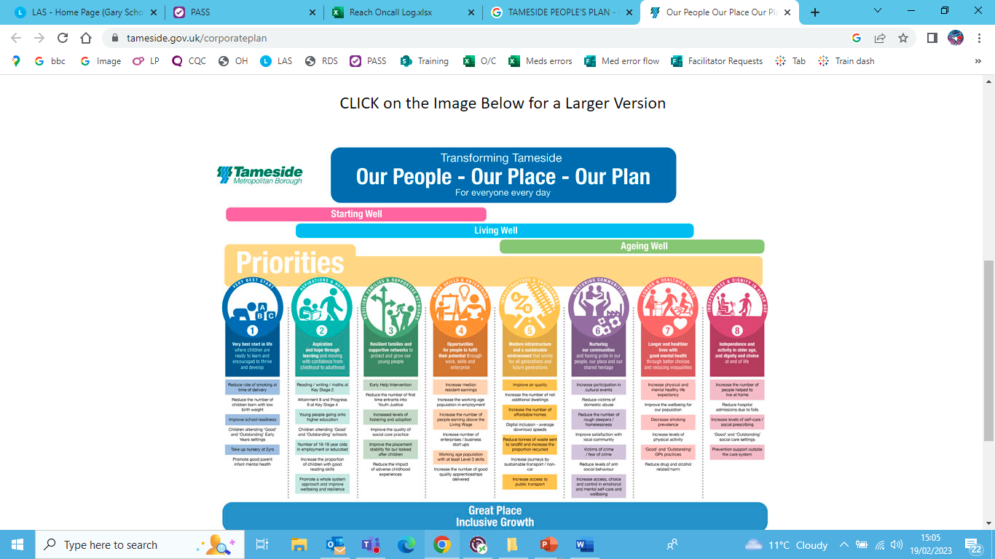
Statement of Purpose
October 11, 2024

Tameside Metropolitan Borough Council

Tameside Learning Disability Services
Provider ID; 1-101615417.

Part 1 Introduction

Tameside Council prides itself on providing high quality services. We continually strive to improve the way we deliver services to enhance the health and wellbeing of the people we work with.

This Statement of Purpose gives a summary of the activities for;

- Tameside Council In house Learning Disability Provider Services known as Tameside Learning Disability Services.

It has been created as part of our regulation, by the Care Quality Commission (CQC) and is designed to inform;

- People who use the service, their carers, families and advocates
- Stakeholders
- Staff

Tameside Learning Disability Services
Provide a range of support services, to enable vulnerable people to lead independent lives. There is a strong focus on people being in the right place at the right time with the right support and early intervention combined with robust working relationships with colleagues in the health, private and voluntary sector within Tameside. Tameside prides itself on Our People, Our Place, Our Plan for all its residents. We strive for everyone to start well in life, to live well and to age well. The plan brings together the priorities and ambitions of Tameside Council and NHS Tameside and Glossop clinical commissioning group.
The service is committed to providing outcome focused support, which is person centred, to ensure individuals have the opportunity to exercise informed choices and to develop independence, to achieve their own personal ambitions and aspirations.

Registration
The service is registered with the Care Quality Commission (CQC) to provide the following activities;

- Personal Care
- Extra Care Housing
- Supported Living

Our regulated services are for:
- Adults with learning disabilities.
- Adults with physical disabilities & sensory needs.
- Adults who are autistic and other co-occurring conditions.
- Adults with mental health conditions, including acquired brain injury and dementia.
The core purpose is to support people aged 18 years or over to live as independently as possible, within the community. However some involvement for the purposes of introductions and assessments may commence with individuals from 17 years onward. This is to promote a smooth & seamless transition from Children services into Adult Social Care.

We provide these by:
- Working with individuals.
- Working in partnership with a wide range of organisations.
- Working in partnership with the local community.
- Training staff to provide a competent workforce.
- Recruiting staff who share our values.
- Working to clear strategies and policies.
- Ensuring high levels of quality assurance and value for money.

Tameside Council Registered Individual
Director of Adult Services – Mrs Stephanie Butterworth
Stephanie.butterworth@tameside.gov.uk

Part 2. Aims and Objectives

We aim to make a real difference, deliver flexible services to ensure that:

People who use our services:
- Understand the care and support choices available to them.
- Can express their views, so far as they are able to do so and are involved in making decisions about their care and support.
- Have their privacy, dignity and independence respected.
- Have their well-being protected and are safeguarded from harm.
- Have their views and experience taken into account, in the way the service is provided and delivered.

Those acting on behalf of people who use our services:
- Understand the care and support choices available to the people using our service.
- Can express their views and are involved in making decisions regarding an individuals’ care and support.

Objectives - The following objectives are derived from the new CQC fundamental standards.

- Recognise the diversity, values and human rights of people who use our service.
- Provide services in a fair, transparent and consistent way.
- Uphold and maintain the privacy, dignity and independence of people who use our service.
- Put people who use our services at the centre of their care and support by enabling them to make decisions.
- Provide information that supports people who use our services or others acting on their behalf, to make decisions about their care and support.
- Enable people who use our services, to care for themselves, where this is possible.
- Encourage and enable people who use our services, to be an active part of their community.
- Encourage and enable people who use our services, to be involved in how the service is run.

Part 3 Registered Services

Tameside Council Registered Individual
- Director of Adult Services – Mrs Stephanie Butterworth
- Stephanie.butterworth@tameside.gov.uk
- Tameside One. Market Place, Ashton Under Lyne, Wellington Road, OL6 6BH.

Our registered services are:
- Extra Care services for adults with Learning Disabilities, Mental Health, Acquired Brain Injury, Autism and Dementia.

- Supported Living services for adults with Learning Disabilities, Mental Health, Acquired Brain Injury, Autism and Dementia.

  - Registered Manager – Alison White. Alison.white@Tameside.gov.uk

  - Location – Dukinfield Town Hall, King Street, Dukinfield, Cheshire. SK16 4LA.

Regulated activities managed by this manager
Personal Care
Learning Disability
Physical Disability
Sensory needs
Autism
Mental Health
Acquired Brain Injury
Dementia

Extra care

Providing 24/7 tailored support packages across Tameside which focuses on the individual’s care, health and wellbeing needs. We focus on building individual strengths by supporting people to increase community participation and development.

These services provide personal care for people living in their own homes. The needs of people using the services may vary greatly according to their circumstances and assessed needs. Some people are provided with support, over a full 24-hour period or, in some cases, the person may live independently, and support is provided by a visit at various times of the day. Staff are available as and when required for these individuals throughout a 24-hour period.
Supported Living

Providing 24/7 tailored support packages across Tameside which focuses on the individual’s care, health and wellbeing needs. We focus on building individual strengths by supporting people to increase community participation and development.

These services provide personal care for people living in their own homes. The needs of people using the services may vary greatly according to their circumstances and assessed needs.

Extra Care Locations
Beaumont Place, Stephens Road, Stalybridge, Cheshire, SK15 1FL
24 flats

Carlton Springs, Union Street, Ashton Under Lyne. OL6 8GD
16 flats

Hart St Flats. 1 Hart Street, flats 1-5, Droylsden, Manchester. M43 7AN
5 flats

1 Mount Street, flats 1-24, Hyde, Cheshire. SK14 1AF
24 flats

121 Town Lane, Flats 1-3, Denton, Manchester. M34 2DJ
3 flats

11 Corporation Street, Stalybridge. SK15 2JL
24 flats

Supported Living Locations
16-18 Astley Road, Stalybridge, SK15 1NJ
249 Broadoak Road, Ashton-Under-Lyne, OL6 8RP
1 Consort Close, Dukinfield, SK16 4XX
5 Dean Street, Mossley, OL5 0PE
1 Grange Close, Hyde, SK14 5PW
18 Hart Street, Droylsden, M43 7AW
4 Hulmeswood Terrace, Haughton Green, Denton, M34 7BY
12 Jennings Close, Newton, Hyde, SK14 4UF
13 Mallory Road, Newton, Hyde, SK14 4DU
27 Neal Avenue, Ashton-under-Lyne, OL6 6PA
47 St Albans Avenue, Ashton-Under-Lyne, OL6 8DG
53 Sandy Bank Avenue, Hattersley, Hyde, SK14 3LW
158 Stamford Road, Audenshaw, M34 5WW
27 Wakefield Road, Stalybridge, SK15 1AJ
29 Wakefield Road, Stalybridge, SK15 1AJ
1-2 Wildclough, Gee Cross, Hyde, SK14 5PP

The schemes and properties are owned by both private landlords and housing associations.

Terms and Conditions in Respect of Services to Be Provided

Tameside Learning Disability Services are available to;
- People from the age of 18 upwards who have a learning disability or physical disability and/or sensory needs, service users who are autistic and/or mental health conditions, acquired brain injury and/or dementia whose assessed needs meet the needs under an adult care act assessment.

Part 4 Registered Manager

Tameside Learning Disability Services
Registered Manager:
- Alison White, Head Of Service
- Alison.white@tameside.gov.uk
- Tameside One. Market Place, Ashton Under Lyne, Wellington Road, OL6 6BH
Qualifications;
- Degree in social policy and administration 2nd class honours
- NVQ level 4 in social care

Training and Development

We work closely with our Learning and Development department to achieve this and have a training strategy relevant to the specific service area which;
- Facilitates the development of specialist skills and knowledge for all staff, to support them in their work with people with a disability.
- Supports a culture of equality and diversity.
- Develops the skills of social care staff to deliver person centred approaches.
- Increase awareness of the health needs of people with a disability.
- Increases knowledge and understanding of staff, in relation to the application of the Mental Capacity Act, when working with service users with a disability.
- Develops the skills and knowledge of staff, to safeguard vulnerable adults.
- Improves the ability of staff, to communicate effectively with people with a learning disability.
All staff receive mandatory training on a rolling programme with bespoke training sought where necessary.
Mandatory training:-
- Autism Awareness
- Carbon Literacy Course
- Care Act - Introduction & Overview
- Care Certificate
- Corporate Induction
- Cyber Ninjas - updated Version 2022
- Cyber Unpacked
- Data Confident
- Dementia Awareness
- Deprivation of Liberty Safeguarding (DoLS)
- Diabetes Awareness
- Diversity Inclusion and Belonging
- Epilepsy Awareness
- Equality and Diversity Flick
- Finance Training
- Fire Safety Awareness
- First Aid
- Fluids and Nutrition - For health & Social Care
- Food Hygiene Safety Essentials
- Food Hygiene Safety Level Two
- GDPR Essentials (Act Now Training)
- General Data Protection Regulations 2018
- Health and Safety in the Workplace
- Health and Safety Induction - For Health and Social Care
- HR Essentials
- Induction
- Infection Prevention and Control
- Information Security
- LGBTQIA+
- Manual Handling
- Moving and Handling
- Medication Training
- Medication Awareness and Safe Handling of Medication
- LTS - Staff Medication Competency Assessment
- Mental Capacity Act
- Mental Health, Learning Disability And Dementia for Health and Social Care
- My Performance Training
- New data protection law, definitions and principles
- Oral Health Care
- Person Centred Planning
- Person Centred Approaches
- Personal Development for Health and Social Care
- Personal Safety:Lone worker
- Prevent
- PROACT-SCIPr-UK
- Privacy and Dignity - For Health and Social Care
- Recruitment, Selection, & the Employee Experience
- Safeguarding Training
- Safeguarding Adults Level Two
- Safeguarding Against Radicalisation
- Safeguarding Children Level One
- Shining a Light on Suicide
- Unconscious Bias Flick
- Values
- Working in a Person-Centred Way - For Health & Social Care
- Workplace and Wellbeing
Current Bespoke Training:-
- Mental Health Awareness
- Dysphagia
- Catheter / Stoma Care
- PEG Feeding
- Trauma and attachment

QUALITY ASSURANCE

As part of our quality assurance this Statement of Purpose will be reviewed on an annual basis. However, CQC will be informed of any changes to services, within 28 days of the review being completed.
We are required to provide evidence, on request to CQC of compliance with all the essential standards. We have a robust framework in place to maintain on going compliance and undertake internal annual quality service reviews, to assess the standard of our service provided and to promote a culture for continuous quality improvement.

Tameside Council are committed to providing high quality services to people, by providing caring, competent, well-trained staff.
We work closely with our Learning and Development department to achieve this and have a training strategy relevant to the specific service area which;
- Facilitates the development of specialist skills and knowledge for all staff, to support them in their work with people with a disability.
- Supports a culture of equality and diversity.
- Develops the skills of social care staff, to meet the personalisation agenda and deliver person centred approaches.
- Increase awareness of the health needs of people who receive support.
- Increase an awareness of the health, psychological and social needs of people with learning disabilities, mental health, acquired brain injury, autism, sensory needs and dementia.
- Increases knowledge and understanding for staff, in relation to the application of the Mental Capacity Act, when working with service users with a disability.
- Develops the skills and knowledge for staff, to safeguard vulnerable adults.
- Improves the ability of staff, to communicate effectively with people with a learning disability, mental health, acquired brain injury, autism, sensory needs and dementia.
- Which continues to maintain and further develop our Autism Accreditation status.

Service Delivery

We aim to provide services that are person centred, based upon individuals support plans and assessments, through co-production.
This will be achieved by:
- Listening and empowering individuals, carers, staff and families – to ensure that all services provided are person centred and tailored to each individuals needs.
- Requesting that all service users receive a timely initial and comprehensive assessment to fully assess needs and develop a care/support plan.
- Ensuring that assessments balance risk and needs and take into account what is important to the person and for the person.
- To regularly undertake service user reviews.
- Ensuring that care/support plans are outcome focused and take into account personal preferences and wishes.

We seek to involve and increase participation of people in the planning and review of the services that are provided.
This will be achieved by:
- Putting people who use our services at the centre of their care and support, by enabling people to make decisions in regard to their own lives.
- Providing information that supports people who use our services or others acting on their behalf, to make decisions about their care and support.
- Creating opportunities, which encourage individuals to be involved in all discussions which are likely to affect them,
- Learning and utilising feedback
- Providing individuals with information, regarding the customer compliments and complaints procedure and supporting them in the use of it.
- Enabling and empowering people, to be at the centre and in control of their individualised support plan.

The service will consult with people about their satisfaction with the service and suggestions for improvement.
This will be achieved by:
- Service user consultations and satisfaction surveys.
- User led meetings.
- Compliments, Comments & Complaint logs.
- Feedback, through Person Centred Reviews.
- Feedback through annual reassessment reviews.

Summary of The Complaints Procedure

Tameside Learning Disability Services welcomes and encourages your comments, compliments and feedback so that we can learn from your experiences. We want you to tell us when we have got things right and also when we could have done things better or differently.

Listening to your concern or complaint:

If you are unhappy with our services in any way, please tell us. We want to know, so we can try to put things right. In the first instance you can discuss with the manager directly providing the service. Alternatively you can contact the Service Unit Manager, Team Manager or the Registered Manager for the service on 0161 342 5240.
If you have approached the service and you are still not satisfied, you have a legal right to make a complaint. Our Complaints Team will advise you on the complaints procedure and support you with your compliant.

Complaints Team
The Complaints Team aim to acknowledge receipt of your complaint, within five working days of receiving it and will tell you how the matters you have raised will be handled. Your complaint will be recorded and then forwarded to the manager of the service involved, who will investigate and try to provide a full response to you, in writing, within twenty working days. If they think it will take longer than this to investigate your complaint properly, they will contact you to let you know. While this is happening, if you need any information or advice, or are dissatisfied in any way, then please do not hesitate to contact the team.

Complaints Team Contact Details:
Tameside One, Market Place, Wellington Road, Ashton Under Lyne, OL6 6BH

Email: complaints@tameside.gov.uk

If your complaint cannot be resolved to your satisfaction, then the Complaints Team will advise you on how you can take your complaint to the Local Government and Social Care Ombudsman and let you know how you can do this.
Local Government Ombudsman; PO Box 4771, Coventry. CV4 0EH
Telephone: 0300 061 0614 Text ‘call back’ on 0762 480 3014

Care Quality Commission

You may also contact the Care Quality Commission (CQC) at any stage of the complaints procedure. CQC is the independent regulator of health
and adult social care services in England and their contact details appear below.

Care Quality Commission
Citygate
Gallowgate
Newcastle upon Tyne
NE1 4PA

Telephone: 03000 616161
Email: enquiries@cqc.org.uk

