Windows Magnifier

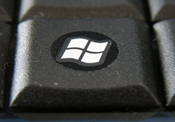
To turn on press and hold down the Windows key and the plus key and +

To change display mode, depending on operating system version, either press: Ctrl + Alt + M (this will cycle through the various display modes) or press…
Ctrl + Alt + F full screen mode
Ctrl + Alt + D docked mode
Ctrl + Alt + L lens mode

Ctrl + Alt + R resize lens
Ctrl + Alt + I invert colours

Windows key and + to increase magnification

Windows key and − to decrease magnification

Windows key and Esc to exit magnifier

