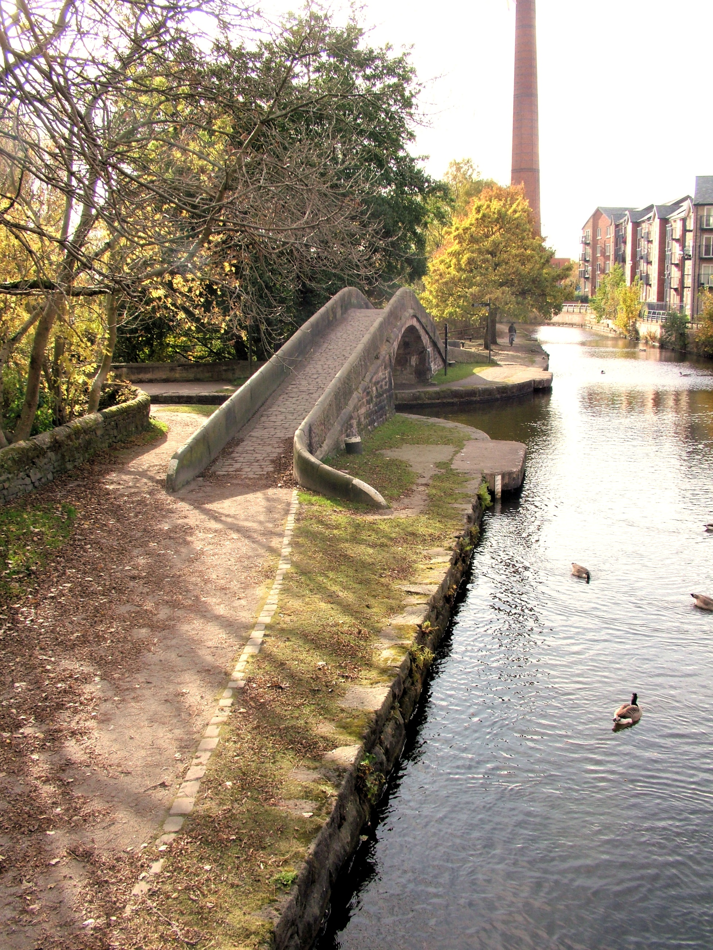

**FLOOD RISK MANAGEMENT STRATEGY**

**Foreword**

Flooding is a risk to all communities in our area and across the country. Homes and businesses could be flooded when heavy and prolonged rainfall exceeds the capacity of the drainage systems

.

The impact of flooding is not just a minor disruption. A flood can lead to long-term health problems. Properties that aren’t adapted can take months before they can be used again. The infrastructure we rely on for our daily lives – roads, power supplies, telecommunications etc – can be threatened leading to short and sometimes extended periods of disruption.

That is why we need to make sure we not only have appropriate and well maintained flood defences but also make emergency plans for extreme flood events. We also need to make sure our borough is as resilient as it can be.

A lot of good work is being done regionally to improve resilience. A range of agencies are working together to provide a seamless response to floods. But no matter what we do, there is always a risk of being overwhelmed by an extreme event. Climate change will increase the risk of extreme flooding.

Although Tameside hasn’t suffered to the same extent as some other parts of the country, we cannot be complacent. During the last few years, all will be aware of serious problems encountered by individual families, communities and businesses resulting from incidents of localised flooding. It is important that all agencies continue to work in partnership, with the communities affected, to ensure we reduce the risks associated with flooding.

Therefore, I welcome this Local Flood Risk Strategy which provides information for everyone on the approach the Council and other partner agencies will take in managing flood risk in the borough.



Councillor Allison Gwynne

Executive Member (Clean & Green)

Glossary – 1 Acronyms / Initials

|  |  |
| --- | --- |
| AGMA | Association of Greater Manchester Authorities |
| CFMP | Catchment Flood Management Plan |
| Defra | Department for Environment, Food and Rural Affairs |
| DG5 | Directive General 5 |
| EA | Environment Agency |
| FCERM | Flood and coastal erosion risk management |
| FDiGA | Flood Defence Grant in Aid |
| FRMP | Flood Risk Management Plan |
| GIS | Geographic Information System |
| GMCCRU | Greater Manchester Civil Contingencies and Resilience Unit. |
| IDB | Internal drainage board. There are none of these in Tameside |
| LLFA | Lead Local Flood Authority |
| LP | Local Plan |
| MTP | Medium Term Plan |
| NPPF | National Planning Policy Framework |
| OFWAT | Office of Water Services -  The Water Services Regulation Authority is the economic regulator of the water and sewerage sectors in England and Wales. |
| PFRA | Preliminary Flood Risk Assessment |
| RBMP | River Basin Management Plans |
| RFCC | Regional Flood and Coastal Committee |
| RMA | Risk Management Authority |
| SFRA | Strategic Flood Risk Assessment |
| SuDS | Sustainable drainage systems |
| SWMP | Surface Water Management Plan |
| UKCP09 | United Kingdom Climate Projections 2009 |
| UU | United Utilities (the local sewerage undertaker) |

**Glossary – 2 General**

|  |  |
| --- | --- |
| Assets | Structures, or a system of structures used to provide drainage infrastructure and / or manage flood risk |
| Aquifer | A body of rock that holds or transmits groundwater |
| Catchment | An area that supplies a river with water (rainwater, snow etc.) – the area of land where the rainfall drains to a single watercourse |
| Catchment Flood Management Plan | A document produced by the Environment Agency which sets out how flood risk should be managed within a river catchment |
| Climate change | A change in the statistical distribution of weather patterns when that change lasts for an extended period of time |
| Critical infrastructure | Installations such as national grid sub-stations, hospitals, water infrastructure, key transport infrastructure and hazardous sites, whose failure in service would have widespread impacts |
| Culvert | A covered channel or pipe to direct the flow of water |
| Defences | A structure that is used to reduce the probability of floodwater affecting a particular area (for example a raised embankment) |
| Directive General 5 | DG5 is a level of service indicator used by OFWAT to measure the performance of water companies. For a property to be listed on the DG5 Register it must have suffered internal flooding at least once in the past 10 years with incapacity in the public sewers being the cause |
| Emissions Scenario | Projection of possible levels of greenhouse gas emissions throughout the twenty-first century (low, medium and high) used by UKCP09 |
| Flood | The temporary covering by water of land not normally covered with water |
| Flood Defence Grant  in Aid | Funding made available (subject to approved) by the Environment Agency for reducing flood risk |
| Flood Risk Management Plan | Document required by December 2015 in order to comply with EU Directive |
| Fluvial Flooding | Flooding from overflowing rivers and streams |
| Groundwater | Water that is in the ground, this is usually referring to water in the saturated zone below the water table |
| Groundwater  flooding | Flooding which occurs as a result of groundwater rising above the surface. |
| Lead local flood  authority | An upper tier local authority with particular responsibilities under the Flood and Water Management Act 2010 |
| Main River | A watercourse shown as such on the Main River Map, and for which the Environment Agency has responsibilities and powers |
| Medium Term Plan | Table used by the Environment Agency to indicate investment needs, compiled based on submissions by risk management authorities |
| Ordinary watercourse | A watercourse that does not form part of a main river |
| Pluvial Flooding | Flooding from rainfall |
| Preliminary Flood  Risk Assessment | Document required to comply with European Floods Directive |
| Public sewer | A sewer which is the responsibility of a sewerage undertaker. Within the Tameside area, this is United Utilities |
| Receptor | Something that may be harmed by flooding such as people, property, infrastructure or key services |
| Recovery | The process of rebuilding, restoring and rehabilitating the community after an incident such as a flood |
| Regional Flood and Coastal Committee | Environment Agency committee responsible for making decisions at a regional level |
| Reservoir | A natural or artificial lake where water is collected and stored until needed. Some reservoirs in areas such as Tameside were initially built for industry and are no longer serving their original purpose but may have other benefits such as amenity or nature conservation |
| Resilience | The ability of the community, services, area or infrastructure to avoid being flooded or lost to erosion, or to withstand the consequences of flooding or erosion taking place |
| Return Period | An estimate of the average interval of time between a rainfall event of a certain intensity or size. |
| Risk | The significance of a potential event in terms of likelihood and Consequences |
| Risk Management  Authorities | Organisations that have a key role in flood and coastal erosion risk management as defined by the Flood and Water Management Act (2010). These are the Environment Agency, lead local flood authorities, district councils where there is no unitary authority, internal drainage boards, water companies, and highways authorities. |
| River flooding | Occurs when the water level in a channel overwhelms the capacity of the channel |
| Sewer Flooding | Flooding caused by wastewater discharge from sewers |
| Strategic Flood Risk  Assessment | Planning document which looks at the probability of flooding and the level of risk taking into account development and likely future development |
| Standard of  protection | The flood event return period above which significant damage and possible failure of the flood defences could occur. |
| Surface water  flooding | Flooding from rainwater (including snow and other precipitation) which has not entered a watercourse, drainage system or public sewer |
| Surface Water  Management Plan | A plan for managing the component of pluvial flooding directly caused by extreme rainfall or sewerage |
| Sustainable Drainage  Systems | An approach which makes use of different techniques in order to replicate the natural drainage of a site. |
| Watercourse | Rivers, streams and all ditches, drains, cuts, culverts, dikes, sluices, sewers (other than public sewers within the meaning of the Water Industry Act 1991) and passages, through which water flows |

**1. Tameside Flood Risk Management Strategy**

**1.1 Introduction**

1.1.1 The Local Flood Risk Management Strategy (or “local strategy”) will provide a framework for the effective management of local flood risk. It meets the requirement under Section 9, The Flood and Water Management Act 2010 for Tameside MBC, as the local Lead Local Flood Authority (LLFA), to produce a strategy for managing flood risk.

The purpose of the local strategy is to:

* Form the evidence base for flood risk management decisions
* Provide a framework within which communities are supported in becoming better informed about flood risk issues and can have a say in local flood risk management

• Set objectives for the management of local flood risk

• Co-ordinate flood risk management activity at a local level

1.1.2 This document does not duplicate the flood response to serious, major and mass incidents where the Tameside MBC emergency response plan is activated, nor does it deal with the recovery from major incidents for which there is a generic recovery plan held by the Greater Manchester Civil Contingencies and Resilience Unit.

This strategy will provide information on the council’s response to local flooding incidents and links to local and regional plans.

**1.2 Background**

1.2.1 Flooding is a natural event and an environmental risk that we need to understand so appropriate steps can be taken to manage the potential impacts. There is often an assumption that local authorities and other agencies are “responsible” for dealing with all things relating to flooding, and that individuals or their communities have no role to play outside the immediate period of flood events. However, whilst the authorities may have a role to play in management of flood risk, they cannot “solve” flooding; people need to be encouraged and supported to play an active role in managing their own flood risk as individuals and within communities.

1.2.2 Tameside’s Flood Risk Management Strategy addresses flood risk in the administrative area of Tameside MBC. The area covers approximately 40 square miles; it is part of Greater Manchester and is within the river catchment areas of the Irwell and Upper Mersey. This area is shown edged red in Figure 1 below.

**Figure 1 Tameside, Greater Manchester**

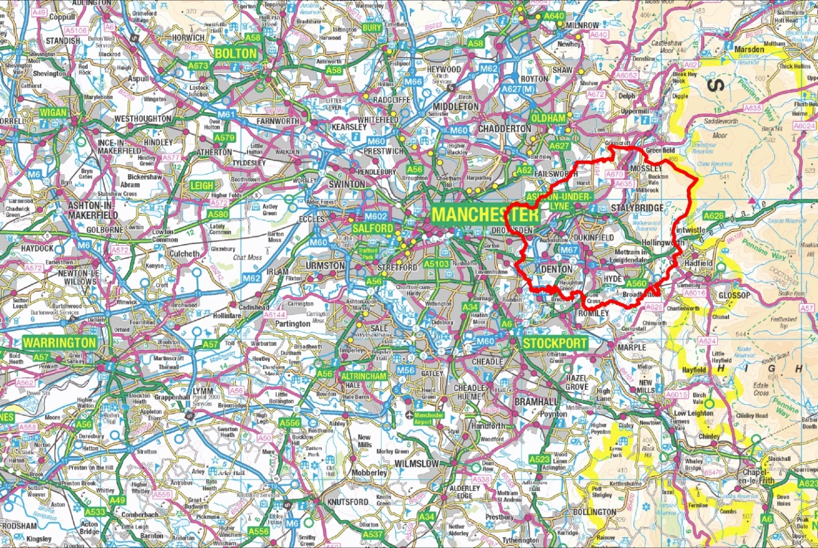

**Figure 2 Tameside Watercourses and Flood Zones**

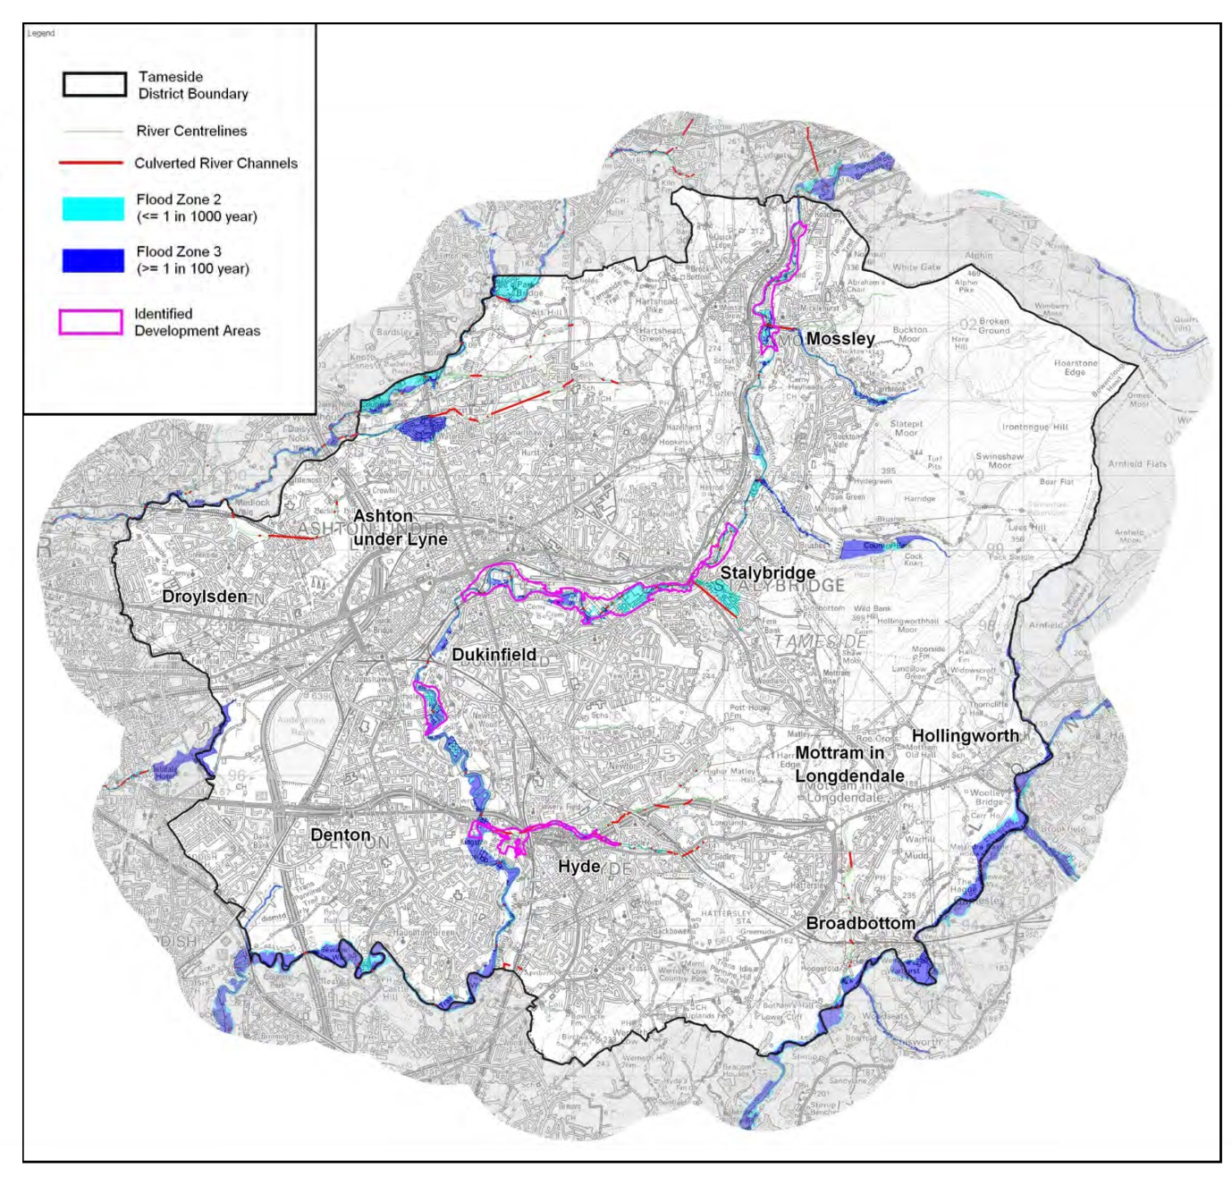

**1.3 National context for local strategies**

1.3.1 The Flood and Water Management Act 2010 provides legislation for the management of risks associated with flooding. The Act reinforces the need to manage flooding in a coordinated and sustainable manner. It places a number of new roles and responsibilities on local authorities, which are designated a ‘Lead Local Flood Authority’ (LLFA). The preparation of this Local Flood Risk Management Strategy is just one of the duties placed upon the council.

**1.4 Risk Management Authorities & their functions**

1.4.1 In addition to designating Lead Local Flood Authorities, The Flood and Water Management Act 2010 identifies certain organisations as ‘Risk Management Authorities’ (RMAs) which have specified responsibilities, duties and powers related to local flood risk management.

Some responsibilities are new and others were set out in previous legislation. Table 1 sets out the risk management authorities in Tameside.

1.4.2 Flood risk management is the responsibility of everyone, not solely the organisations identified by The Flood and Water Management Act. No single body has the means to reduce all flood risk alone. Effective management will involve various bodies each with a range of relevant duties and powers. The more that these organisations can work in partnership with the community, the more effectively they will be able to manage flood risk.

**Table 1 Flood Risk Management Authorities in Tameside**

|  |  |  |
| --- | --- | --- |
| **Role in FWMA** | **Risk Management Authorities in Tameside** | **Area of Responsibility** |
| The Environment Agency | The Environment Agency (Greater Manchester Merseyside and Cheshire) | Flooding from main rivers |
| Lead Local Flood Authorities | Tameside MBC | Council Flooding from ordinary watercourses, surface water or groundwater |
| Water (and Sewerage) Companies | United Utilities | Flooding from water supply, surface and foul or combined sewers |
| Highway Authority | Tameside MBC | Providing and managing highway drainage and roadside ditches |

1.4.3 Table 2 sets out those organisations that are seen to be key stakeholders in the local strategy but are not formal risk management authorities. We will engage with these organisations formally by consulting them directly on this draft strategy and will work with them as necessary in relation to the infrastructure they provide.

**Table 2 Key local flood risk management infrastructure stakeholders in Tameside**

|  |  |
| --- | --- |
| **Infrastructure** | **Organisation** |
| Electricity distribution network, sub stations, ground level transformers etc. | National Grid / Electricity North West |
| Gas pipelines and associated pumping stations | Transco |
| Various rail lines and stations | Network Rail |
| Tramlines and stops | Metrolink |
| Canals | Canal & River Trust |
| Motorways and trunk roads | Highways Agency |
| Social Housing | New Charter Housing Association etc |

**1.5 National Strategy**

1.5.1 As the risk management authority responsible for ensuring the management of the risk of flooding from main rivers and the sea, the Environment Agency is required to produce and maintain a national strategy for flood and coastal erosion risk management in England.

Tameside’s local strategy needs to be consistent with the national strategy. In addition, the council works closely with the Environment Agency to address issues of flood risk within the borough, particularly the risk from the Rivers Medlock and Tame.

1.5.2 The National Strategy sets out a national framework for managing the risk of flooding and coastal erosion. It aims to help risk management authorities and communities understand their different roles and responsibilities and will be particularly relevant to Lead Local Flood Authorities (LLFAs) which have new responsibilities under the Flood and Water Management Act (2010). It addresses all forms of flooding and coastal erosion consistent with the definitions in the Act. More information on the national strategy, including its aims and objectives, can be found in Section 2.

**1.6 Structure**

1.6.1 This strategy sets out our aims and objectives for managing local flood risk (Section 2) before summarising flood risk in Tameside (Section 3). Section 4 sets out the Council’s approach to local flood risk management and Section 5 provides information about the response to flooding incidents and issues around flood resilience. Section 6 indicates how this strategy will be monitored and reviewed.

Please refer to the Action Plan in Section 8, Table 7 for details of the measures to be taken to implement the strategy and achieve the objectives.

**2. Context and Objectives**

2.1 The objectives for the local strategy need to take into account the strategic aims and objectives of the national strategy. The overall aim of the national strategy is to ensure the risk of flooding and coastal erosion is properly managed by using the full range of options in a co-ordinated way. Its objectives are;

**Strategic Aims and Objectives of National Strategy;**

i. Communities, individuals, voluntary groups and private and public sector organisations will work together to:

• manage the risk to people and their property;

• facilitate decision-making and action at the appropriate level - individual, community, or local authority, river catchment, coastal cell or national;

• achieve environmental, social and economic benefits, consistent with the principles of sustainable development.

ii. Government will work with individuals, communities and organisations to reduce the threat of flooding and coastal erosion by:

• understanding the risks of flooding and coastal erosion, working together to put in place long-term plans to manage these risks and making sure that other plans take account of them;

• avoiding inappropriate development in areas of flood and coastal erosion risk and being careful to manage land elsewhere to avoid increasing risks;

• building, maintaining and improving flood and coastal erosion management infrastructure and systems to reduce the likelihood of harm to people and damage to the economy, environment and society;

• increasing public awareness of the risk that remains and engaging with people at risk to encourage them to take action to manage the risks that they face and to make their property more resilient;

* improving the detection, forecasting and issue of warnings of flooding, planning for and co-ordinating a rapid response to flood emergencies and promoting faster recovery from flooding.

2.2 The aims and objectives of the local strategy also need to take account of Tameside Council’s wider priorities, which are set out in our Corporate Plan. The Plan is structured around three themes;

* Supporting economic growth and opportunity
* Increasing self-sufficiency and resilience of individuals and families
* Protect the most vulnerable.

**2.3 Tameside’s Aims for Local Flood Risk Management**

2.3.1 The aims for managing local flood risk in Tameside are:

**i. Knowing when and where it will flood**

* We will aim to improve knowledge of when and where it will flood and the roles of different agencies and the wider community.

**ii, Improved planning and reducing the risk of flooding and its impact**

* Recognising that flooding is a natural event that will occur despite all efforts to prevent it, we aim to minimise the impacts of flooding, in terms of both disruption and financial impact.
* We will aim to achieve environmental, social and economic benefits from flood risk management, consistent with the principles of sustainable development and taking into account the impact of climate change.

**iii. Dealing with flooding incidents and the aftermath**

* We aim to ensure that when the worst happens, residents are cared for and supported appropriately and that Tameside can recover as quickly as possible from flood events.

**2.4 Tameside’s Objectives for Local Flood Risk Management**

2.4.1 The objectives for managing local flood risk are;

**i. Knowing when and where it will flood**

* To build up and maintain a detailed evidence base for local flood risk that is fit for purpose and proportionate.
* To ensure that householders and businesses understand the flood risk that affects them, and their responsibilities in protecting their properties.
* To facilitate effective partnership working within a co-operative community, maximising the benefits of resources invested in flood risk management.
* To work with partners to enable citizens and responders to have the most reliable warnings about potential flooding.

**ii. Improved planning and reducing the risk of flooding and its impact**

* To secure effective funding for flood defence works and ensure that the best use is made of financial resources available for flood risk management.
* To undertake works which will reduce flood risk to residents and businesses
* To ensure that, in a growing borough, new development is not at an unacceptable risk of flooding, does not materially increase the risk of flooding elsewhere, and where possible reduces flood risk
* To maximise the take-up of flood insurance by residents and businesses
* To manage the increased flood risk as a result of climate change in a sustainable way
* To require well designed Sustainable Urban Drainage Systems (SUDS) where appropriate in new development and promote retrofitting of SUDS in existing development.

**iii. Dealing with flooding incidents and the aftermath**

* To respond appropriately to flood events, recognising that response should be proportionate to the scale of the incident and that, in the event of a major incident, other agencies will lead the response
* To ensure that we are a resilient borough and can recover quickly from flood events, minimising the disruption flooding causes

2.4.2 These objectives are considered to be proportionate to the risk in Tameside and suitable to meet local needs. They take into account the local risks outlined in Section 3 and the wider context set out above.

2.4.3 The objectives will influence our approach to the new duties and how projects will be prioritised and reviewed..

2.4.4 Measures to achieve the local flood risk objectives will also contribute to meeting wider environmental objectives such as improving water quality and increasing health and wellbeing. Effective partnership working is likely to be particularly important in this regard.

2.4.5 It will be important to protect important natural assets such as European protected sites during the planning and implementation of flood defence measures.

**3. Knowing When and Where it may Flood**

3.1.0 Risks arise from a variety of sources of flooding which are known to interact with each other. The main sources of flood risk include rivers, canals, surface water and groundwater. The effects of all types of flooding are expected to increase as a result of climate change

3.1.1 Information regarding the flood mechanisms which affect Tameside is available in a number of plans and assessments. These are shown in Table 3. More details on the information on flood risk summarised within this section can be found within these documents, particularly the Strategic Flood Risk Assessment (required for land use planning purposes) and the Preliminary Flood Risk Assessment (required under The Flood Risk Regulations 2009).

3.1.2 In addition, the Environment Agency has produced Catchment Flood Management Plans (CFMP) which provide an overview of the flood risk across catchments and recommend actions to be taken to manage flood risk over the next 50 to 100 years. These were published in 2008 and some of the actions are now a little out of date. It is anticipated that in future the relevant actions from CFMPs will be collated along with actions from all Local Flood Risk Management Strategies and transferred to Flood Risk Management Plans.

3.1.3 In recent years the Environment Agency has been undertaking considerable planning work, which will lead to the publication of Flood Risk Management Plans (FRMPs). FRMPs identify the risk from flooding and set out objectives and measures for managing that risk. In so doing, they aggregate information about all sources of flooding - and coastal erosion where appropriate - to better inform prioritisation, decision making and work programming.

**Table 3 Recent Flood Risk Studies and Strategies in Tameside**

|  |  |  |  |
| --- | --- | --- | --- |
| **Title** | **Date** | **Produced By** | **Purpose** |
| Greater Manchester  Strategic Flood Risk  Assessment | 2008 | Scott Wilson for AGMA | To provide information on flood risk across Greater Manchester to inform planning decisions |
| Mersey Estuary  Catchment Flood  Management Plan | 2008 | Environment Agency | To guide strategic management of fluvial flood risk within the Mersey Estuary catchment |
| Surface Water  Management Plan | 2013 | JBA for AGMA | To provide information on flood risk from  surface water and sewers |
| Tameside Preliminary Flood  Risk Assessment | 2011 | JBA | A screening exercise under the 2009 Flood Risk Regulations |
| Tameside Strategic Flood Risk Assessment | 2015 | TMBC | Provide a framework for the effective management of local flood risk. |

3.2 **Greater Manchester Flood Risk**

3.2.1 The Greater Manchester sub-region consists of a complex hydrological network that interlinks all of the ten districts and has a complex mix of varying and interlinked flood sources and associated risks.

Figure 4 shows the surface (fluvial) connections between districts.

**Figure 4 Hydrological connections with other districts**

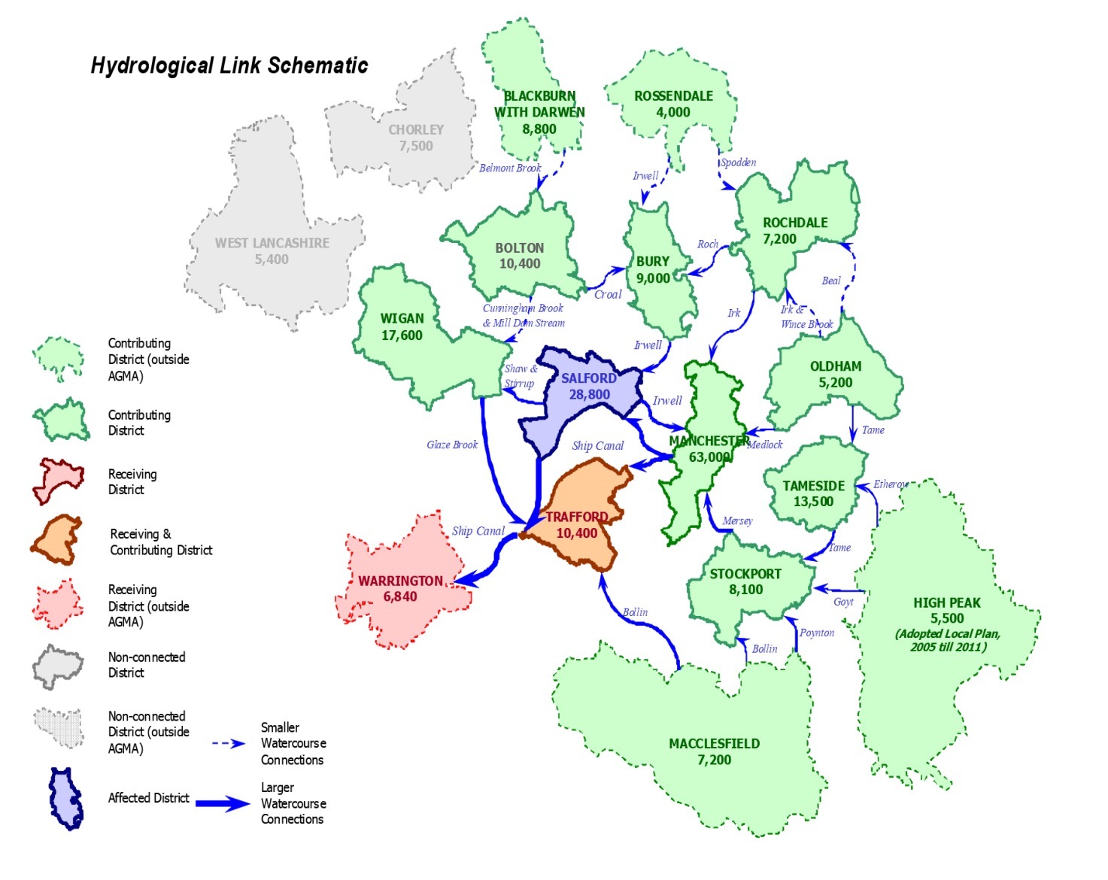

3.2.1 The Irwell and Mersey catchments dominate the sub-region, accounting for 78% of the total catchment area. Glaze Brook, the River Bollin, Sinderland Brook and the River Douglas make up the remainder of the river catchments in Greater Manchester with all, apart from the River Douglas, draining into the Manchester Ship Canal.

3.2.2 During high intensity rainfall events, the topography of Greater Manchester exacerbates surface water flood risk due to overland flow from higher ground ‘ponding’ in low-lying areas of land. In more urbanised areas, the flooding extents and depths can be greater due to the presence of buildings, infrastructure, poor permeability and the underlying drainage system.

3.2.3 Known problem locations are often associated with culverts along ordinary watercourses, which can become blocked or exceeded during large rainfall events. In some areas, this type of flooding may present a more significant risk than other sources of flooding, including that from rivers.

**3.3 Knowing When and Where it will Flood**

Figure 5 below illustrates the range of different types of flooding incidents across the different months of the year, based on historical data supplied by local authorities for the 2008 Greater Manchester Strategic Flood Risk Assessment.

**Figure 5 Historical Flooding in Greater Manchester**

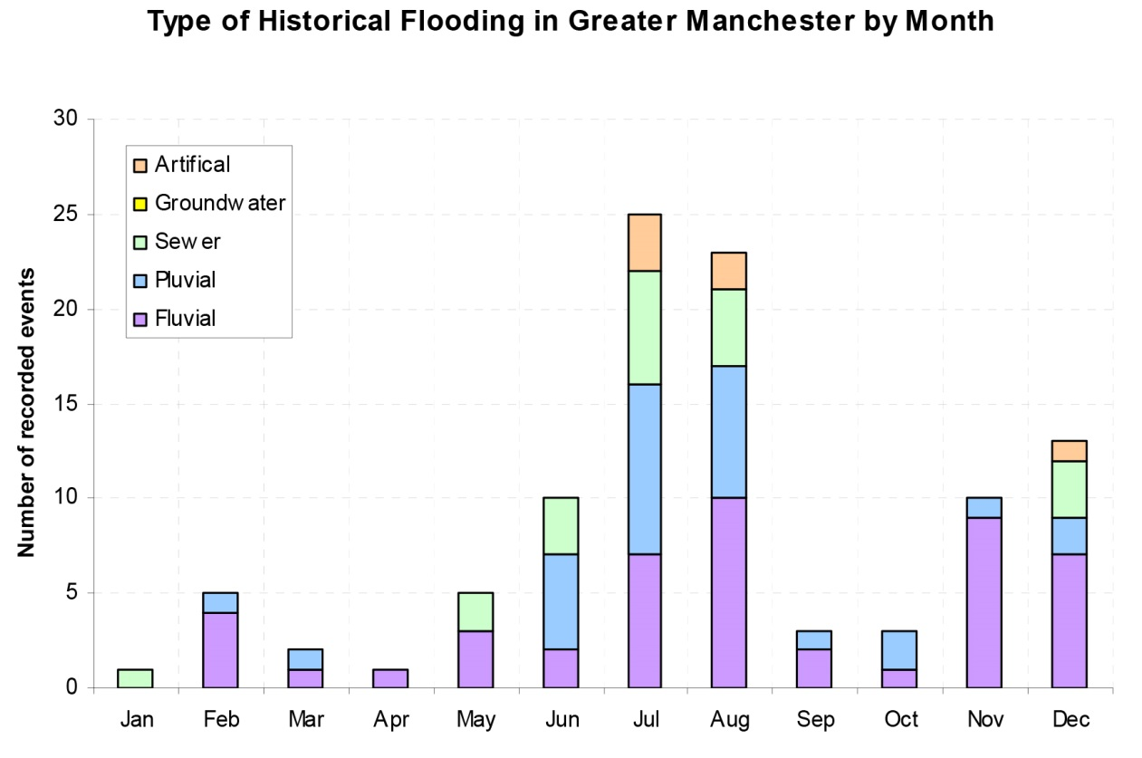

**3.4 Different Types of Flood Risk**

**3.4.1 Surface Water Flooding**

Surface water flooding is caused by overland flow during periods of sustained or heavy rainfall. Water ponds where it becomes obstructed or collects in low lying areas and local drainage capacity is unable to cope with the volume of water experienced. The risk of surface water flooding increases as the amount of urban area and area of impermeable hard surfacing increases.

3.4.1.1 The Greater Manchester Surface Water Management Plan (SWMP) was published in February 2013. This was commissioned by all 10 Greater Manchester councils and funded by government grant. See Figure 6 for the extent of surface water flooding as modelled by the surface water management plan.

3.4.1.2 The Environment Agency published an updated Flood Map for Surface Water in December 2013, which has superseded the surface water management plan as the best available information on surface water flooding. The main difference is that the national information includes modelled flooding outlines and depths for a 1 in 1000 year flood whereas the most extreme flood modelled for the surface water management plan is the 1 in 200 year event with an added allowance for climate change.

**Figure 6 TAMESIDE - SURFACE WATER FLOODING PLAN**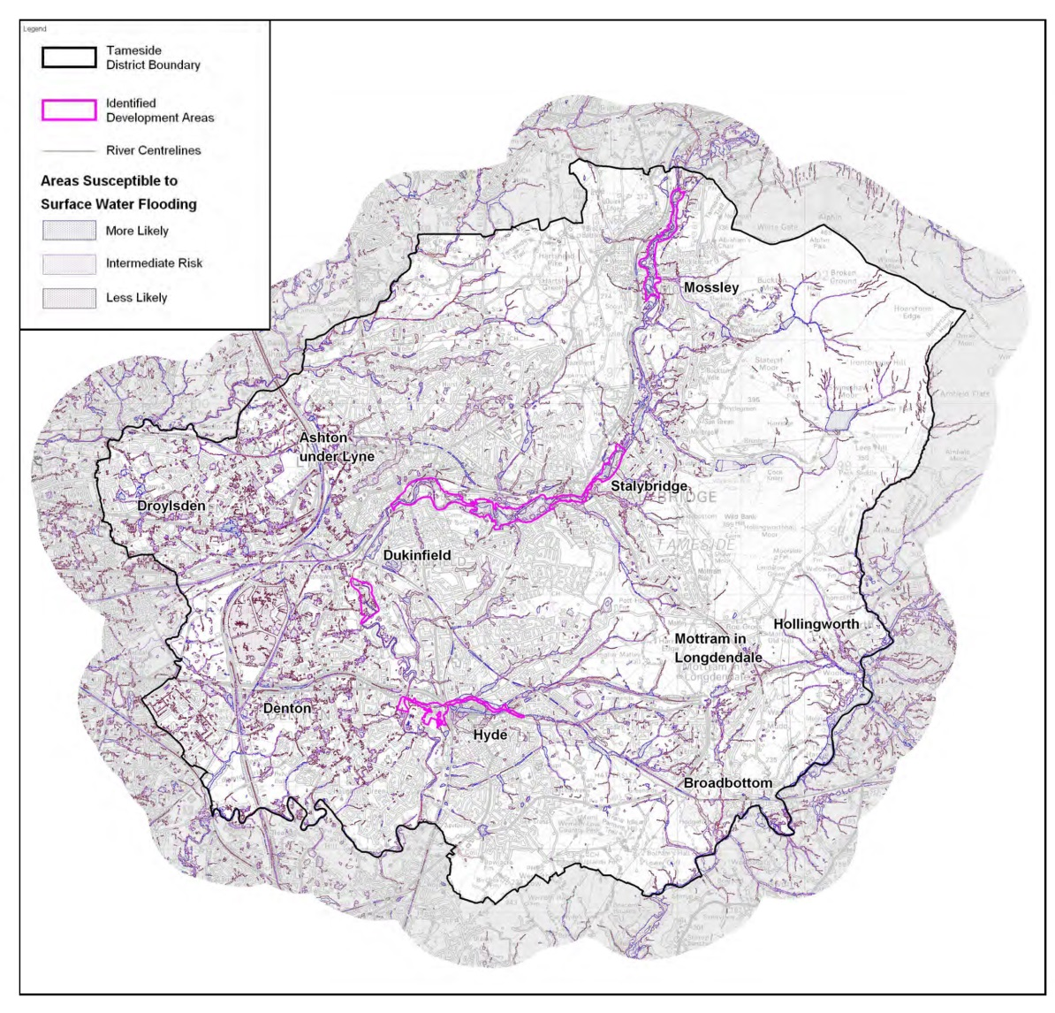

**3.4.2 Groundwater Flooding**

Groundwater flooding occurs when water normally held underground rises to a level where it breaks the surface in areas away from usual channels and drainage pathways. It is generally a result of exceptional extended periods of heavy rain, but can also occur as a result of reduced abstraction, underground leaks or the displacement of underground flows. Once groundwater flooding has occurred, it tends to be more persistent than other sources of flooding and can typically last for weeks or months.

3.4.2.1 The most extensive area on Figure 7 is “shallow groundwater”, which is where the water table is present near the surface. This does not necessarily mean that there is an expectation that the water table will rise above the surface, particularly as the aquifers generally have relatively small fluctuations in groundwater level. However, there is the potential for localised groundwater flooding (for example of basements) in these areas.

3.4.2.2 The second area is “areas at risk of groundwater flooding”. These are areas where the watertable is expected to fluctuate as rivers rise and fall, and there is a risk that the water table will rise above the surface, causing groundwater flooding.

3.4.2.3 Groundwater flooding is traditionally difficult to resolve and requires the installation of expensive land drainage systems that require a positively drained outlet. The Environment Agency and Local Government Association have produced a document which advises those suffering from groundwater flooding which can be found on the Local Government Association website.

**Figure 6 TAMESIDE – GROUNDWATER FLOODING**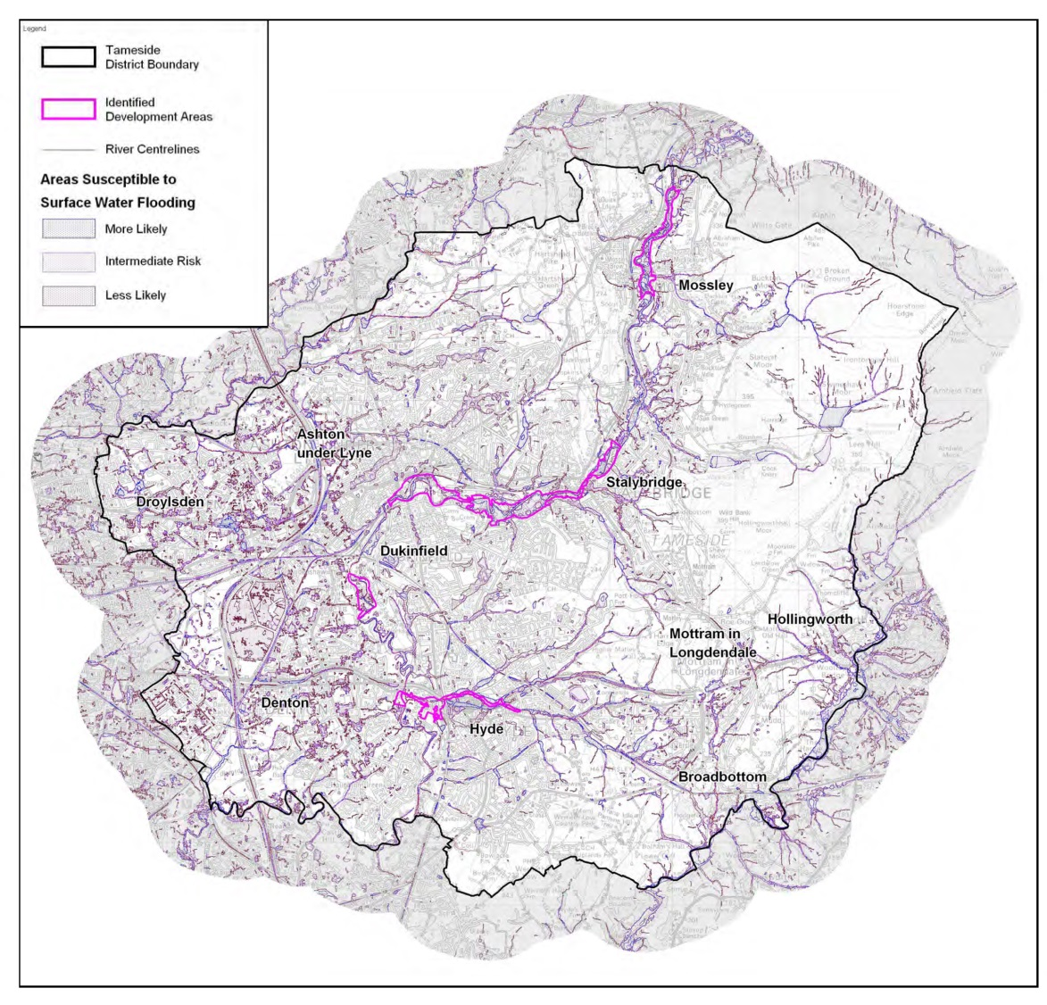

**3.4.3 River flooding – main rivers**

Large rivers are watercourses which have been designated as ‘main rivers’ on the maps held by the Environment Agency. They are often large water courses which pose the greatest flood risk. The Environment Agency has responsibility for leading on the management of flood risk from main rivers.

3.4.3.1 The main rivers in Tameside are River Tame, Etherow, and Medlock, these total approximately 50km in length. The main river which affects the greatest number of properties is the River Tame with properties in Mossley, Stalybridge, Ashton-under-Lyne, Dukinfield, Hyde and Denton potentially at risk. The Environment Agency is currently working on the ‘Tame Strategy’ to help further understand influences and potential mitigation along the Tame catchment in Oldham, Tameside and Stockport.

**3.4.4 River flooding - ordinary watercourses**

An ordinary watercourse is any watercourse which does not form part of the main river network (see Glossary for a full definition). Ordinary watercourses usually fall under the responsibility of the landowner and can be in the form of a ditch, stream, channel or piped watercourse. The most common causes of flooding from ordinary watercourses is when the capacity of a watercourse is exceeded or if an obstruction to flow occurs. Within Tameside there are approximately 200km of ordinary watercourses.

3.4.4.1 Victorian times many watercourses in industrial areas were culverted and the location of these “hidden” watercourses is not necessarily known.

3.4.4.2 The Flood and Water Management Act 2010 has transferred regulatory powers for consenting and enforcement on ordinary watercourses to lead local flood authorities. The reason for this is to ensure that certain activities which may have an adverse effect on flooding are being regulated. The Council is now responsible for authorising works on or near to watercourses and to undertake enforcement action where appropriate. The council is in the process of publishing a Consenting Works Near Ordinary Watercourses policy. This policy will set out the application process and also enable the council to charge for this service. Consenting of works relating to main rivers is regulated by the Environment Agency using the same legislation.

**3.4.5 Canal Flooding**

The Flood and Water Management Act 2010 makes no reference to canals. Navigation authorities are mentioned within the Act but not as risk management authorities. Canal flooding is caused by overtopping or breach of the canal network. Within Tameside the canal network constitutes of sections of the Ashton Canal, Huddersfield Narrow Canal and the Peak Forest Canal. The canal network within Tameside is actively managed by the Canals and Rivers Trust. The Canal & River Trust is a charity and manages 2,000 miles of waterways in England and Wales.

**3.4.6 Sewer Flooding**

Within Tameside, the sewer network (pipes, manholes, pumping stations, Treatment works etc.) is managed by United Utilities (UU).

3.4.6.1 There are two key causes of flooding from the sewer network

* Flooding due to lack of capacity in the sewers
* Flooding due to obstruction of the sewer or breakdown of equipment such as pumping stations.

3.4.6.2 The network is made up of a combination of separate systems where foul sewage and surface water are carried away for disposal in separate pipes and combined systems where the sewer takes both foul flows and surface water run-off. Typically combined sewer systems are found in the older areas. Flooding due to lack of capacity arises because much of the sewer network in Tameside made up of combined sewers and thus there is a significant increase in flow in wet weather. Whilst the majority of the sewer network manages this additional flow well there are locations that are at risk of flooding due to under capacity. This risk has increased in some areas due to the spread of impermeable surfaces over the years. Where flooding is reported to UU and subsequent investigations prove it to be due to lack of capacity then the properties/areas affected are added to the UU Register. Wherever it is feasible to do so, UU can provide mitigation measures to reduce the likelihood of properties flooding using measures such as the fitting non-return valves.

3.4.6.2 The other main cause of flooding is blockage of the sewer network which can be caused by a number of factors such as fat, sanitary items, construction materials etc. These types of events are random in nature. However UU has a proactive programme to manage the risk of them occurring. Additionally, UU carries out some public education work to reduce their occurrence such as the “What not to flush” campaign. Details of this can be found at;

<http://www.unitedutilities.com/thinkbeforeyouflush.aspx>

**3.4.7 Highway Flooding**

Highway flooding is caused by surface water run-off not being collected by the highway drainage system. The most common cause of highway drainage flooding is blocked gullies or blocked/collapsed drains or sewers. Road gullies are generally connected to highway drains which receive water from the adopted highway. However there are situations where surface water gullies are connected to surface water and combined public sewers.

3.4.7.1 The consequences of highway flooding can be significant and can result, not only in disruption to communities, but also in an increased risk of accidents to road users. The council manages the risk of flooding to highways by ensuring that all highway drainage gullies are cleansed regularly. In areas known for excessive accumulations of debris and leaf-fall, additional visits are undertaken.

**3.4.8 Land Drainage Flooding**

From time to time we have to deal with a number of land drainage flooding incidents. The majority of these incidents relate to residents complaining of flooded gardens rather than internal property flooding. Some of these problems can be explained by existing groundwater problems but others may relate to a neglected watercourse (either open or piped). In these situations the council will assist by trying to identify the source of the problem and help to determine way to mitigate the issues identified.

**3.4.9 Reservoir Flooding**

Whilst water within reservoirs can be regulated, flood risk can arise and the most significant risk is from failure of a reservoir dam for example through a breach in the dam wall. Whilst the likelihood of such an event is low, the flooding consequences from such an event could be significant. There are 56 top tier reservoirs located in and around Greater Manchester which could potentially flow into the conurbation in a flood event such as a breach of the dam. As a result, a series of off-site plans have been developed through the AGMA Civil Contingencies and Resilience Unit to ensure an appropriate response is put in place for managing such risk. The majority of the reservoirs in and around Tameside are monitor and managed by United Unities as required to ensure their structural integrity and safety.

3.4.9.1 The Environment Agency has produced and published online reservoir maps which show the largest area that might be flooded if a reservoir that holds over 25,000 cubic metres of water was to fail. For Tameside, these areas are, in the main, associated with river catchments and in the areas bordering the Audenshaw reservoir complex. Details can be viewed at;

<http://watermaps.environment-agency.gov.uk/wiyby/wiyby.aspx?topic=reservoir#x=394983&y=395576&scale=7>

**3.4.10 Summary of Flood Risk**

Table 4 below summarises the number of properties at risk of flooding.

**Table 4**

|  |  |  |
| --- | --- | --- |
| **Type of Flooding** | **Properties at risk in**  **Greater Manchester** | **Properties at risk in Tameside** |
| Flooding from rivers (including Manchester  Ship Canal) in an extreme  (1 in 1000 year) event | 50,000 | TBC |
| Surface water flooding in a 1 in 200 year event | 30,000 | 4,900 |

**3.4.10.1 Climate Change Implications**

Changes in Climate can affect local flood risk in several ways but impacts will depend on local circumstances. Wetter winters and more intense rainfall may increase river flooding. Also, more intense rainfall causes greater surface runoff, increasing localised flooding and erosion. This in turn may increase pressure on drains, sewers and water quality.

Climate projections for Greater Manchester suggest that annual precipitation is expected to increase slightly by the 2050s. Winter precipitation, however, is likely to increase significantly, with the most likely estimate being a 14% increase. Of greatest significance for flooding is the expected increase in extreme rainfall. It is estimated that there will be an 11% increase in rainfall on the wettest day in winter. Summer precipitation is expected to decrease overall, but the wettest day in summer is expected to have similar amounts of rainfall to the baseline period, so flash flooding in summer is likely to continue to be an issue.

Some flood models have an allowance for climate change built into them. These model what difference a particular percentage increase in river flow or overland flow would make to flood risk.

**Impact of climate change on surface water flooding**

As an example of the impacts of climate change on flooding, Table 3.3 below compares the numbers of properties that would be risk in a 1 in 200 year flood with the number that would be at risk in a flood of this frequency once climate change is taken into account.

The table shows that the number of properties at risk is significantly increased, particularly in terms of those that are affected by deeper water.

**Table 5 Impact of Climate Change on Surface Water Flooding**

|  |  |  |
| --- | --- | --- |
|  | Number of residential properties  (depths of 0.1m or greater) | Number of residential properties  (depths of 0.3m or greater) |
| 1 in 200 year | 7,713 | 1,439 |
| 1 in 200 year plus  climate change | 10,817 | 8,860 |

**3.4.11 Communicating Flood Risk**

Successful implementation of the local strategy objectives will require effective communication with residents and businesses, as well as with a wide range of external organisations. It is important that, as a lead local flood authority, Tameside MBC:

* Is clear about what we can and cannot achieve and ensure that both partner organisations and the wider community have realistic expectations.
* Establishes long-term relationships with stakeholders and communities which build a greater awareness of flood risk and help the council understand and respond to local concerns.

**Tameside’s Approach to the New Duties**

**4. Lead Local Flood Authority**

4.1.1 Following the publication of the Government’s response to the recommendations of the Pitt Review, which recommended that local authorities should lead on the management of local flood risk, consideration is being given to the establishment of a *Strategic Flood Forum* in order to bring together the different functions responsible for flooding at a strategic level; Strategic Planning, Emergency Planning, Asset Registers / Consenting, Operational Management etc.

4.1.2 The Association of Greater Manchester Authorities (AGMA) represents the ten local authorities in Greater Manchester which work together strategically, as many issues are not constrained by administrative boundaries and in order to help reduce duplication. In order to support the districts in meeting their flood risk management duties, appropriate AGMA governance arrangements have been established through the newly constituted North West Regional Flood and Coastal Committee (RFCC) and the Greater Manchester Flood and Water Management Board (see Annex 2).

4.1.3 In addition to the Risk Management Authorities there are a number of other key stakeholders with interests in infrastructure and service provision. This is discussed further in Section 2 of this document.

**4.2 Preliminary Flood Risk Assessment (PFRA)**

4.2.1 All Lead Local Flood Authorities (LLFA) are required to prepare a PFRA to meet the requirements of the 2009 Flood Risk regulations. The PFRA is a high level screening exercise to determine whether there is a local flood risk within the LLFA area based on historic and potential future flood risk. Local flood risk includes that arising from surface water, groundwater, ordinary watercourses and canals. It does not include flooding from main rivers as that is the responsibility of the Environment Agency under the regulations. The 2009 flood risk regulations were put in place by the government to ensure compliance with the EU Floods Directive.

The PFRA is a high level screening exercise to determine local flood risk within Tameside based on historic and potential future flood risk arising from surface water, groundwater, ordinary watercourses and canals.

Tameside’s Preliminary Flood Risk Assessment (PFRA) was approved by an Executive Decision on 31 August 2011. A copy of the full document and the covering Executive Decision can be viewed at;

<http://www.tameside.gov.uk/flooding/riskassessment>

4.2.1 The Environment Agency’s updated Flood Map for Surface Water acts as the Local Flood Risk Hazard Map and was published in December 2013. The requirement for a Local Flood Risk Management Plan will be met by the publication of the north-west Flood Risk Management Plan by the Environment Agency late 2015.

**4.3 New Duties under Flood & Water Management Act 2010**

Table 4.1 lists the new duties under the Flood and Water Management Act 2010 and indicates where more information on these duties and our approach to them can be found.

**Table 6 Key Duties of LLFA under FWMA 2010**

|  |  |  |  |
| --- | --- | --- | --- |
| **Section of Act** | **Duty** | **Duty Explained** | **LFRMS**  **Section** |
| **9** | **Local Flood Risk**  **Management**  **Strategy** | A lead local flood authority must develop, maintain, apply and monitor a strategy for local flood risk management in its area (a “local flood risk management strategy”). Including risk from surface water runoff, groundwater and ordinary watercourses. | **1** |
| **21** | **Development of an Asset Register** | Tameside, as the Lead Local Flood Authority are required to maintain a register of assets or features which are considered by us to have a significant impact on flood risk. A record of information for each recorded asset must be maintained. | **4** |
| **19** | **Investigation** | On becoming aware of a flood in its area, a lead local flood authority must, to the extent that it considers it necessary or appropriate, investigate.  • which risk management authorities have relevant flood risk management functions  • whether each of those risk management authorities has exercised, or is proposing to exercise, those functions in response to the flood. | **4** |
| **23 (Land**  **Drainage**  **Act)** | **Consenting and**  **Enforcement**  **of Ordinary**  **Watercourses** | Responsibility for regulating activities on ordinary watercourses in most areas transferred from the Environment Agency to lead local flood authorities. Please see section 23 of The Land Drainage Act for further details. | **4** |
| **30** | **Designation of**  **Assets** | Any structure or feature (natural or manmade) that, in the opinion of the designating authority, affects a flood or coastal erosion risk is eligible for designation. It is entirely for the relevant authority to decide what to designate. | **4** |
| **32** | **SuDS** | Duty live from 6th April 2015 and forms part of the planning application process.  Adoption / maintenance by LLFA unless otherwise determined. | **4** |
| **54** | **Overview and**  **Scrutiny** | An overview and scrutiny committee must be established to review and scrutinise the flood risk management functions of the LLFA and other risk management authorities as required. | **6** |
| **Byelaws** | **Byelaws** | Byelaws are not mandatory and there are no current plans to introduce new byelaws. . | Not  Covered |

**4.4 Asset Register**

4.4.1 Tameside’s asset register is comprised of a geographical information system (GIS). The register can be made available for viewing at council offices by appointment.

4.4.2 The register contains records of a number of assets under the responsibility of the council and other flood risk authorities which have a significant effect on flooding. Obtaining detailed records for all the assets will be a long process, with both time and funding required to ascertain ownership and condition of assets. Information which is available is recorded as a matter of course on the GIS system. Determining which assets are the most significant would assist with prioritising the gathering of data for the register.

**4.5 Designation**

4.5.1 Designating structures or features has the effect of limiting what alterations can be made without the designating authority’s prior consent. This does not affect the day-to-day operation of the asset, nor does it mean that it cannot ever be modified, merely that consent will be required to ensure that any work done does not increase flood risk. Only structures features which have an impact on flood risk can be designated.

4.5.2 Defra have published additional guidance on the designation process for Risk Management Authorities. This guidance advises that designation should be risk based and targeted where it is most appropriate. In particular, if the owner is aware of the flood risk management function served by their structure/feature and has appropriate systems in place to manage the risks, designation may not be appropriate.

4.5.3 A process for designating assets is currently being developed. Currently Tameside has not designated any assets as Flood Risk Structures. Where existing structures/features are identified that could have an effect on flood risk but have no existing flood risk classification, these features will be designated.

**4.6 Investigations**

4.6.1 AGMA has adopted a policy for undertaking investigations of flooding in accordance with Section 19 of the Flood and Water Management Act. This policy sets out criteria of when the results of an investigation will be published. Although the policy states that investigations only need to be published once five or more properties are flooded internally, in practice most incidents in Tameside are below that level. Investigations will also be undertaken for less serious incidents, including flooding to areas of environmental importance, but the investigation will be proportionate to the incident and may not be published.

4.6.2 It should be noted that all incidents of surface water flooding are recorded by Tameside MBC. However, only those incidents which are in the interest of the public or highlight important information will be published. A recording system is set up on the GIS system, linked to the asset register. Also the Highways Service receives many other (highway related) complaints and record these separately on the ‘Symology’ software system.

4.6.3 When undertaking an investigation in line with AGMA’s policy all relevant flood risk authorities will be consulted. Any investigation undertaken will be linked to the asset register in order to make the assessment of flood risk more transparent and open to relevant bodies such as risk management authorities and asset owners. It is not our intention to make this information available to the public except in instances where investigations are published under Section 19 of the FWMA.

**4.7 Consenting and Enforcing**

4.7.1 This area of work has been inherited from the Environment Agency. Historically there were very few applications for works to ordinary watercourses in Tameside. We have developed our own guidance note and application form which will be available online shortly.

**4.8 Sustainable Drainage Systems**

4.8.1 On 18th December 2014 Defra informed local authorities that the duty to ensure that sustainable drainage systems form part of developments and to ensure that a regime to maintain systems is in place would be live from 6th April 2015. This has become a local planning authority responsibility but the LLFA has become a statutory consultee. Nonstatutory technical standards have been published by Defra and changes to the National Planning Practice Guidance have also been published.

SuDS installed will be recorded in the Asset Register and adoption / maintenance is by LLFA unless otherwise determined.

4.8.2 These changes are less significant than what was originally proposed however they do provide additional tools for the authority as it continues its ongoing work to promote the appropriate use of SuDS in developments. We will continue to work with neighbouring authorities, the Environment Agency and other stakeholders in order to ensure a robust approach to drainage within the planning system.

**4.9 Funding for Flood Defence Works**

4.9.1 Each year risk management authorities (RMAs) are invited to submit details of proposed flood and coastal erosion flood management works which require funding for the next five years. The proposals are captured in a table known as the Medium Term Plan (MTP). The MTP from each region is combined onto one table to give an indication of investment needs across England.

4.9.2 Although proposals shown on the MTP should not be constrained by affordability, it is important that RMAs ensure the potential projects are deliverable in the time indicated and are economically, technically, environmentally and socially justifiable. Once all the submissions are received, the proposals from all RMAs, including the Environment Agency, are prioritised on the same basis to match available funding.

4.9.3 The yearly allocation of Flood Defence Grant in Aid is prioritised to ensure projects provide good value for money and achieve the Environment Agency’s corporate targets. For the 2013/14 allocation process, Defra’s Partnership Funding approach for prioritising capital schemes will be used. The allocations are made to all RMAs through the RFCCs; each RFCC has its own capital programme containing the allocations for all RMAs in its area.

**5. Flooding**

**5.1 Response to Flooding Incidents**

5.1.1 Flooding is one of the main risks to communities and businesses in Greater Manchester. The Association of Greater Manchester Authorities (AGMA) Civil Contingencies and Resilience Unit (CCRU) works with all Greater Manchester local authorities, emergency services and key partners such as the Environment Agency and United Utilities to ensure that organisations, people and places are well prepared for an event such as flooding and that appropriate response and recovery plans are in place. The CCRU maintain the Greater Manchester Community Risk Register which lists a range of flood events and key risks to Greater Manchester.

5.1.2 Duties on local authorities and other front line responders are set out in The Civil Contingencies Act 2004. Duties include co-operation and sharing data, risk assessment and maintaining public awareness to warn and inform communities during times of emergency.

Flood risk assessments such as those provided by the Environment Agency and other bodies are of vital important in helping to determine where risk is highest and the emergency plans that should be in place to manage and respond to that risk. The work carried out by the Environment Agency, LLFA and others to engage with communities raising awareness and increasing preparedness is also of great importance to ensure that wherever possible risk is reduced in communities and that communities are better prepared to respond to and recover from flooding.

5.1.3 A Multi Agency Flood Plan has been produced which sets out the response measures that will be activated in a flood risk emergency event including support for vulnerable people and the roles of key response organisations. Tameside MBC will work closely with the AGMA CCRU, Environment Agency and emergency services to ensure flood risk assessment data and reports of flood event investigations are shared effectively and will help to target communities and properties at significant risk of flooding.

5.1.4 Our response to flooding incidents is largely dependent on the cause of the flooding. It is expected that clean-up operations within properties will be undertaken by residents and their insurers. Investigations will be undertaken for all flooding incidents as noted in Section 4. The investigation will be proportionate to the type of flooding and in some cases will result in information being held on file rather than in direct action. Where flooding occurs as a result of defective highway drainage assets, works will be ordered to repair the asset or if improvement works are required a scheme will be prioritised within the Highway Service subject to available funds.

5.2 **Flood Warnings**

5.2.1 At present the Environment Agency operates a flood alert and flood warning service which covers Greater Manchester.

5.2.2 Up-to-date information can be assessed at;

<https://www.gov.uk/check-if-youre-at-risk-of-flooding>

**5.3 Flood Insurance**

5.3.1 Flood insurance can be expensive and possibly also difficult to obtain for some residents. The government is working with the insurance industry to put a scheme in place to help provide affordable flood insurance. The high levels of deprivation in some parts of the borough may make the cost of flood insurance an obstacle for some people.

5.3,2 In June 2013 the Association of British Insurers (ABI) and the Government agreed a Memorandum of Understanding (MoU) on how to develop a not-for-profit scheme, known as “Flood Re”, that would ensure flood insurance remains widely affordable and available. It will provide a fund to enable insurers to pass the flood risk element of home insurance (buildings and contents) at a premium that will be capped depending on the property’s Council Tax band. Flood Re will not set premium rates. Insurers will pass into Flood Re those high flood risk homes they feel unable to insure themselves, retaining the non-flood risks such as fire, theft and subsidence.

5.3.3 The council will work to promote the take up of flood insurance, and staff who work directly with vulnerable residents will be made aware of the issues and able to signpost residents to more information.

**5.4 Flood Resilience**

5.4.1 It will never be possible to remove all risk of flooding, and therefore it is important that buildings and communities in flood risk areas are resilient to flooding. Flood resilience can be about the materials used in a building, so that if it does flood it can be dried out and reoccupied more quickly and easily. Resilience can also be about less tangible things, such as people looking out for each other and assisting the more vulnerable members of the community, who for example might need help to evacuate or to deploy flood gates on their property.

5.4.2 The Catchment Flood Management Plans which the area include actions to investigate appropriate methods to provide protection or resilience to key infrastructure such as the wastewater, electricity and transport networks, with a view to relocating such infrastructure away from flood risk areas in the longer term. The council will support infrastructure providers in undertaking this work.

**5.5 Recovery after a Flood**

5.5.1 If there is a major flood then it will take a significant amount of time to clean up afterwards and some properties may need to remain unoccupied for several months. The Civil Contingencies and Resilience Unit hold a generic recovery plan, because the issues around recovery are similar regardless of the type of incident. This plan would be activated in the event of a major flood and all the relevant functions of the council would play their part in the recovery effort.

**6. Monitoring and review**

**6.1 Updating**

6.1.1 Progress against this strategy and the action plan will be reviewed regularly. Progress updates will be published on the council’s website, at least annually. The list of measures will be kept under review and updated as necessary.

6.1.2 Any need for a wider review of the strategy will be identified through discussions at the Strategic level within the council.

**7. Governance**

**7.1 Regionally**

**7.1.1 Greater Manchester**

The Greater Manchester authorities and AGMA work together strategically wherever possible, to ensure that the new statutory duties associated with the FWM Act are implemented in the most efficient and effective manner based on a series of key principles including:

* many flood risk management issues in Greater Manchester extend beyond single districts in terms of causes of risk, their impact and the opportunities for solutions
* technical capacity and capability is varied across Greater Manchester especially in terms of spatial planning and drainage engineering expertise and there are opportunities for pooling expertise and capacity building at a Greater Manchester level
* there is often added value in doing things once strategically rather than several times locally in terms of ensuring consistency, robustness and the capacity to do things
* more robust evidence and a stronger case for flood risk management investment can be developed at a strategic Greater Manchester scale with additional benefits for local priority schemes

The objectives ensure that AGMA has appropriate governance arrangements (Figure 8) in place to set GM-wide priorities, set the strategic direction and attract investment through the newly constituted North West Regional Flood and Coastal Committee (RFCC) and the Greater Manchester Flood and Water Management Board.

**Figure 8 Governance structure**



**7.1.2 The Greater Manchester Flood and Water Management Board** provides a vehicle for strategic co-operation and joint working between the AGMA Commissions, EA, UU and the RFCC covering spatial planning, climate change, drainage and flood infrastructure and emergency planning. It provides an effective working interface with the RFCC ensuring that Greater Manchester maximises the potential to secure resources through Flood Defence Grant in Aid, Local Levy funding, partnership projects and the EA as part of their capital investment programmes.

**7.1.3 Flood Risk Officers Group (FROG)** provides a forum for joint working between the ten districts representatives of Greater Manchester LLFA’s and partner organisations to deliver the strategic Greater Manchester flood risk work programme and support local priorities for flood risk management an delivering new powers and duties.

**7.2 Regional Flood and Coastal Committee (RFCC)** wascreated by the FWMA and provides democratic input into local decisions and help coordinate flood and coastal erosion risk management. It promotes efficient, targeted and risk-based investment and provides a link between the EA, LLFA’s, other RMA’s.

**8. Actions**

**8.1 Action Plan**

This action plan lists the measures which are currently identified to implement the aims and objectives of the Local Flood Risk Management Strategy. Many of these actions will be for the council to implement in its role as lead local flood authority. Other actions will be for partners such as the Environment Agency or United Utilities. Similarly, resources to carry out these actions may come from a range of sources. Where no resources are currently identified for an action, implementation of that action will be delayed until resources become available.

We will aim to improve knowledge of when and where it will flood and the roles of different agencies, amongst all relevant agencies and the wider community.

**Table 7**

|  |  |  |  |  |
| --- | --- | --- | --- | --- |
| **Measures** | **Lead** | **Resource Identified** | **Benefits /**  **Outcomes** | **Progress / Target** |
| Maintain the Asset Register | TMBC | Existing Officers | Centralised register available to staff and other agencies | Ongoing |
| Produce a Policy for the prioritisation of assets | TMBC | Existing Officers | Identification of priorities and potential cost implications | Not yet commenced/  2018 |
| Collect and recorded detailed information for asset priorities | TMBC | Existing Officers but likely to require additional support | Build on existing knowledge. Gap analyse to support processes to expand risk knowledge | Not yet commenced/  2018 |
| Produce an  improved map of  ordinary watercourses, | TMBC | Existing officers | Greater knowledge of watercourses in urban and rural areas | Ongoing / 2016 |
| Gather more information regarding flood risk associated with ordinary watercourses. | TMBC | Existing officers | More robust processes for dealing with assets which impact on flood risks | 2017 |