TAMESIDE ADULT SERVICES
Learning Disability Service

STATEMENT OF PURPOSE

THIS TELLS YOU ABOUT
WHAT WE WILL DO
TO SUPPORT YOU

What is in this booklet

- Mission Statement

- Service Aims

- How to access the service

- Workforce

- People who are responsible for the service

- Suggestions, compliments, or complaints

- Other formats

Mission Statement

We help and support autistic people, people with learning disabilities, or other conditions, to do things on their own or with some support.

We will make sure you get value for money.

When you tell us what you want or need, we will work with you, your family and friends, and anyone else who knows you well, to make it happen.

Service aims

We want to support adults to be safe, to do things on their own or with a little support, and to do things in the community.

We offer specialist help and support for autistic people, people with a learning disability, people with complex health needs, people with behaviour needs, people with an acquired brain injury, or people with mental health conditions, who a social worker has said meets the conditions for being supported by us.
We follow the laws set by the government.

Service aims

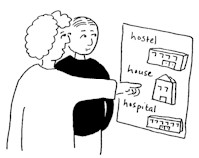
For people to decide what they want to do

For people to be safe

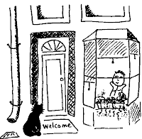

For people to live in the community

To help people be healthy

Service aims

To have good, trained staff

To help people go to college or go to work

To plan help and support just for you
(Person-centred planning).

How to access the service

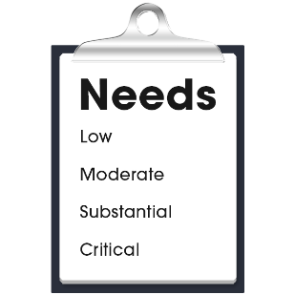
If you need help and support to live in your local community, with access to staff who can help you, your social worker will complete an ‘assessment’ of your needs.

You can use the learning disability service if you are over 18 and:

Have a learning disability, or

Have an acquired brain injury, or

Have a mental health disorder, or

You are autistic, and

Meet the conditions for getting support, and

Live in the Tameside area.
You can contact the team, who will find you a social worker

The telephone number is 0161 922 4888
What happens next

If the assessment shows that you have met all the conditions to be able to get help and support from us your social worker will talk to the Accommodation Options Group.

This group manage all the properties available to people who meet the conditions of getting help and support.

Your social worker will have already talked to you, your family and friends, and anyone else who knows you well, about the type of place you want to live in.

They will find you the right place to live and the right staff

It might be a house Or a flat

Workforce

Our staff do training to make sure they do a good job.

Here is a list of some of the training that they do:

QCF
Care Certificate

Person-Centred Planning

PROACT-SCIPr-UK training
Working Safely

Workforce

Manual Handling

Autism awareness and Oliver McGowan training

Any other important training

People who manage the service

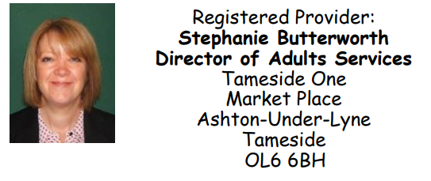

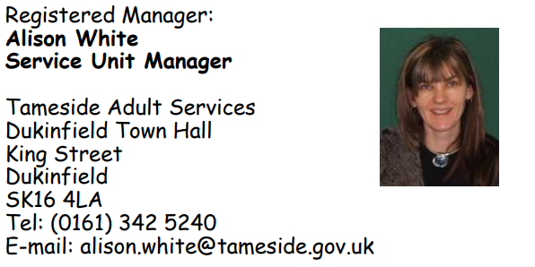

Suggestions, Compliments and Complaints

Tameside Homemaker Service want to make sure we are providing quality services to people who use our services.

We want to know what you think of the services we provide.

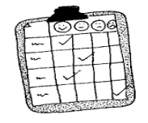
We know you might have ideas that will help make the service better
If you would like to know more about how to make the service better, or how to complain about something, or to tell us what you think we do well, you can ask for a copy of this leaflet.

Suggestions, Compliments and Complaints

You can also contact:
enquiries@cqc.org.uk
03000 616 161

Other formats

Please ask your assessor or social worker if you would like this information translated into Gujarati, Urdu or Bengali, or in another format such as CD-ROM or Braille

