Access Statement for Central Art Gallery
2017-18

This access statement does not contain personal opinions as to our suitability for those with access needs, but aims to accurately describe the facilities and services that we offer all our guests/visitors.
Access Statement for Central Art Gallery
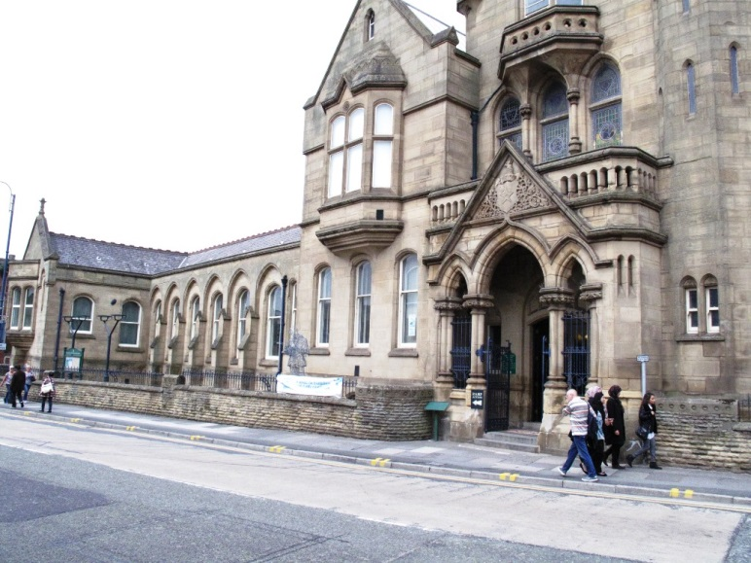
Introduction
Central Art Gallery is located above the Central library on Old Street in Ashton-under-Lyne. The galleries host a varied programme of temporary exhibitions with shows of artists from across the region including paintings, sculpture, installation and textiles. Central Art Gallery also runs a programme of adult art courses, a knit and natter knitting group and special events. The art gallery is made up of 3 distinct galleries - one is permanently dedicated to the work of local Hyde Artist Harry Rutherford. The art gallery is approximately 7/11.2km miles east of Manchester City Centre and approximately 1/2 mile south of Ashton-under-Lyne Railway Station, Metrolink Stop and Bus Station.
The gallery is accessible via both a lift and stairway from both inside Ashton Central Library and directly off the main road (Old Street). The galleries themselves are all on one level without any ramps, steps or internal doorways.
There is a small shop selling a range of souvenirs but no cafe facilities. Staff are able to suggest nearby places for refreshments and other attractions. An attendant is on duty within the gallery should you require any assistance. The galleries full range of exhibitions, events and activities can be found on our website at: www.tameside.gov.uk/museumsgalleries.
The gallery is a member of the Visit England Visitor Attraction Quality Assurance Scheme (VAQAS).
We look forward to welcoming you. If you have any queries or require any assistance please phone 0161 342 2650 or email portland.basin@tameside.gov.uk.
Pre-Arrival
- For maps of how to reach us and to help plan your journey by car and public transport please use a journey planning website; simply enter your postcode and ours, which is OL6 7SG to get directions.
- The nearest railway station is Ashton-under-Lyne, which is approximately, 1/2 mile away (10-15 minute walk). Taxis are not available at the station. The nearest taxi-rank is approximately 1 minutes’ walk away to the side of Ashton-under-Lyne Town Hall.
- The nearest bus stop is opposite the railway station but services do not run directly to Central Art Gallery.
- Car Parking in Ashton under Lyne can be seen on: www.tameside.gov.uk/carparksmap/ashton.
- The Ashton-under-Lyne Metrolink stop is adjacent to the Bus Station which is located at the end of the 'Eccles to Ashton-under-Lyne' line.
Car Parking and Arrival
- There is no public car park immediately near the Art Gallery but there are 2 designated accessible parking bays to the left of the main entrance to Ashton library at the bottom of the side door ramp (see details below).
Main Entrance:
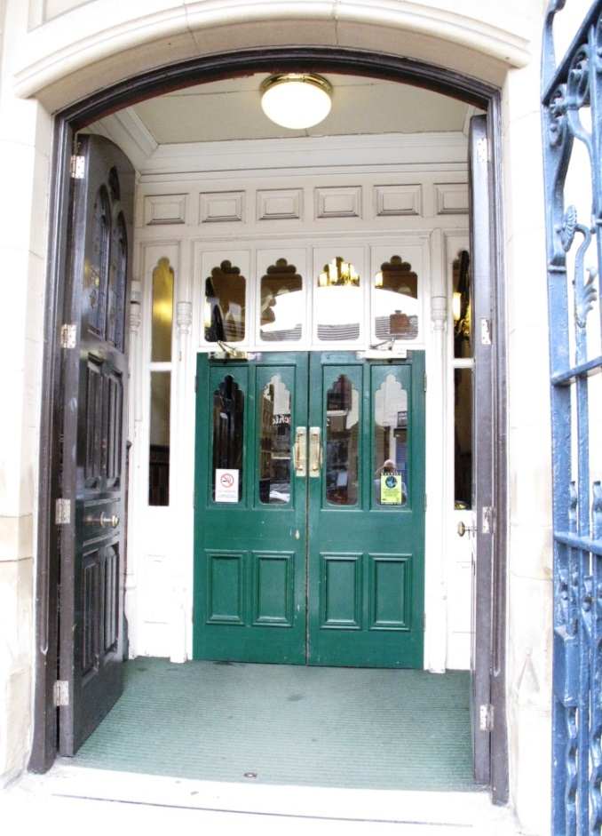
- Double yellow lines run the full length of the main road immediately outside the library building, with no unloading permitted as there is a set of traffic lights immediately outside the main entrance.
- A 'Ramp Access' sign directs users to the left of the main entrance (See below).
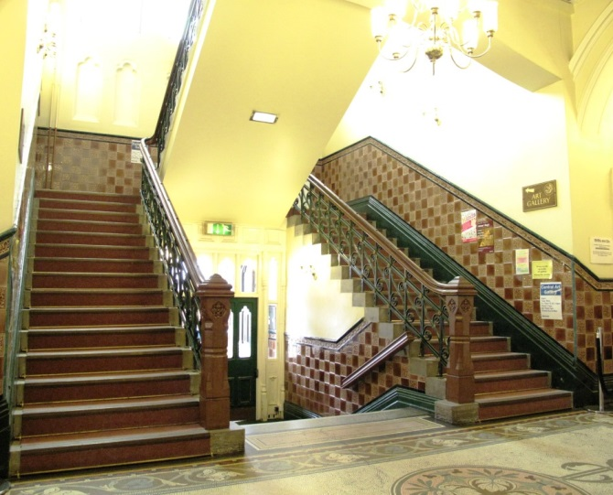
- When facing the main entrance there is a set of iron gates with a width of 65ins/165cm which are fixed open and which lead to 3 stone steps that in turn lead to a set of manually operated double doors, which open inwards, with even paving stones before the steps. The first double doors (library doors) are always fixed open when the gallery is open and measure a width of 6' 4"/163cm. This leads to a green short pile carpet area leading to a further set of reasonably heavy manually operated double doors with brass handles measuring 65ins/165cm high from the floor, opening outwards. Through the library doors there is a green short pile carpet leading up to 5 smooth tiled steps (grey and white mosaic) with wooden hand rails on either side of these steps. These steps lead into the main entrance area for the library. Within this area there is no lift nor ramp access to the art gallery above. This area is well lit with uplighters on the walls and there are 2 standalone chairs within this space.
- Access to the art gallery in this area is by stairway from the main library entrance. A wooden hand rail runs the full length of the stairway. The stairway is lined with a pink short pile carpet.
- The gallery signage is predominantly in large gold lettering on wooden panels stating 'Art Gallery'.

Ramp Access through the library's side door:
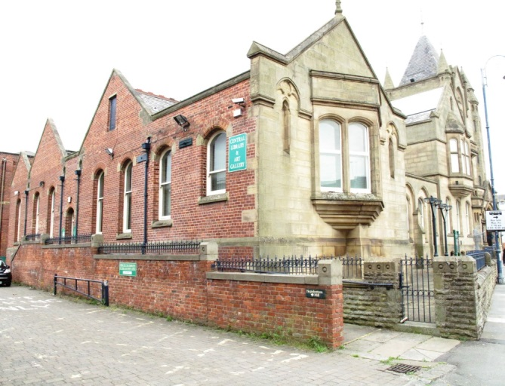
- A 'Ramp Access' sign is outside the main entrance to the library (see above).
- Even paving stones to the front of the library. 8 feet/244cm from the kerb edge with no lowered kerb stones is the main entrance.
- 122 feet/37.2 metres to the left of the main entrance is the start of the ramp.
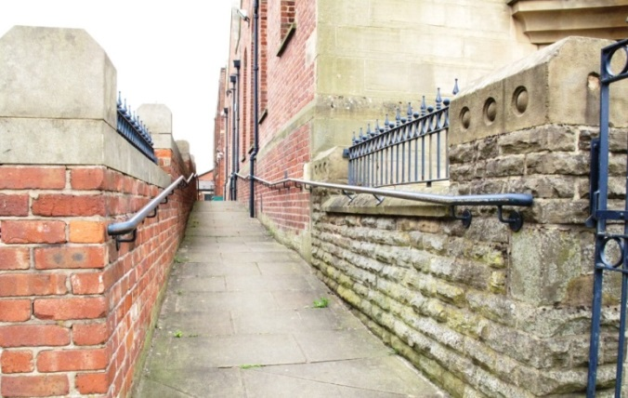
- The ramp increases gradually for a length of 64 feet/19.5metres to a 'push button' automatic door opening on right (31 ins/79cm from the ground). A metal hand rail runs the full length of the ramp on both sides.
- There is a drop kerb immediately to the left at the start of the ramp.
- The ramp area is well lit with overhead flood lights in the evening.
- The width of the ramp is 55ins/140cm.

In front of the side door:
- 7 even stone steps with yellow edge markings and ridged top paving stones descend into a staff car parking area.
- The steps are 3 feet/ 91ins wide with a metal hand rail on either side of the steps.
- Signage indicating the opening times of the gallery are in large font, to the right of this door in cream on green lettering.
Side Door Entrance:
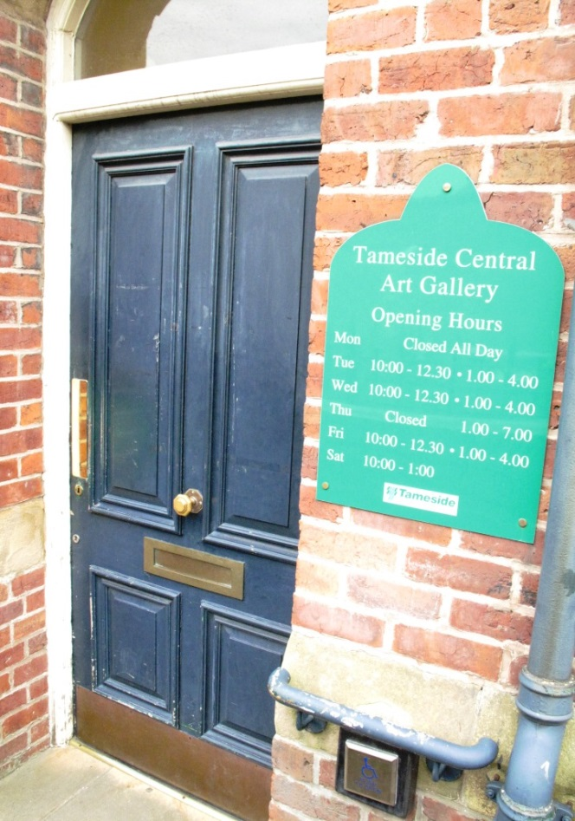
- The width of the door is 42ins/107cm wide and opens inward slowly and automatically once the 'push button' is pressed.
- The doorway leads onto a green short pile carpeted area with a further 'push button' on the left to open the door (inwards) when returning this route.
- The following double manual doors are always open and have a clearance of 39ins/99 cms leading to a long corridor of green short pile carpet with natural and artificial light the full length of the corridor (access to public library rooms).
- This corridor is 87ins/221cms wide and may contain several obstacles including display stands.

Corridor Steps:
- Towards the end of this corridor are 5 carpeted steps with a metal handrail the full length of these steps.
Lift (Corridor):
- A lift 'not suitable for outdoor mobility scooter' provides an alternative route to the aforementioned steps.
- Library staff can be asked for assistance
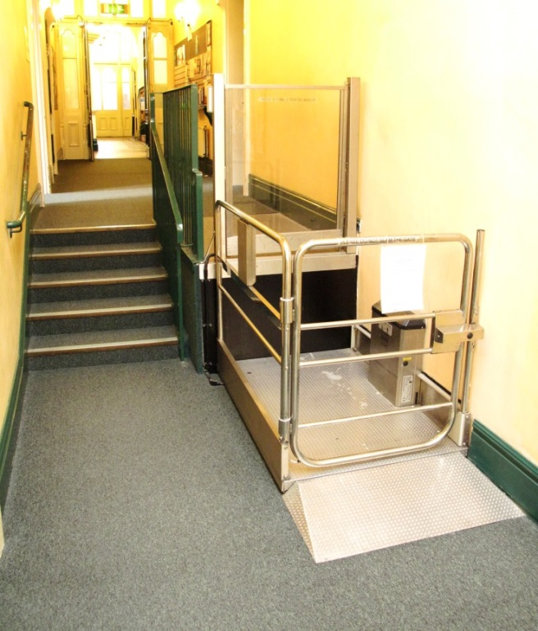
- A 'push button' operates the lift 33ins/84cm from the floor.
- 250kg is this lifts maximum capacity.
- Instructions on operating this lift are clearly visible at all stages of the operation including an 'alarm' button.
- The lift exits onto a short pile green carpet and through 2 double doors which are always open, with a width of 41ins/105cm.
- This doorway leads into the library's main entrance area and the base of the stairs which lead to the art gallery (see above)

Lift (to the art gallery):
- On the left, opposite and after the aforementioned corridor lift, is a doorway measuring 35ins/88cm wide leading to a short pile green carpet and access to the gallery lift on the left.
- The art gallery lift is manually operated with a button 37ins/94cm from the ground.
- The lift door width is 31ins/79cm wide.
- The lift is 58ins/140cm long and 37ins/95cm wide with a green short pile carpet inside and a mirror opposite with 1 aluminium hand rail on each side of the lift 35ins/89cm from the floor. The lift interior is 6'6"/2 metres high.
- There is no room to turn inside the lift and visitors exit the same way they enter on the gallery level.
- The maximum capacity for the lift is 8 persons or 600kg and is manually operated by pressing the button for level 1.
- The lift issues verbal instructions 'mind the doors please' on closing but there is no full length door strip so care is recommended on entering the lift.
- On arriving at level 1 the verbal instruction 'first floor and art gallery, doors opening' is used and the door opens automatically leading to a level, pink short pile carpeted area in front of a doorway to the art gallery measuring 35ins/89cm wide with clear signage to the left of this doorway.
- The remainder of the art gallery is all on 1 level, with no ramps.
- The following gallery spaces (galleries 1 and 2) have polished smooth wooden flooring and both natural and artificial light providing well lit gallery space.
- Facing this area are 2 doorways both of which lead into the galleries main reception area and measure 39ins/99cm in width.
Main Reception Area:
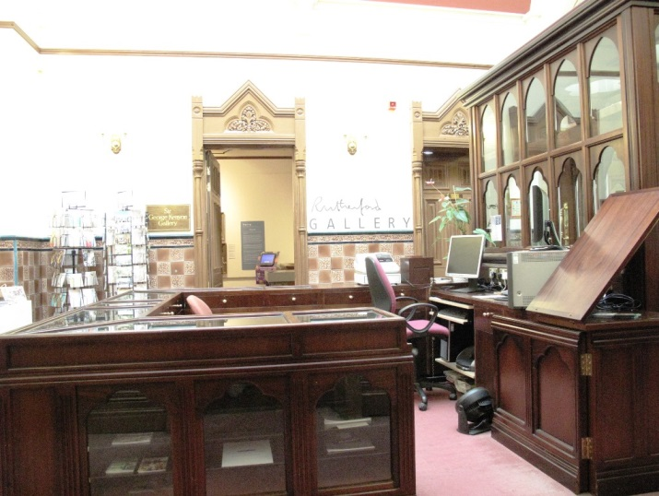
- From the main library reception area 15 steps lead to the art galleries landing followed by a further 14 steps to the reception desk of the art gallery itself. At the top of these steps are 2 doors measuring 37ins/94cm wide with pink short pile carpet through which is the galleries reception area/shop and staff to assist. This whole area is well lit with natural light and uplighters.
- Gallery 3 (The Rutherford Gallery) leads off from the main reception area through a doorway opposite reception.
Main Entrance, Reception and Ticketing Area
- Admission to the art gallery is free to everyone.
- The art gallery is located on one level with step free, level access, throughout the public areas.
- There is one free-standing chair in this area.
- The floor surface is a pink short pile carpet.
- The area is evenly and well lit with a balance of overhead lighting and natural light.
- The reception/shop desk area is all the same height (32ins/81cm) from the ground.
- No wheelchair loan is available.

Attraction (displays, exhibits, rides etc.)
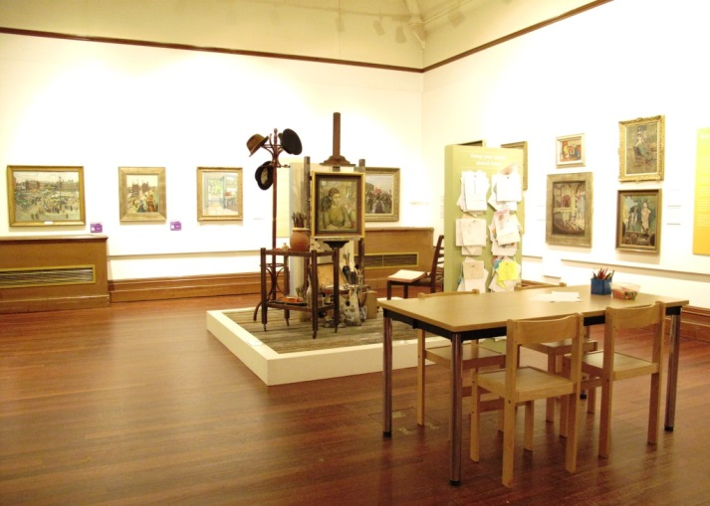
- Central Art Gallery is located above the library on Old Street in Ashton-under-Lyne, the gallery spaces host a varied programme of temporary exhibitions including group and solo shows of artists from the region including paintings, sculpture, installation and textiles. the gallery runs a programme of adult art courses, a knit and natter knitting group and special events, for more information please contact us below or see our events calendar. We welcome noise and mess in our galleries and this is a family friendly space. Drop by during the school holidays and make something to take home at our craft table.
- There are several leather seating areas around the gallery as well as free-standing chairs throughout.
Public Toilets
- The nearest public toilet for use by gallery visitors is those operated by the Central Library located below the art gallery on the main corridor before the aforementioned corridor lift.
- A dimly lit corridor with a green short pile carpet, leads off the main library corridor through a doorway measuring 33ins/84cm wide and doors which are closed 15 minutes prior to the library closing towards a space of blue linoleum flooring with 'Accessible', 'Ladies' 'Gents' and Baby Change' rooms, clearly sign posted.
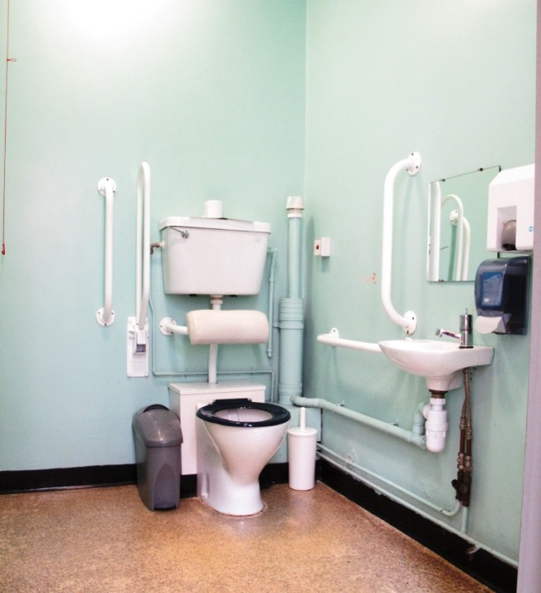
'Unisex Accessible Toilet':
- This facility is operated by a RADAR key - ask at the Reference Library for this key (off main library corridor).
- The door opens outwards, manually, using a handle 44ins/112cm from the ground and is fairly light weight to open.
- Inside are both horizontal and drop down grab rails as well as a hand rail behind the door.
- There is a lever tap above the washbasin, hand sanitiser, hand dryer (no paper towel dispenser) and toilet.
- The floor surface is non-slip.
- The toilet is 17ins/42 cm from the floor.
- The hand basin is 29ins/74cm from the floor.
- There is an emergency pull cord to the left of the toilet with emergency lighting in place.
'Gents':
- Non-slip flooring through manual push door, which opens outwards.
- Blue ultraviolet lighting is in operation in this toilet.
- 1 cubicle and separate urinal and washbasin to the side with hand sanitiser, hand-dryer & mirror.
'Ladies':
- Non-slip flooring through manual push door, which opens outwards.
- 2 cubicles and 2 separate washbasins to the side with hand sanitisers, hand-dryers & mirror.
'Baby Change':
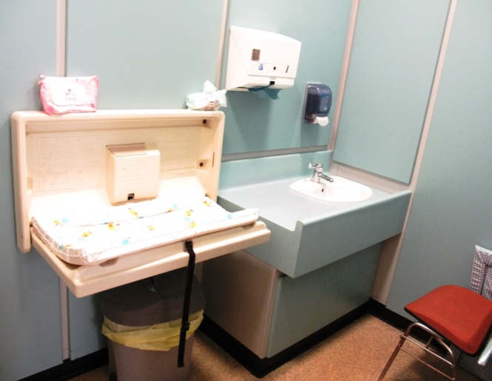
- This facility is kept locked but library staff can provide access on request.
- Inside is a hand sanitiser, standalone chair, toilet, washbasin with lever tap, hand sanitiser, paper towel dispenser and baby changing platform.

Catering
- The galleries small shop does not sell refreshments. Staff are able to suggest nearby places for refreshments. There is nowhere within the gallery to take refreshments.

Shop(s)
- There is a small shop within the main reception area of the gallery selling a range of souvenirs.
- This area is level throughout.
- Staff can offer assistance if required.
Additional Information
- Selected staff have received equality awareness training and dementia awareness training.
- We have a set of evacuation procedures - should you require it someone will assist you with evacuation out of the building.
- We welcome trained assistance dogs.
- Reception staff can offer guidance on other local and regional points of interest.
- Clear signage is used throughout the gallery using a variety of fonts, sizes and colour schemes but mainly lettering on brown panels.
- We have no hearing loop system in the art gallery.
Future Plans
- We constantly review the content of our website, endeavoring to make it as accessible as possible.
Contact Information
Address (Inc postcode): | Central Art Gallery, Old Street, Ashton-under-Lyne, Tameside, OL6 7GS.
Telephone: | 0161 342 2650
Email: | portland.basin@tameside.gov.uk
Website: | www.tameside.gov.uk/museumsgalleries/central
Grid Reference: | SJ 937 989
Hours Of Operation: | Opening times: Tue, Wed, Fri (10am-12:30pm) & 1-4pm, Saturday (10am-1pm). Closed Sundays, Mondays and Thursdays.
Local Accessible Taxi: | 1. Radio Cabs - 0161 330 2090. 2. Cavalier Radio Cars - 0161 338 5500. 3. Stamford Cars Uk - 0161 339 4411.
Local Public Transport: | 1. Transport for Greater Manchester - www.tfgm.com/Pages/default.aspx. 2. Rail enquiries - 08457 484950.

